PEDAGOGICAL CURRICULA FOR FACILITATORS
A BETTER PREPARATION FOR SENIOR LIFE

KA204-2017-012

Project title: Bepresel
Grand Agreement Number: KA204-2017-012
Publisher: Ljudska univerza Ptuj (Public University of Ptuj), Slovenia
For the publisher: Tanja Božič
Editing: The partnership of the ERASMUS+ project Bepresel
©Authors: Tanja Božič (SI), Petja Janžekovič (SI)

PEDAGOGICAL CURRICULA FOR FACILITATORS

Key words: training/educational program, methodology, teaching materials, facilitators’ skills

INDEX
Key words: training/educational program, methodology, teaching materials, facilitators’ skills 2
1. GENERAL PART 4
1.1 INTRODUCTION 4
1.2 THE TARGET GROUP 5
1.3 duration of tHE Training program 6
1.4 training GOALS 6
1.5 GOALS and competences 6
2. methodology 7
2.1 using the program for facilitators 7
2.2 organization of THE education 8
2.3 teaching aids and materials 8
3. educational modules and contents 9
3.1 MODULE 1: presentation of THE training program TO THE facilitators (2 HOURS) 10
3.2 MODULE 2: PRESENTATION OF THE EDUCATION PROGRAM FOR seniors and the senior fitness test (3 HOURS) 13
3.3 MODULE 3: The role of the facilitator -working with THE targer group (3 hours) 19
3.4 MODULE 4: facilitating THE educational program for better preparation for senior life (3 hours) 26
3.5 MODULE 5: THE FACILITATOR'S EDUCATIONAL PLAN – PREPARATION AND CONDUCTING (3 hours) 30
3.6 MODULE 6: A PRACTICAL EXAMPLE OF THE EDUCATION – PILOTING THE PROGRAM (2 hours) 34

GENERAL PART

INTRODUCTION
Population ageing is one of Europe's greatest triumphs but at the same time one of the greatest challenges faced in the 21st century.
We need to provide seniors citizens with a “new understanding of the ageing processes” to replace the current understanding and approach to the ageing processes, known in Denmark as the “decay theory” or “theory of withdrawal”.
The purpose of the project “A better preparation for senior life” is to improve the health promotion initiatives for seniors in the involved countries and the EU, by developing a strategy for a more effective outreach to seniors, to motivate them to take part in education about their health. The initiatives will include the opportunity for the seniors to make their own health/strength profiles. It will also include tailored counselling on how to improve physical and mental active ageing activities to keep the seniors independent for longer.
We need a new scientific based knowledge and understanding from the seniors or pre-elderly seniors entering this period of their lives, to ensure that they will enter senior life well-equipped. They need more facts and to be empowered and able to carry out their active ageing activities properly to not only live longer, but also to stay independent and self-governing.
The average life expectancy is increasing and thereby the years the seniors need care and support. The quality of the activities performed by the seniors, does not have the needed level to improve their health and physical strength later in life. Being active is not enough.
If a person on an evening walk doesn’t reach the 80% of the maximum capacity for at least 3 to 5 minutes, 3 times a week, it won’t help them maintain their physical strength. Their abilities will slowly get worse, and they will need care in 3, 5 or 8 years.
This project intents to transform the scientific knowledge about senior health into understandable knowledge, and thereby provide seniors citizens with the competences they need to stay independent longer.

THE TARGET GROUP
Facilitators: skilled and competent older adults (60+), with working experience, preferably in medical sciences, professional areas or with teaching competences. They must be willing to participate in the training program for facilitators and afterwards conduct a 12-16 hours educational course on a better preparation for senior life.
The facilitators should also be “similar to participants in the target groups”, but it is not obligatory – the most important thing is that the peers are confident, competent, educated and motivated to teach. It is preferred that they have experience as facilitators or teachers in adult educational programs.
Facilitators in the program should be communicative, knowledgeable, emphatic and ready to accept diversity without judgement or pre-labelling.
Over the implementation period of the educational program, facilitators should spread tolerance, equality and democracy amongst the participants, for whom it is necessary to know the basics of human rights and civic education.
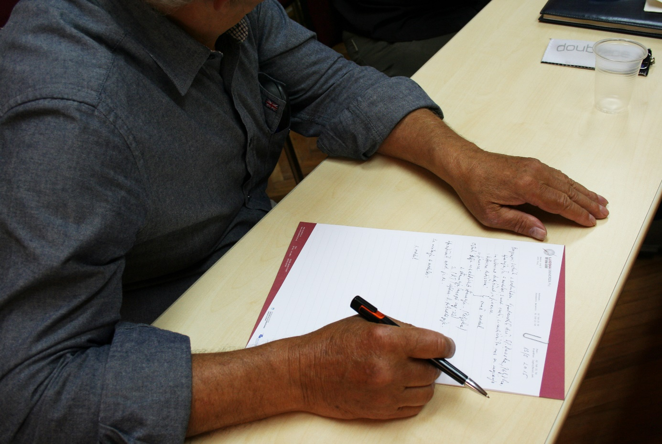

duration of tHE Training program
The senior Pedagogical Curricula requires the senior health educator in Senior Health issues and the Senior Health promotor in the 12-16 hours lessons program to have the skills to perform tests of the seniors. They need to have the abilities to test a minimum of 8 documented physical parameters.

training GOALS
The main goal of the training is to prepare the future facilitators (skilled and competent older adults) to become facilitators (peer facilitators) in the educational program Bepresel (A better preparation for senior life) and to get acquainted with the physical fitness test for the seniors.

1.5 GOALS and competences
The managements’ goals
Future facilitators:
- Are familiar with the content of the study group/educational program
- Learn about designing the goals for the study group and its implementation
- Learn about the different forms of motivations
- Learn how to choose and conduct the conversations in the educational program
- Learn about the organization and methods of working in a group
- Learn about resources and learning tools
- Learn about the process of performance evaluations in the educational program

Operational goals
Facilitators will:
- Discuss the community’s learning and its anthropological foundations as an important ground for working with seniors in the educational program
- Examine the communication and the communicational forms in education, especially in education for seniors
- Understand the non-hierarchical forms of learning
- Conduct the actual educational programs for seniors in groups

methodology

using the program for facilitators
The program has been produced as a resource for the people who will be facilitating the educational programs prepared by the Bepresel partnership. It can be read alone as a basic introduction to facilitate the training.
The content of the program is divided across several topics that broadly cover the following issues:
- Principles of learning
- Guidance on preparing the educational program for a better preparation for senior life and the senior fitness test
- Guidance on how to use the participatory training methods
- Guidance on the writing and production of handouts and overhead projections
Suggestions for evaluating the educational program
If you are an experienced facilitator, you could use the program as a reference tool or as a help to update your current practice and skills, especially on the field of better preparation for senior life. If you are new to training or lack experience in facilitating learning, you might find it useful to read the entire program and use it as a support to assist you in planning and carrying out your educational program.
Important notice!
Facilitators, when transferring learning content, should only relate facts. They should not provide personal information, experiences, beliefs or opinions on questions that will be asked.
If they do not know the answer, they should seek a scientific answer to the question, rather than give their own beliefs.

organization of THE education
The program is carried out in a group of 4 facilitators in the form of blending learning. We organize an introductory and concluding meeting. In between these meetings the modular education in the classroom will take place. A detailed syllabus is published below.

teaching aids and materials
The following teaching aids will be provided:
- Classroom with typical didactic materials
- A whiteboard, an interactive board, a flip chart (demo board), poster sheets, A4sheets, pens, markers and notebooks for the lecturer and participants
- technical equipment and devices needed for the physical fitness test
For successful implementation the following is also needed:
- A classroom, an adapted for adult education, a network of computers with internet access, LCD display and a DVD player

educational modules and contents

DURATION OF THE PROGRAM AND MODULES

MODULE 1 | PRESENTATION OF THE TRAINING PROGRAM TO THE FACILITATORS | 2 HOURS
MODULE 2 | PRESENTATION OF THE EDUCATIONAL PROGRAM FOR SENIORS AND THE SENIOR FITNESS TEST | 3 HOURS
MODULE 3 | THE ROLE OF THE FACILITATORS WORKING WITH THE TARGET GROUP | 3 HOURS
MODULE 4 | FACILITATING THE EDUCATIONAL PROGRAM FOR A BETTER PREPARATION FOR SENIOR LIFE | 3 HOURS
MODULE 5 | FACILITATOR'S EDUCATIONAL PLAN – PREPARATION AND CONDUCTING | 3 HOURS
MODULE 6 | PRACTICAL EXAMPLE OF EDUCATION – PILOTING THE PROGRAM | 2 HOURS
TOTAL |  | 16 HOURS

We recommend that you conduct this training either in:
- One-week training – approx. 3 hours a day (from Monday till Friday)
- Three weeks training – 2 modules per week – 2 x a week

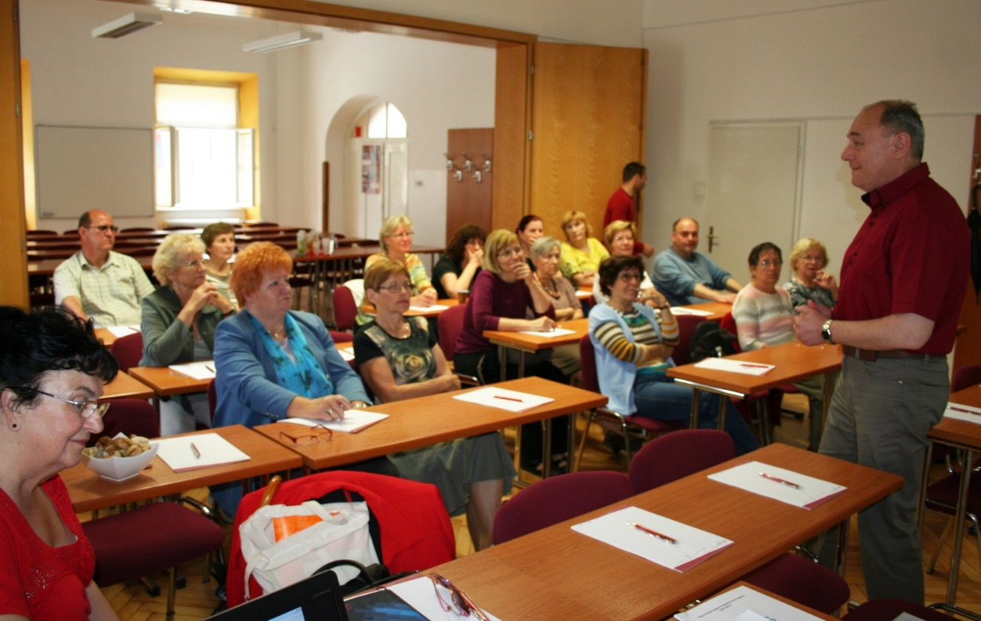

3.1 MODULE 1: presentation of THE training program TO THE facilitators (2 HOURS)

Training contents:
Content 1: short introductory presentation of project Bepresel (A Better preparation for senior life), a presentation of the training program for the participants, their obligations during the implementation and the benefits for their peers (social, financial, networking, topics, etc.).
Content 2: characteristics of good andragogic practice and skills for individual/team work during training.
Training methods:
The training methods must be adapted to the respective group of participants but are generally interactive, allowing communication throughout the training.
To successfully deal with the units, clear and innovative methods that suit the target group are needed. The following methods beside lectures (presentation, speech) are recommended:

- Workshop: Group work and pair work
- Video/movie and discussion
- Outdoor activities – ex. educational walk, lesson in the garden
- Indoor activities – ex. physical exercises
- Brainstorming on flipcharts
- Inputs from the trainers and possible experts
- Individual work to explore themselves
- Story telling
- Group discussions (round tables, plenary, tables in U-form)
- Creative activities

UNIT 1: INTRODUCTION OF THE TRAINING PROGRAM FOR THE BEPRESEL FACILITATORS
Duration: 1h
Aims:
- The mentor introduces the training program to the facilitators
- Participants discuss why they want to become facilitators (motives)
- Participants get to know each other
- Participants get to know the aims and goals of the training program for the Bepresel educators (facilitators)
Contents:
- Introduction of the training program for the seniors who wants to become facilitators in the Bepresel project
- The participants’ motives
- The aims of the facilitators training and the methods for delivering the educational program and the senior fitness test
- Advantages and disadvantages of the facilitators’ role
Activity 1.1: Motives for being a facilitator
- Purpose of the exercise: clarify motives for the participants
- Duration: 1 hour
- Group size: 4-8
- Instructions for the trainer:
Let participants introduce themselves with their name, age and personal details about where they live or used to work. Then hand out cards and pens and have them write down their personal

motives for becoming a facilitator. You will see that they are similar. Collect them and pin them on a board. Then have each person talk about their motives. After that hand out a second set of cards and pens and have them write down their past area of facilitator’s role: friends, seniors’ group and societies, University for Third life period, mentoring etc. and put them on a board to see who in the group has similar interests.
- Equipment: chairs in a circle
- Tips and tricks for the trainer:
There should be enough space for all small groups to conduct the exercise. This exercise needs a setting of trust, as participants give insight into their lives, which are personal and might be emotional. It needs to be clear that the information is confidential and handled with care.

uNIT 2: THE FACILITATORS SKILLS
Duration: 1 hours
Aims:
- To encourage participants to look at their skills in a systematic way
- To encourage participants to look for further learning opportunities if they lack a skill
- To make each participant more aware of their skills and talents
- To encourage participants to look back and rediscover skills and talents
- To help participants appreciate that throughout life they have learned through experience as well as formally
- To pinpoint that some skills are more important than others in later stages in life
Content:
- To complete a personal skills profile or memory map (what I know, what I am good at)
- To compile a skill profile as an important step towards future action
Activity 1.2: Memory map
- Purpose of the exercise: to map skills
- Duration: 1 hours
- Group size: 4-8
- Instructions for the trainer:
Encourage participants to think about their skills. Help them unpick everyday skills like cooking or cleaning, which could be relevant for facilitators. Give examples of skills: like language skills,

reading skills, using ICT, past experience, etc. Encourage participants to write everything down on a blank piece of paper and have them discuss the results in pairs.
Use the memory map to collect all the skills from the participants in a structured way. Let them fill in and systematically express the skills they have gained from: work, education, further education, family life, facilitator, free time, special life events and others.
- Equipment: memory map
- Tips and tricks for the trainer:
Have them present their main skills in plenary. Applaud after each person. A skill profile or memory map is a personal document. It should be emphasised that people should select skills that matter to them rather than skills that pleases the trainer.
This activity is narrative and helps to draw out the participants personal memories and experiences. It works well with those who would not particularly enjoy filling out a written questionnaire.

3.2 MODULE 2: PRESENTATION OF THE EDUCATION PROGRAM FOR seniors and the senior fitness test (3 HOURS)

Training contents:
Content 1: presentation of the goals of the face-to-face program for seniors and the competences needed for working with the described target group.
Content 2: Exercise. What kind of a facilitator am I and what kind of a facilitator do I want to become? Group evaluation of the exercise. Conducting the overall model of the Bepresel facilitator intended to lead the participant’s group.
Training methods:
The program proposes discussions as well as many dynamic methods of working in pairs or small groups. During the 16 hours of the programme, the participants will be developing their competences in discussion and sharing thoughts in a small group on the subject “better preparation for senior life”.
Teaching tips:
- Frontal teaching method – lecture/presentation of the prepared face to face program

- Group discussion in a circle – the participants will communicate more openly and listen more attentively in a circle, close to each other
- Listen to each other – a circle allows the participants a better overview of the group
- Practical exercises – practical exercises, based on the learning contents of the educational program for better preparation for senior life and the senior fitness test
- Asking questions – asking questions on different subjects is the basis for proper understanding and, later, conducting the program
- Join the discussion – the trainer encourages participation by joining the discussion.
- Silence or breaks in a conversation – time for the participants to think. You can offer, “Let’s think about this together”.

UNIT 1: INTRODUCTION TO THE EDUCATIONAL PROGRAM FOR better prepraration for senior life and the senior fitness test
Duration: 2 hours
Aims:
- Future facilitators are familiarised with the content of the educational program for better preparation for senior life and are trained to use the learning modules, materials and techniques.
- Trained facilitators are comfortable in delivering the educational program according to the schedules and contents.
- Facilitators get familiarized with the senior fitness test and how to conduct it.
- Facilitators understand and are more motivated to deliver the “better preparation for senior life” course to a pilot group of participants.

Contents:
- to get an overview on the face-to-face educational program for a better preparation for senior life
- Facilitators are presented with issues of active ageing, to give them a better understanding of its process and the positive attitude towards ageing.
- To be trained and motivated to lead the small group of participants, partly based on the facilitators’ past experiences and teaching skills, and partly on newly acquired competences.
- To present the senior fitness test and teach the facilitators how to conduct it.
- To present the contents of the programme in a simple, interesting and understandable manner.

Activity 1.1: Lecture on the content of the Bepresel educational program for better preparation in senior life and the fitness test
- Purpose of the exercise: Participants are introduced to the contents of the Bepresel educational program and the senior fitness test. A mentor presents the overall structure of the program and the goals, its general and specific modules and explains the reasons for the modules.
The purpose of introducing the educational program within this topic is to highlight the variety of learning opportunities that exist and how some of these techniques may be applicable to the training plans.
Mentors are introduced to all the technical equipment needed to conduct the test. They are given detailed instructions on how to use the equipment.

- Duration: 1,5 hours
- Group size: 4-8
- Instruction for the trainer:

Before starting the exercise, the trainer (mentor) and the participants (future facilitators) must be clear as to why they are going to do the training and what they want to communicate. The mentor formulates objectives for the educational program and specific objectives for each session/exercise within the program and the senior fitness test. An important point is to write objectives describing what the participants will be able to do as a result of the training.

Objectives from the trainer’s viewpoint:
“To familiarize the participants with the complete contents of the educational program for better preparation for senior life and the general and specific modules that they will be able to conduct it in the face-to-face learning form. Special attention should be given to presenting the fitness test to the seniors.”

Some objectives from the participants’ (future facilitators) viewpoint:
“Tthe facilitators will understand the overall structure of the educational program for better preparation for senior life, the general and specific modules and will be able to conduct face-to-face education and perform/demonstrate the senior fitness test.”

Educators will be using the blueprint from the educational program for better preparation for senior life, prepared by the Bepresel partnership. It describes the goals, objectives and contents of the educational program.

- Equipment: whiteboard/flipchart, LCD projector, computer, sheets of paper, writing utensils, technical equipment for the fitness test (indoor bike, personal scale, dynamometer, blood pressure monitor, measuring tape, skin wrinkle meter, BMI calculator etc.)

- Tips and tricks:
Ensure that all the testing areas are fully explained and that the future facilitators understand the purpose and use of the tools used during the physical fitness tests.

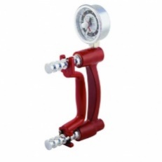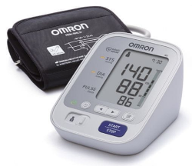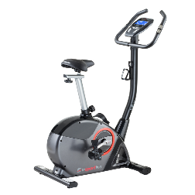

Activity 1.2: opening the meeting
- Purpose of the exercise: the success of the face-to-face Training Program largely depends on the way the sessions are conducted by the facilitator. The facilitator’s role is to enable positive cooperation and interactions between the participants. Future peers will be practicing opening the meeting with a short introduction, a presentations of the working methods and the goals of the training program.

- Duration: 1,5 hours
- Group size: 4-8
- Instructions for the trainer:
It is necessary to come to an agreement about the syllabus and the working methods future facilitators are going to use in every stage of the program. Therefor it is wise to give them an opportunity to practice the short introductive opening in pairs and to discuss the recommendations for training sessions.
Learners will use the prepared syllabus and the contents of the educational program, supported by Power Point presentation, to familiarize the facilitators with a complete overview of the activities and goals of the Bepresel program and the senior fitness test.

- Equipment: whiteboard, flipchart, LCD projector
- Tips and tricks for the trainer:
Typical recommendations for the training sessions include:
- Title: a short slogan in a simple language, sometimes suggesting association
- A few words on the training session: motivation and general information on the issues discussed at the meeting
- Objectives: short description of the desired results of various parts of the meeting, such as: preparation, introduction, main tasks and conclusion

- What we need: list of materials helpful in the performance of the task and the fitness test
- Tips: practical and teaching issues that will be helpful in conducting the meeting
- Introduction: proposed warm-up activities at the start of the training session
- Main tasks: a list of proposed tasks has been devised for each subject
- Conclusion of a training session: each session ends with a summary of the main tasks and sometimes with an assessment of the benefits of the Program; this may be a group exercise, or a dialogue based on open-ended questions.

IMPORTANT TIPS FOR THE BEGINNING OF THE EDUCATIONAL PROGRAM
- To arouse interest, participants need a bridge into the topic
They may attend because they want to learn, but the structure still needs to guide them into the material. Do this by using several approaches e.g.:
- A discussion
- Interesting input
- A good icebreaker
When the learners are not motivated to take part in the process, discussions encourage them to consider the positive aspects of being involved.
- Agree to group rules
Agree on how the facilitators and participants relate to each other, how the educational program will operate, and what is acceptable behaviour during the program.
- Clarify the program
This is a two-way process. Facilitators have a program designed to achieve the learning goals, but the participants also arrive with their own expectations of the program. It is necessary for both parties to agree on how these two predetermined views will come together. Two strategies can help create a shared vision of the workshop.
- Before the event, good communication with participants will identify the critical issues and introduce participants to the methodology of the educational program.

- At the beginning of the program, encourage the participants to express their expectation and align these with the planned program. The outcome of this process depends on the nature of the gaps, the facilitator and the participants. This process is very important and should represent a genuine exchange of information.

UNIT 2: what kind of a facilitator/teacher am i?
Duration: 0,5 hour
Aims:
- Get future facilitators to recognize their strengths and weaknesses according to the contents of the Bepresel program.
- Get facilitators to understand the importance of communication and teamwork, to be emphatic, to encourage open communication and to be willing to listen and recognize the issues of the participants in the group.
- Get facilitators to be comfortable in the role of the facilitators/leader of the group of seniors (60+).

Contents:

- Understanding the basic principles which must be applied in a training course for a better preparation for senior life: seniors must find and understand information, assess whether it is relevant to them, and in the end apply the information.
- Both the receptive skills (to take up information) and the expressive skills (to express knowledge and opinions) needs to be promoted in the Bepresel-training course.

Activity 2.1: Facilitator and/or teacher?

- Purpose of the exercise: Participants discuss the differences and similarities between teachers and facilitators in pairs and try to figure out when and why a teacher becomes a facilitator.

- Duration: 0,5 hour
- Group size: 4 - 8
- Instructions for the trainer:
Participants are seated in pairs in a circle, facing each other. The facilitator explains the purpose of the exercise in 5 minutes. They write their remarks and comments on a piece of paper and try to list as many characteristics of both teacher and facilitator as possible.
After 15 minutes the participants are asked to report on their findings and when each pair presents its research, a discussion is made possible. The mentor lists the important findings (pros and cons) on a whiteboard/flipchart.

- Equipment: whiteboard / flipchart, sheets of paper, writing utensils
- Variations:
The mentor can offer an evaluation session at the end of the module, so future facilitators get the opportunity to jointly create the image of a successful facilitator – a list of the most important competences and skills.
- Tips and tricks for the trainer:
Make a list of the competences of a good facilitator in 2 parts:
a) competences I am good at
b) competences I am weak at/need further education on

3.3 MODULE 3: The role of the facilitator -working with THE targer group (3 hours)

Training contents:
Content 1: Future facilitators (peers) get an overview of the teaching processes, different motivational factors for learning, communicational styles and the importance of good communication techniques.
Content 2: The role of the facilitator in the group. The methods of presentation and the conduction of information to the target group. The heterogeneity of the seniors and their needs and everyday life.
Content 3: How to develop useful learning experiences. Didactical methods for conducting exercises. Competences of modern facilitator for the target group.
Training methods:
The learning process is fundamental to training. It is vital that the facilitator have a basic understanding of the process to assess the most effective approach to education for a given situation. Research on how adults learn most effectively shows that training tends to be more successful when:
- Participants have been involved in defining, or refining, their own learning objectives;
- The content is focused on real problems faced by the participants;
- Training is undertaken in a varied and participatory environment.

This thinking underpins one of the standard models of training, known as the learning cycle, illustrated in the diagram below. The learning cycle involves experiencing, observing, thinking and applying.

Learning cycle

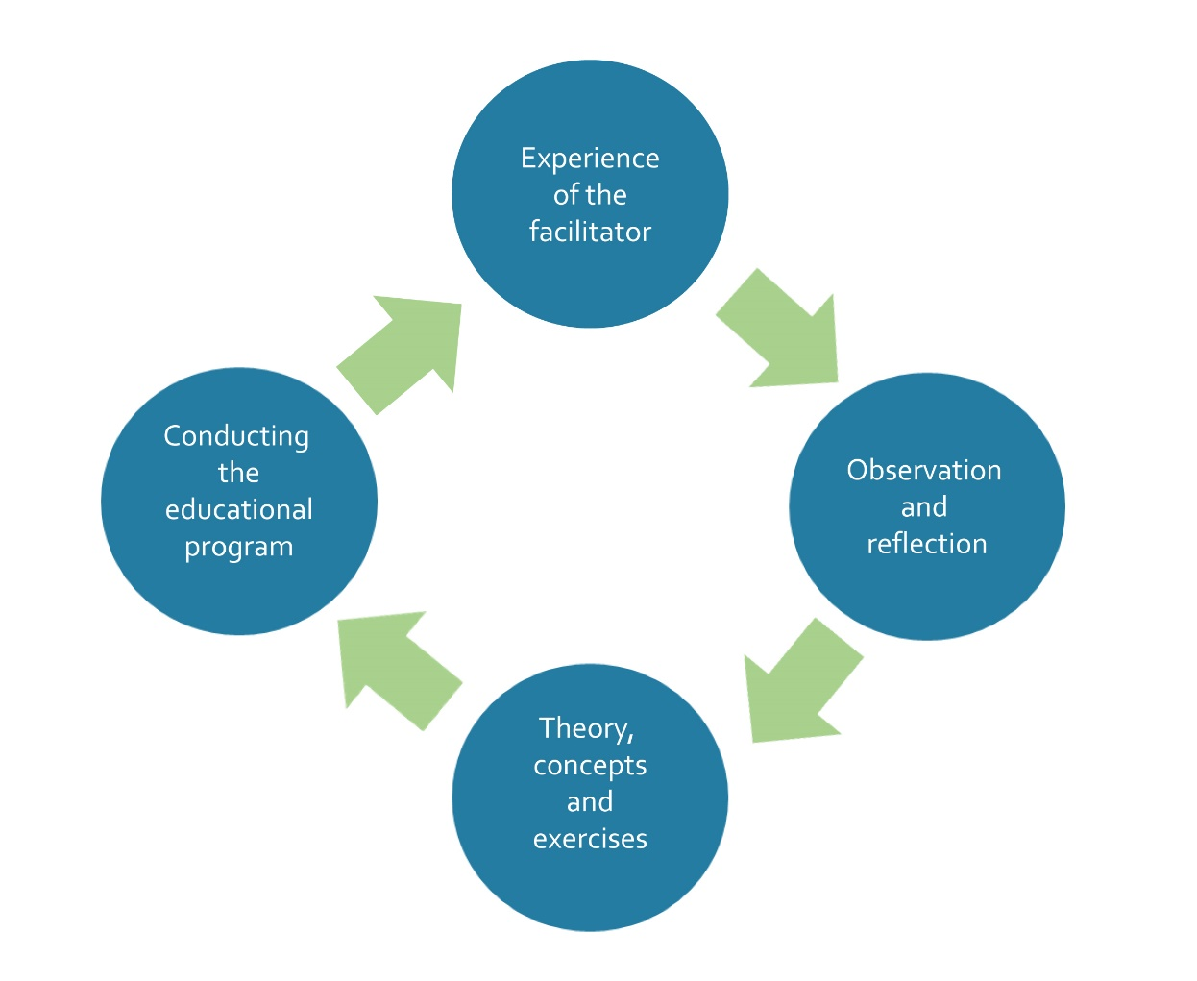

The following methods are recommended:
- Lectures
- Group work and pair work
- Brainstorming on flipcharts
- Individual work for in-depth understanding
- Storytelling
- Group discussions (round table, plenary, tables in U-form)
- Information searching – finding information on different topics on the Internet
- Demonstration of the fitness test

UNIT 1: THE teaching processes and THE communication teChnique
Duration: 1 hour
Aims:
  - Future facilitators familiarize themselves with the teaching processes they are going to use when delivering the program to participants.
  - Facilitators are able to use different methods of facilitating the contents of the program for a better preparation for senior life.
  - Facilitators are familiarised, confident and reliable in the communication techniques for conducting the educational program.

Contents:
- Getting to know the processes and goals of a successful facilitator.
- Participants are encouraged to recognize their abilities and to compare different roles and communication styles for conducting learning materials to the target group.
- Facilitators are able to relay the information to participants in a simple and understandable way.
- Future facilitators efficiently communicate with participants and develop the positive learning atmosphere and good relations in the group.
- Peers/facilitators understand the importance of listening and equal inclusion of the participants in the group.

Activity 3.1: Communication styles and techniques

- Purpose of the exercise:
Peers understand and can apply different communication techniques while working with the group of participants.
- Duration: 1 hours
- Group size: 4 - 8
- Instructions for the trainer:
Discussion in a group: what is communication? what is its purpose? The importance of listening and proper ways of leading a discussion in a group.

Prepare the list of different communication styles on a flipchart (Assertive, Aggressive and Submissive) and explain each of them shortly. Then ask participants to discuss them in a group.

After 15 minutes ask one representative from each pair to present their summary on the issue. If needed, explain the communication styles again.

- Equipment: flipchart, paper, utensils

- Tips and tricks for the trainer:
For different styles of communication and techniques and their use refer to the following web links:
- http://www.au.af.mil/au/awc/awcgate/sba/comm_style.htm
- http://www.clairenewton.co.za/my-articles/the-five-communication-styles.html
- http://www.healthlinkbc.ca/healthtopics/content.asp?hwid=ta4901
- http://www.google.si/books?id=lEfVVa6h8dEC&lpg=PA3&ots=l9ye5ax8- Y&dq=types%20of%20communication%20style%20active%20ageing&lr&hl=sl&pg=PA7#v=onepage&q&f=false

UNIT 2: the role of a facilitator
Duration: 1 hours
Aims:
- Participants get to know the goals of the facilitator’s activities
- Participants talk about the advantages and disadvantages of being facilitators
Contents:
- Introduction of the training program for seniors who wants to become facilitators (peers) in the “A Better Preparation for Senior Life” project.
- The facilitators’ motives.
- The goals of the facilitators training and the methods for delivering the educational program for seniors on a better preparation for senior life.
- The advantages and disadvantages of the facilitators role.
- The facilitators role as a group leader

Activity 3.2: The facilitator in a group – role-playing

- Purpose of the exercise:
Getting familiar with the role of the facilitator and its importance to successfully lead the group of seniors/participants in the educational program. The main goal of a facilitator is to draw out knowledge and insight from the group members. A facilitator will use different skills, tools, exercises and natural abilities to keep a group discussion moving smoothly.

In general, facilitators have three responsibilities:
- to make sure that everyone has a chance to express their ideas and feelings
- to keep the discussion moving in a direction that produces a product without rushing the group (this product may be a decision, a plan, a proposal or a brainstorm)
- to maintain a safe and respectful group environment where the group has taken ownership of what safety and respect mean to them.

- Duration: 1 hours
- Group size: 4 - 8
- Instructions for the trainer:
Ask participants if there is a volunteer for the instructional demonstration. If there isn’t a volunteer, the trainer should take the leading role.
The other participants take the role of seniors, participating in the face-to-face program and try to have a group discussion on selected topic from the face-to-face educational program (health issues, physical activities, condition and muscle strength, blood pressure, nutrition and eating habits of seniors etc.). The one playing the role of the facilitator should be able to successfully conduct the discussion, follow the red line of the discussion and steer it if needed and to overcome possible differences and tensions within the group.
- Equipment: chairs in a circle
- Tips and tricks for the trainer:
In a group that is being facilitated well, each group member:
- is the expert of his or her own experiences
- is equal to the other participants and the facilitator
A well-facilitated group creates a wonderful flow of ideas and experiences amongst the group members.

UNIT 3: THE competences of A modern facilitator for THE target group
Duration: 1 hour
Aims:
  - Facilitators recognize the competences of the modern facilitator – it can be divided into 4 groups: a) communication and relations, b) effective facilitating/mentoring, c) organization and leadership and d) self-development.
Contents:
    - Facilitator will effectively communicate with the group of participants, following the recognized competences and conduct the learning material in a democratic and open way.
    - Recognition of the participants social skills, strengths and weaknesses.

    - Positive facilitating attitude and effective use of different strategies to conduct the Bepresel contents.
    - Efficient combinations of individual, frontal and group learning/teaching methods.
    - Raising subject motivation amongst participants with different and innovative approaches.
    - Understanding of the ICT support for modern facilitator.
    - Raising awareness about the importance of continuous learning.

Activity 3.3: Recognizing our competences
- Purpose of the exercise:
Short introduction to the general/key competences list: understanding the differences and the importance of them.
- Duration: 1 hour
- Group size: 4 - 8
- Instructions for the trainer:
Ask participants to prepare a list of their formal and non-formal skills, competences, informal practices and professionally developed skills. Then make a list of all of them on flipchart or whiteboard and try to arrange them in a group according to EU-based key competences list.
The trainer presents the eight key competences (listed below) to the participants, followed by a discussion about understanding them and a comparison of the key competences with the participants skills that they have already collected in their memory maps: what they already know, what they put the emphasis on and what they have yet to learn…
- Equipment: flipchart, whiteboard, chairs.
- Variations:
- Tips and tricks for the trainer:
There are eight key competences describing the essential knowledge, skills and attitudes: Communication in the mother tongue, which is the ability to express and interpret concepts, thoughts, feelings, facts and opinions in both oral and written form in an appropriate and creative way in a full range of societal and cultural contexts.
- Communication in foreign languages, which involves, in addition to the main skill of communication in the mother tongue, mediation and intercultural understanding.
- Mathematical competences and basic competences in science and technology. Mathematical competences are the abilities to develop and apply mathematical thinking in order to solve a range of problems in everyday situations, with the emphasis being placed on the process, activity and knowledge. Basic competences in science and technology refer to the mastery, use and application of knowledge and methodologies that explains the natural world. These involve an understanding of the changes caused by human activity and the responsibility of everyone.
- Digital competences involve the confident and critical use of the information society technology (IST).
- Learning to learn requires the ability to pursue and organize one's own learning, either individually or in groups, in accordance with one's own needs, and an awareness of methods and opportunities.
- Social and civic competences. Social competence refers to personal, interpersonal and intercultural competence and all forms of behaviour that enables individuals to participate in social and working life in an effective and constructive way. It is linked to personal and social well-being.
- Sense of initiative and entrepreneurship is the ability to turn ideas into action. It involves creativity, innovation and risk-taking, as well as the ability to plan and manage projects to achieve objectives.
- Cultural awareness and expression involve appreciation of the importance of the creative expression of ideas, experiences and emotions in a range of media (music, performing arts, literature and the visual arts).
These key competences are all interdependent, and the emphasis in each case is on critical thinking, creativity, initiative, problem solving, risk assessment, decision taking and constructive management of feelings.

FIVE TIPS FOR SUCCESSFUL TRAINING
When planning education facilitators should:
- ensure that a good learning environment is created in advance;
- focus on the participants current needs and problems;
- use a variety of participatory training techniques that are rooted in the participants’ own knowledge and experiences;
- have participants work in small groups when they are reflecting on the activities in which they have participated;
- ensure flexibility and allow adaptations to the educational activities as they progress

3.4 MODULE 4: facilitating THE educational program for better preparation for senior life (3 hours)

Training contents:
Content 1: delivering the face-to-face program for better preparation for senior life and the different learning methods and how to conduct them in the most efficient manner in a group;
Content 2: the modules of the face-to-dace educational program for better preparation for senior life. Training methods and exercises.
Training methods:
To successfully become a facilitator, clear and innovative methods that suit the target group of the training are needed. The following methods are recommended:
- frontal lectures
- practical examples
- group work and pair work
- brainstorming on flipcharts
- usage of ICT tools
- inputs from the trainers and possible experts
- group discussions (round tables, plenary, tables in U-form)
- demonstration
Tips and tricks for the future facilitators
Always take the characteristics of the seniors into consideration and that seniors learn differently. Older adults are characterized by a transition from dualistic to relativistic and dialectical thinking. The established characteristics of older adults and the findings of motivational and developmental-psychological theories show that the best teaching methods for adults are groupwork and experiments. These include: the discussion method, the problem method, the case method, the project method, the simulation method and others. Knowledge gained in the discussions is more permanent and emotionally coloured.

UNIT 1: delivering the face to face program for better preparation for senior life
Duration: 1 hour
Aims:
- Peer facilitators masters the basic principles and procedures for planning, developing, delivering and evaluating the face-to-face program for better preparation for senior life.
- Facilitators are capable of efficient application of different methods needed to delivering results from the Bepresel program.
- Understanding of the target groups specifics and the ability to connect them to the general goals of the Bepresel program.
- Enthusiastic and motivational relation towards topics of better preparation for senior life – “acting as an example”.

Contents:
- The educational program for better preparation for senior life is addressed to people of the age of 60+ and is conducted in modules of 16 hours of classes.
- Consolidating the participants’ skills: their knowledge, abilities, and good practices on the field of better preparation for senior life.
- The program is devised in an inclusive way, allowing each participant to join open discussions and to share their thoughts on the discussed subjects and ensures a greater flexibility for subjects suited to specific goals, needs, values, age, stage of life, health, and hobbies, related to a better preparation for senior life.
- Addressing support and measures which may be adjusted to the expectations and aspirations of participants in the group.

Activity 4.1: My experiences “I can perform the face-to-face program”
- Purpose of the exercise:
Future peer facilitators are selected from various backgrounds and profiles. Therefore, some differences are expected. The purpose of the exercise is to acquire knowledge of the basic principles and processes of the face-to-face learning program. The purpose it also to understand how and when to efficiently apply appropriate learning methods tailored to the target group and understand the target groups specifics. It is also to learn how to use one’s own educational skills when performing the face-to-face program. The exercise is meant to summarize all experiences in the field of teaching such as; leading the group, study circles, lecturing, working with seniors etc.
- Duration: 1 hour
- Group size: 4 - 8
- Instructions for the trainer:
Ask participants to think about their previous experiences. Try to encourage them to connect their skills with the educational program. Prepare the list of all past experiences and evaluate them within the group.
Ask participants to think about the learning characteristics of the seniors; their abilities and expectations. They should consider what methods or approaches that would match the target group in the face-to-face teaching.
Participants are asked to present their opinions within a group to ensure everyone can listen to the others. In the end the mentor collects the experiences and lists them on the flipchart.
- Equipment: flipchart
- Tips and tricks for the trainer:
If participants have problems expressing their skills before the group, the mentor can try to invite them to write them down individually and then present them in general.

UNIT 2: MODULES OF The EDUCATIONAL PROGRAM FOR BETTER PREPARATION FOR SENIOR LIFE
Duration: 2 hours
Aims:
- Understanding of the “better preparation for senior life” educational program
- Introduction to the project
- Seniors nutrition and eating habits
- The importance of maintaining or developing condition/stamina
- The importance of maintaining or developing the strength of our muscles
- Understanding the contents of the modules and the abilities to conduct them within the group.

Contents:
The educational program for better preparation for senior life, prepared by the Bepresel partnership.

Activity 4.2: Group discussion
- Purpose of the exercise:
The mentor presents the contents of the modules of the educational program. The group share opinions and discusses the contents, possible obstacles and future issues.
Participants get a general overview over the activities in the program, to prepare them to teach it in a classroom.
- Duration: 1 hour
- Group size: 4 - 8
- Instructions for the trainer:
Introduction of the contents for each module with emphasis on the implementation techniques, simplicity and a clear delivery.
  - Equipment: flipchart
  - Tips and tricks for the trainer:
Since there are 3 different types of learning participants; auditory, visual and kinaesthetic, the trainer can explain the differences to the future facilitators, so they will be able to differentiate amongst them to ease the implementation of training.

Activity 4.3: Exercises, selected from modules
- Purpose of the exercise:
The participants get a general overview about the activities in the program, so they are ready to conduct it in classroom. Participants practice prior to the actual implementation of the teaching methods they are going to use when leading the group.
- Duration: 1 hours
- Group size: 4 - 8
- Instructions for the trainer:
Ask participants to form pairs. Each pair should select 2 different exercises from the educational program and try to conduct it to the other pair. This way we help the participants if they are shy or nervous and explain the importance of self-confidence and trusting one’s own abilities and skills.

3.5 MODULE 5: THE FACILITATOR'S EDUCATIONAL PLAN – PREPARATION AND CONDUCTING (3 hours)
Training contents:
Content 1: Participants become familiar with the educational plan in the program for seniors. They learn what an educational plan is, its purpose and they address some of the examples and basic elements of the educational plans and to whom the plans are for.
Training methods: The facilitator’s educational plan is an essential process that allows important decisions about the program to be made logically and systematically. The main aspect of this role is coordination and bringing various elements together to ensure that the education is planned and carried out effectively.
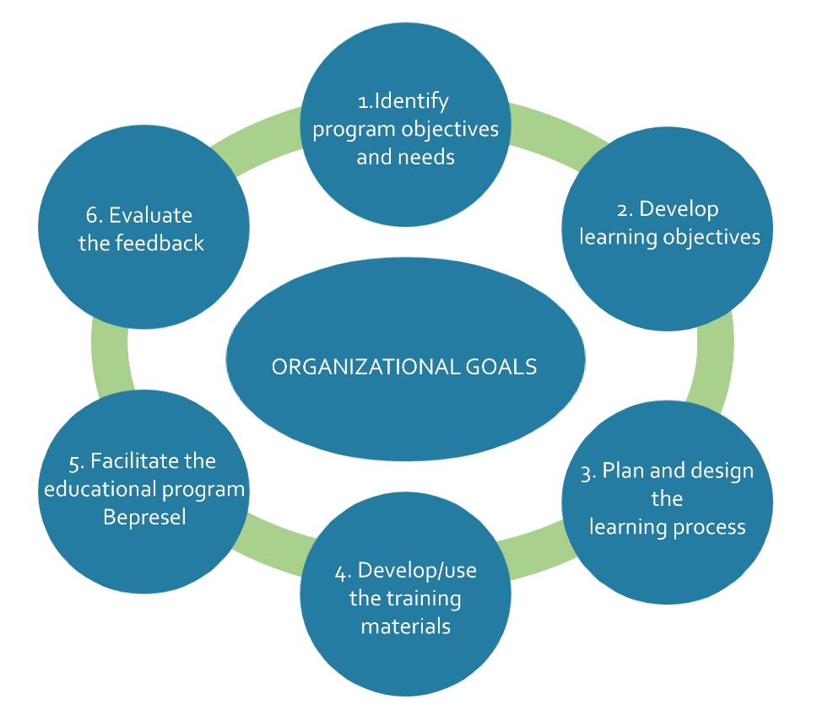
The diagram above illustrates various stages of the process.
Clear and innovative methods that suit the target group of the training are needed to become a facilitator. The following methods are recommended:
- lectures
- group work and pair work
- brainstorming on flipcharts
- group discussions (round tables, plenary, tables in U-form)
- practical exercises

UNIT 1: EDUCATIONAL PLAN – DIDACTICS, MATERIALS, CONTENTS, CONDUCTION
Duration: 3 hours
Aims:
  - To develop an individual action plan for facilitating the program
  - To know the steps to become a facilitator
  - To encourage participants to clarify personal goals
  - To organize thoughts and ideas for future action
  - To plan concrete steps for future action
  - To turn ‘dreams’ for the future into action

Contents:
- Work on the action plans in groups or alone
- Discuss the action plans together
- Make a date for a follow-up workshop

Activity 5.1: Action plan
- Purpose of the exercise: produce an action plan for the facilitators of the Bepresel program
- Duration: 3 hours
- Group size: 4-8
- Instructions for the trainer:

Make sure participants are familiar with the idea of making an action plan. Invite suggestions as to why a plan is a good idea. You can discuss the pros and cons with the whole group; use a flip chart to stimulate the discussion.

Introduce a filled out or partially filled out example of an action plan as this helps people getting started. Allow time for questions before people start their plan.

Participants start filling out the plan using the prepared format, individually or in pairs. After completing the plan, it can be useful for people to discuss their plans in small groups. Let people hear about others plans and talk about their own. This makes plans more real and stimulates networking. People might need some time to adjust their own plans based on fresh input from the discussions. Have additional forms available.

Participants are encouraged to take the plan home and implement it. In a follow-up workshop, participants can be invited to discuss their progress and difficulties.

  - Equipment: Action plan templates, paper, pencils, flipchart, etc.
  - Tips and tricks for the trainer:

It might be hard for some older people to imagine being a facilitator in 5-10 years. It helps to say that plans can also be made for the immediate future of 12 months.

SUGGESTED ACTION PLAN
Think about participants when conducting the program | Specify learning objectives | Test and evaluate
 | Analyse and break down objectives
 | Identify the content and the learning process
 | Decide on the educational methods
 | Devise activities and other outputs
 | Prepare training materials
 | Implement the educational program

FACILITATOR’S CHECKLIST: ADULT LEARNING

1. Is the atmosphere of your educational program friendly and encouraging?

2. Have you made plans to relieve any anxieties that the participants may feel?

3. Will your teaching methods allow participant's previous experience to be acknowledged or used?

4. Does the work allow participants to measure their own progress?

5. Do you make it clear that you are available for additional help if individuals have difficulties?

6. Are the first few minutes of your session always attention grabbing?

7. Do you have frequent opportunities for reinforcement and practice?

8. Are you avoiding lectures or at least limiting them to 10-20 minutes?

9. do you have regular feedback sessions?

3.6 MODULE 6: A PRACTICAL EXAMPLE OF THE EDUCATION – PILOTING THE PROGRAM (2 hours)

Training contents:
Content 1: Participants create a learning project focused on the face-to-face educational program for better preparation for senior life, which will be used when conducting lessons with the seniors.
Training methods:
The following methods are recommended:
- Small groups
The deliberate use of smaller groups when working with larger groups is an important option for facilitators. Working in small groups permits more engagement by participants and may encourage those who are more reticent to contribute further.
Brainstorming
Brainstorming is a simple and effective way of generating ideas and suggestions. Brainstorming generates a large quantity of ideas without regards to their quality; subsequent sorting and prioritizing of the ideas are used to refine the raw results. They are useful for introducing topics and generating an interest before further and more detailed work is undertaken, and they can be used to energize a group and stimulate discussion.
- Case studies
The case study is a useful and flexible method of providing an example for discussion by the participants. Case studies are used in most of the Resource Packs. Facilitators are reminded to consider each case study carefully before deciding to use it with a group of participants and to choose case studies for their relevance to the current issue. It may be necessary for facilitators to rewrite case studies to suit the needs of the participants.
- Checklists
Checklists are used by a group of participants either to remind them of key points or to rate themselves against a set of criteria. They serve as a useful reference point and a summary of important factors being considered by the group. Most checklists are prepared in advance by the trainer or facilitator.

- Discussion exercises
Discussion exercises form a significant part of the exercises and come in many forms. The value of discussion – between pairs, in small groups, or as part of a plenary discussion – is that it engages the participants in the learning process. By contributing to the discussion, participants are either relating and applying the material to their own situation or questioning and disagreeing with it because they cannot see the connection to their own experience. Either way, discussion forms an important part of testing, refining, and ultimately internalizing the course material by the participants. Discussion may be unstructured or structured.
- Lectures and presentations
Speaking to a group as an audience is a long-established method of teaching and demonstrating. It is particularly useful when conveying information or giving an explanation that people need to hear.
- Questions (and answers) – devising questions and questionnaires
The use of questions and answers forms a significant part of the training and learning process within a training course. Apart from the obvious situations in which participants will ask the facilitator questions and vice versa, there are other ways in which the use of questions and answers can enhance a training course. Questionnaires can provide useful information for use by the group and contribute to a self-assessment exercise for individual members. They can be developed either by the facilitator or by the participants themselves. Questionnaire surveys can be carried out by participants, either external with the group or with each other.
- Using visual images and diagrams – diagram, photo and video exercises
Everyone has an inherent ability for visual literacy, and the impact of visual methods on communication and analysis can be profound. They allow literate and illiterate people to participate in the process as equals, facilitating the exploration of complex relationships and generating collective knowledge. In this section, the following list of techniques will be described: diagrams and visualizations, using photos and drawings, and using videos.
- Producing posters, flipcharts
This technique offers an enjoyable and creative way of encouraging participants to synthesize their thoughts or develop key messages from a presentation or a previous exercise. It also provides a way of considering the potential for developing this kind of technique for advocacy or promotion work in general.

- Personal reflection – diaries and logs
By inviting participants to reflect on their own experiences in relation to a topic or an issue, the facilitator is encouraging them to develop a greater understanding and/or an empathy for the situation that others may have had to deal with. This technique encourages greater insight in deciding how to address the issue at hand.
- Role plays
When it is well run, a role-play will have a strong impact, but a poor one is likely to result in criticism and frustration. There is a potential complication in the case of facilitators who may be implementing role plays that they have not developed, so they must be carefully. This should include careful consideration of any cultural aspects that might affect the running of the role-play.

UNIT 1: PRACTICAL EXAMPLE OF THE LEARNING PROCESS – SUPERVISION IN PILOT

Duration: 2 h lecture + 16 h supervision in pilot

Aims:
  - Peers are delivering educational course on better preparation for senior life to participants aged 60+.
  - Peers can implement the desired goals and activities of the educational program for better preparation for senior life
  - Peers can find updates on data needed for delivering the course: additional research through the internet and/or in the library.
  - Peers are following the syllabus and are implementing the exercises and practices prepared in the work plan.

Contents:
    - The educational program for better preparation for senior life for older adults prepared by the Bepresel partnership.
    - Piloting the educational course with the seniors in the classroom – 2 x 12 participants.
    - Evaluation after the implementation – focus group with the participants of the peer training. Validation of the activities, their usefulness and suitability for the desired target group.

Activity 6.1: Intro on piloting the Bepresel educational program
- Purpose of the exercise:

Peers will conduct the educational program for better preparation for senior life in the face-to-face version. The program will last for 16 hours and include 2x12 participants (seniors aged (60+)). The trainer of future peers will supervise the implementation of the program. The peers will be conducting the educational program in pairs for easier delivery and practical issues.

Future peers are prepared to be supervised and the tools for the evaluation are developed. Questionnaire for the peers on the implementation of the educational program before and after the pilot will be fulfilled for evaluation and update purpose.
  - Duration: 1 hour
  - Group size: 4 - 8
  - Instructions for the trainer:

The pilot program will start right after the training, and 2 peers will be selected for implementation. They will be supervised and validated before and after the conduction.
  - Equipment: classroom, computer
  - Tips and tricks for the trainer:

Key Considerations during the implementation

• Participation in the education course

Closely monitor the attendance and involvement of the participants. This is important because of the evaluation of the materials and activities prepared for the participants: Are they suitable and do they serve their purpose?

• Evaluating the activities and achievement

Are you seeing any progress toward achieving the overall training goals that were identified? What comments and other feedback are you getting from the participants that will be useful in ensuring a high-quality training program?

• Changes to the learning activities and materials

Training plans are changed more frequently than most people realize. If they are changed in a systematic approach and distributed to all the relevant participants, the plans can be altered. It can be necessary if the plans are updated.

Activity 6.2 Closing session
  - Purpose of the exercise:

Participation in the classes is a very valuable experience. The experience can be compared to a house – every host wants the guests to be happy with their visit, and the host is proud when the guests feel safe and satisfied.

It is important to summaries the lectures. The last exercise serves as an evaluation summary.
  - Duration: 1 hour
  - Group size: 4 - 8 people
  - Instructions for the trainer:

Sit in a circle so everyone can see each other. At the beginning, the facilitator should thank the participants for their attendance, work and commitment. Then the facilitator should ask for feedback i.e.

What did you gain from this training?

What did you like the most? What would you improve?

How did you like the time spent here?

Everyone takes turns speaking and the mentor is the last to speak.
  - Conclusion: To finish the training, the mentor asks the participants to stand up (in a circle) and tap each other on the back as in “job well done!”
  - Participant’s benefits: This activity is remembered and recalls pleasant feelings Equipment: classroom
  - Tips and tricks for the trainer:

Think about what you gained after the training? Where and how did you use your knowledge and experiences?

THE END

The final stage of any education is the closing of the program. This is extremely important and requires as much planning as the other parts. There are several issues to keep in mind.
- Consolidation is important! Always go back over the key ideas and areas of learning covered. When the learning is spread over several days/sessions, it is important to consolidate new learning with what has already been taught.
- Set up exercises to show that the learning objectives have been achieved.

- Feedback should occur throughout the learning, but the closing session is where the most systematic exchange of feedback between the facilitator and the participants should take place. This exchange is vital, as it provides both the facilitator and the learners with a clear understanding of how the contents of the training were perceived.
- It is essential to emphasize the importance of providing adequate time in the program for the evaluation. Too often, it is at the end of a session where everybody is thinking about finishing, so they do not take it seriously.

Activity 6.3: Supervision in the pilot
- Purpose of the exercise:

The trained peer-to-peer facilitators will be supervised while facilitating the two groups. If needed, the mentor/trainer of the facilitators will interact directly with the participants of the training program.

Duration in minutes: 16 x 45 minutes
  - Group size: up to 12
  - Instructions for the trainer:

The pilot will test the face-to-face Training Program for better preparation for senior life.

In every country, 2x12 older adults will attend the face-to-face program for better preparation in senior life. The trainings will be aimed at improving the skills of participants the (seniors aged 60+). The participants’ concerns, successes and problems related to ageing will be listened to, and the mentor will provide support. Strengths and resources will be valorised after the implementation using questionnaires.

The participants will be hired on a voluntary basis using informative campaigns about the project and the networks of partners and from the members of the Stakeholders’ Committee.
- Equipment: Action plan templates, paper, pencils, flipchart, checklist, photo materials, questionnaires.

- Tips and tricks for the trainer:

During supervision the mentor should follow the work of future facilitators conducting the pilot groups with the Bepresel educational program.

A checklist will be produced for measuring the involvement, overall success, simplicity of conducting, satisfaction of participants and the goals achieved.

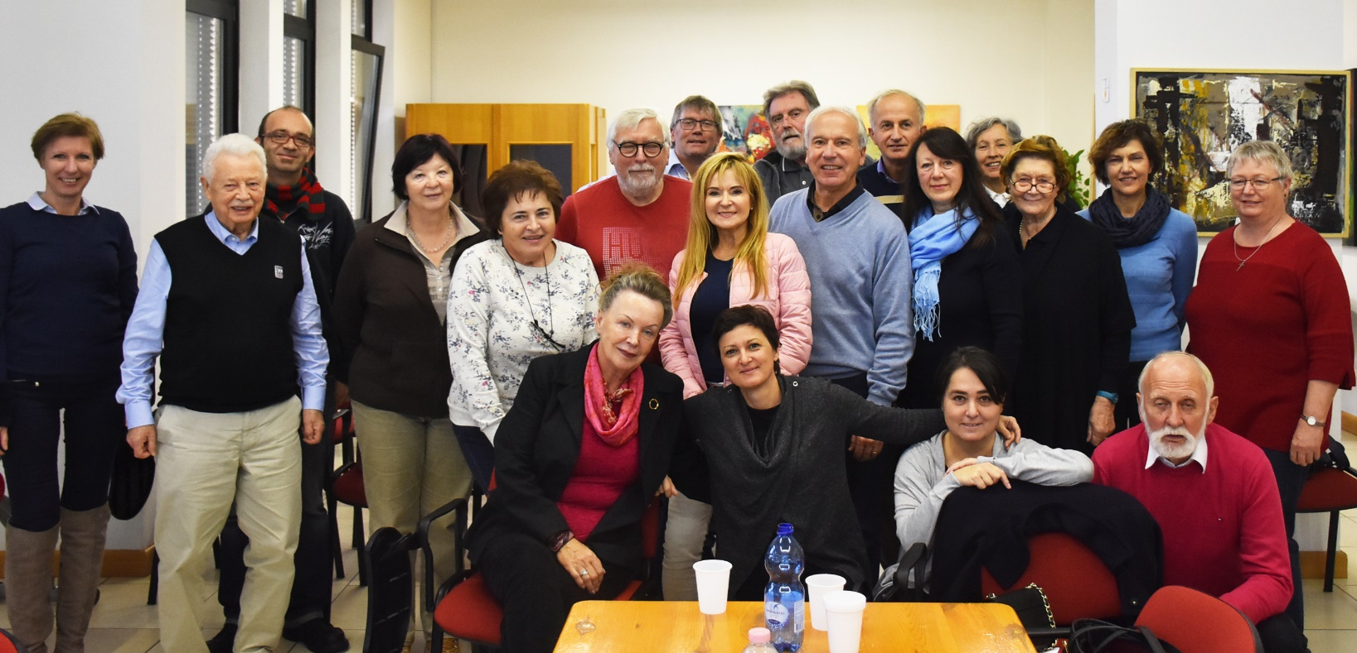

KA204-2017-012

Project partners:
- SOSUAARHUS AARHUS SOCIAL AND HEALTH CARE COLLEGE (AARHUS -DENMARK)
- UNIWERSYTET JAGIELLONSKI (KRAKOW - POLAND)
- UNIVERSITÀ DELLE LIBERETÀ DEL FVG (UDINE – ITALY)
- LJUDSKA UNIVERZA PTUJ (PTUJ – SLOVENIA)
- AOF SKANDERBORG AFTENSKOLE (SKANDERBORG – DENMARK)

This project has been funded with support from the European Commission. This publication [communication] reﬂects the views only of the author, and the Commission cannot be held responsible for any use which may be made of the information contained therein.

http://europa.eu/legislation_summaries/education_training_youth/lifelong_learning/c11090_en.htm

