TEACHERS GUIDLINE:
MODULE 7 – NUTRION
THE BEPRESEL COURSE

Project title: Bepresel
Grand Agreement Number: KA204-2017-012
Publisher: The partnership of the ERASMUS+ project Bepresel
For the publisher: Niels Vestergaard
Editing: The partnership of the ERASMUS+ project Bepresel

OVERALL COMMENTS TO THE TEACHER

This English version is the final revised overall manual of the educational material developed by Erasmus+ BEPRESEL project implemented during the periode of 1st of October 2017 to the 30th of September 2019.
This final version is not identically to the draft versions, developed as background and to inspire the developing off the different national educational content to be implemented and tested during 2 test courses in each partner country.
The 8 test courses was implemented during the period of February-June 2019, by various methodologies and pedagogical approaches.
In the same way be believe it is important future users adapt this material to their national contexts, to your own methodology and especially to the specific profile of the senior learners to be educated.
There might be differences in how power points are to be illustrated in different countries and to different learner groups. You are free to change the pictures & illustrations used at the power points. In the same way you are of course free to change or supplement with national statistical figures, if they are aviable.
It is not the intention providing this material for this module , that you have to or shall use all the slides presented.
The intention is, you pick out the most relevant slides that, that fits
- the time frame you have available for the presentation of this module and
- match the specific profile of the seniors you are going to educate.
In the same way you are free to change the order of the powerpoints.

The text, the suggestions of »what could be said« in connection with the individual power point are for inspiration. As you will see, there are room at the different pages, so you may to write:
- Your own ideas how you will like to present the different slides.
- How you will like to put the facts and documentation into words.
- What you will like to tell the seniors.
- What questions you believe could be good for you to ask the senior learners

  - to answer,
  - to discuss a little,
  - to reflect about.
It is important you make your presentation in your own words.
Create your own personal presentation but please stick to the facts as they are presented and avoid to present your own version of what you think ageing and what ageing period is about.
We believe the pedagogical intention should be, to establish a dialogue with your senior learners based on the slides you present.

Make sure you have time for that.
It is important to be aware using power point very easily speed up the presentation, which might not be beneficial for all senior learners
If it is possible to you, try to remember some of the information you are going to present. It might be a good idea to present some of the information, by chalk and blackboard or at a flip over.
Make sure the seniors have time to think, time to reflect. Time to ask questions.
It is serious to educate seniors have to avoid loosing their independent living later in life, howewer it is still important to have a good laugh once a while during the lessons.
Consider have you might be able to present some of the statements the material provide, with a little humorous approach and a smile

Prepare your self for a little resistance from some among your learners. You will probably meet resistance related to some of the results – statistics and the conclusions to make. To many senior learners some of the info and conclusions will be controversial as they don`t confirms or match, what many seniors believe, what many seniors assume as facts and what they have noticed and know from “their own experiences”.

Try to avoid entering into long discussions – just refer to what science tells – what the statistics show.

Some will also be critical. Make clear from the very begining that they overall frame of what you going to tell and show during the lessons to come, is:

»We aren’t going to talk about training and exercising to become a participant for the next Olympics. You are going to talk about, what it takes, what it require of a little weekly effort, training and ongoing exercises to maintain or develop the daily activities that will make us stay independent for longer later in life.

If any have ambition about making a world record it shold have been redeemed in our younger years.«

SPECIFIC OBJECTIVES OF THIS PART.
You find what the BEPRESEL partnership believe should be the objectives of this modul in the Curriculum: Senior Health Education – a BEtter PREparation for SEnior Life.

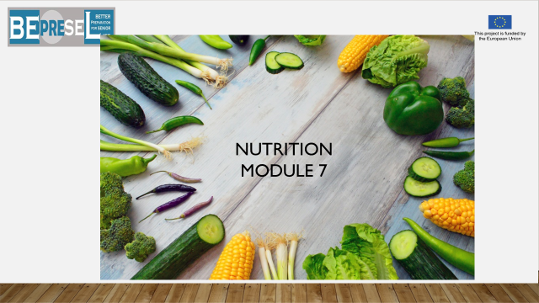

YOU COULD SAY:

It is important to be aware of the food we eat and the food habits we have, when we enter senior life or already are a senior citizen.
All experiences and research show that it changes when we retire and get older – and not always to the best.
The changes are partly caused by the different social events, which is a part of senior life and will have to face and deal with. Almost have of us will lose our spouse or life partners; we will lose dear family members and friends. But the most essential cause having an impact on our food and eating habits – is that we for some reason, become more and more inactive. Less and less physical active.
In many European countries, all public focus is on overweight people. The health challenges that follows when more and more children, youngsters and adults become more overweight. Overweight plays a central part in developing many diseases later in life.
This challenges of course also count for seniors, if overweight is a part of our daily reality.
It is not a part of what we will focus on – we will focus on the consequences of the opposite. That many of us seniors slowly reduce our intake of food as years pass by.
++++++++++++++++++++++++++++++++++++++++++++
ADD YOUR OWN COMMENTS AND IDEAS FOR SPEAK AND PRESENTATION:

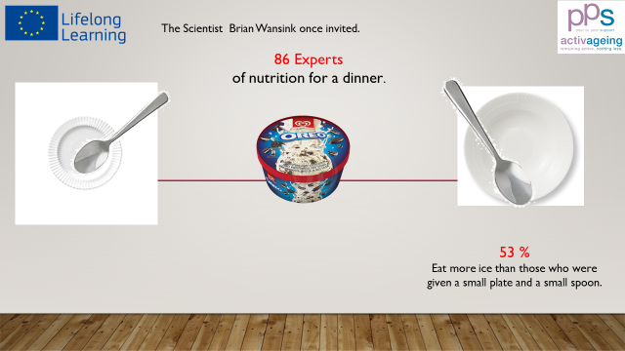

YOU COULD SAY:

Let`s start with some funny experiences regarding food habits and human behaviour sitting at the table.

Something to reflect about later on.

The Dutch scientist Brian Wansink once invited 86 experts of nutrition for a dinner.
The guests were placed separately – some were given big flat plates and big spoons and some were given small flat plates and small spoons. 53% of the guests having big plates and big spoons eat more ice than the other group of guests.

++++++++++++++++++++++++++++++++++++++++++++
ADD YOUR OWN COMMENTS AND IDEAS FOR SPEAK AND PRESENTATION:

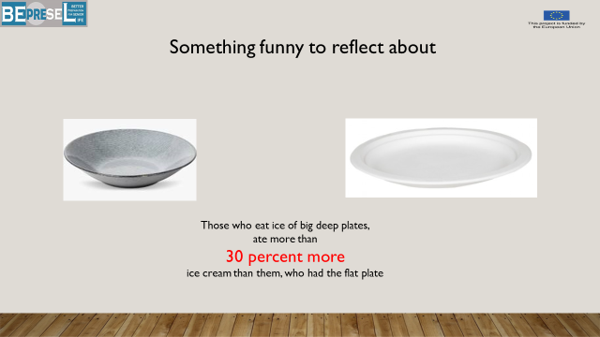

YOU COULD SAY:

And in totally those who ate ice from a big deep plate,
ate more than 30 percent more ice cream than those, who had the flat plates

Interesting – don`t you think?

++++++++++++++++++++++++++++++++++++++++++++
ADD YOUR OWN COMMENTS AND IDEAS FOR SPEAK AND PRESENTATION:

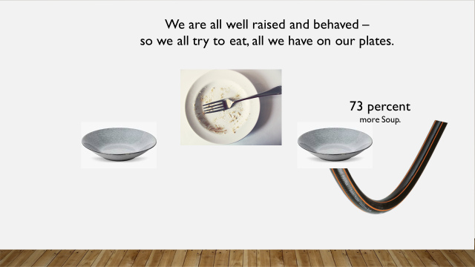

YOU COULD SAY:

Another test showed
We are all well raised to behave well to eat all we food on our plates.

2 groups were served soup – but half of them didn`t known that a small pipeline was constantly filling up their plates.
Those with the pipeline in the bottom of the plate ate 73 percent more soup.
++++++++++++++++++++++++++++++++++++++++++++
ADD YOUR OWN COMMENTS AND IDEAS FOR SPEAK AND PRESENTATION:

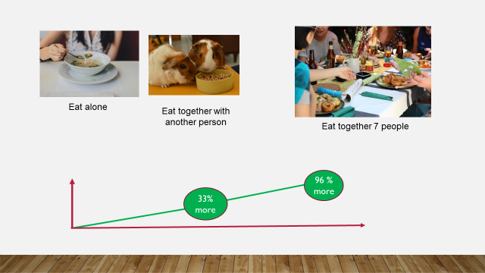

YOU COULD SAY:

Measuring how much people eat in different situations showed, that we eat less if we repeatedly eat alone.
If we eat, together with another person, we eat 33% more on average and it sounds crazy, by if we join a company and eat together with 7 people we almost eat double up or 97% more.

++++++++++++++++++++++++++++++++++++++++++++
ADD YOUR OWN COMMENTS AND IDEAS FOR SPEAK AND PRESENTATION:

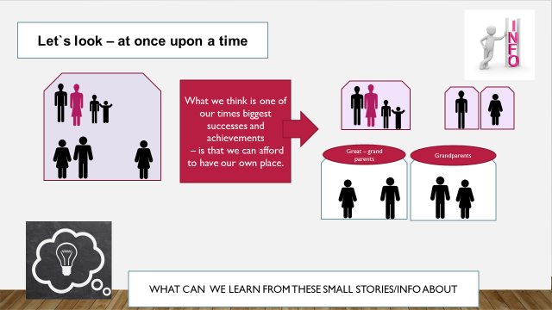

YOU COULD SAY:

Why are these results important?
It is a part of modern life in more and more societies, that people and families live more and more on their own. The big family becomes history in more and more countries and societies.
It might be a good development for many reasons, but it also contain some challenges.
One of the challenges is; that more and more senior citizens will find themselves living alone and on their own.
Most of us in the present generation of seniors are married and due to this fact, half of us will lose our spouse and be in a potential situation where we will live alone and have most of our meals alone. If we don`t act.

++++++++++++++++++++++++++++++++++++++++++++
ADD YOUR OWN COMMENTS AND IDEAS FOR SPEAK AND PRESENTATION:

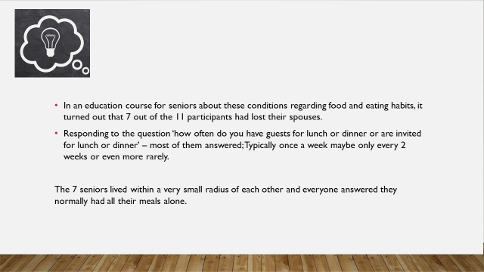

YOU COULD SAY:

In a course of education for senior learners, it showed up that 7 out of the 11 participants all had lost their spouses.

Responding the question
- “How often do you have guests for lunch or dinner”
- “How often are you invited for lunch or dinner?”,

Of course was the answers very differently; ‘
- “Typically once a week maybe only every 2 weeks or even more rarely”.
However, the 7 seniors who lived within a very small distance of each other answered that they had the huge majority of their all meals alone.

++++++++++++++++++++++++++++++++++++++++++++
ADD YOUR OWN COMMENTS AND IDEAS FOR SPEAK AND PRESENTATION:

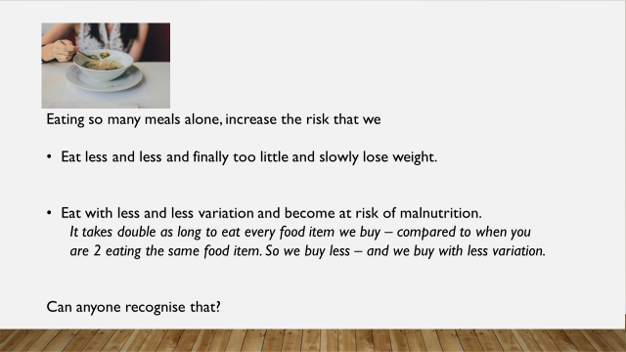

YOU COULD SAY:

Eating so many meals alone, too many meals alone not only lead to that too many of us
- Eat less and less and finally to little and slowly loss weight.

- Eat with less and less variation and become in risk of malnutrition.
  - It takes double as long to eat every food item we buy – compared to being 2 about eating the same food item. So we buy less – and we buy with less variation.

Can anyone recognise that?

However, the main challenge of not eating enough is not only a slowly appearance of underweight. The main challenge by eating less and less – and with less variation is that to many of us become in more and more risk of mal nutrition.
++++++++++++++++++++++++++++++++++++++++++++
ADD YOUR OWN COMMENTS AND IDEAS FOR SPEAK AND PRESENTATION:

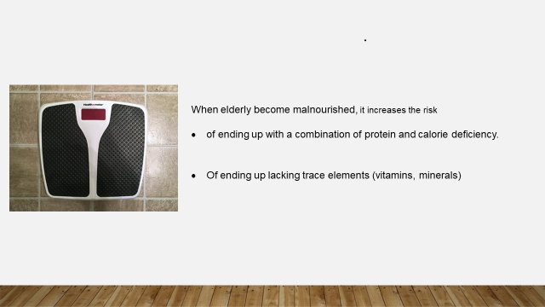

YOU COULD SAY:

When elderly become malnourished, it increase the risk
- of ending up in a combination of protein and calorie deficiency.
- Of ending up in a lack of trace elements (vitamins, minerals)

++++++++++++++++++++++++++++++++++++++++++++
ADD YOUR OWN COMMENTS AND IDEAS FOR SPEAK AND PRESENTATION:

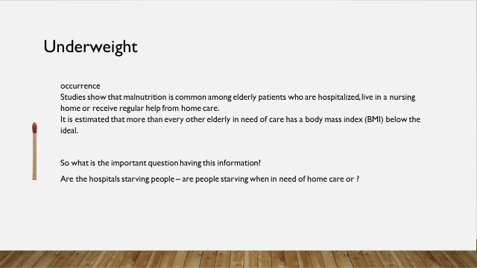

YOU COULD SAY:

Consequences
Poor nutrition in the elderly causes and lead to:
- Reduced ability
- Increased morbidity
- Reduced ability to take care of themselves
- Reduced well-being
- Reduced quality of life in the elderly

++++++++++++++++++++++++++++++++++++++++++++
ADD YOUR OWN COMMENTS AND IDEAS FOR SPEAK AND PRESENTATION:

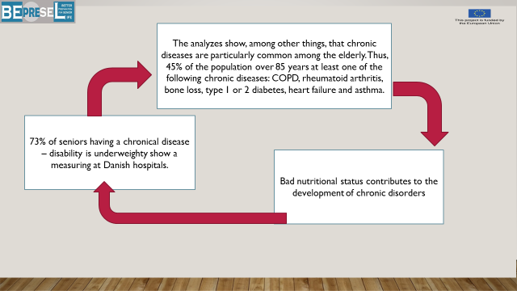

YOU COULD SAY:

Bad nutritional status contributes to the development of chronic disorders and worse chronical disorders

Analysis show, among other things, that chronic diseases or disorders are particularly common among the elderly.

When reaching age 85 at least 45% of us will have minimum one of the following chronic diseases: COPD, rheumatoid arthritis, bone loss, type 1 or 2 diabetes, heart failure and asthma. Many suffer from different of the mentioned.

++++++++++++++++++++++++++++++++++++++++++++
ADD YOUR OWN COMMENTS AND IDEAS FOR SPEAK AND PRESENTATION:

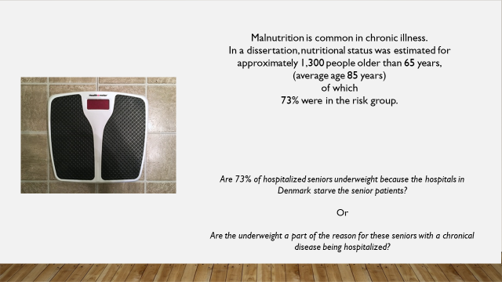

YOU COULD SAY:

Research at Danish hospitals show, that 73% of seniors who has a chronic disease or disability are underweight.

Are 73% of seniors hospitalized under weighty because the hospitals in Denmark starve the senior’s patients?

Or

Are the underweight a part of the reason for, that these seniors having a chronical disease are hospitalized?

++++++++++++++++++++++++++++++++++++++++++++
ADD YOUR OWN COMMENTS AND IDEAS FOR SPEAK AND PRESENTATION:

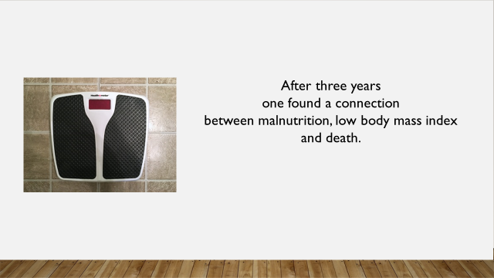

YOU COULD SAY:

When it comes to underweight – a research following seniors during 3 years show a connection between low raking at the Body Mass Index and death.
The connection is probably that we benefit – are more resistant and better to deal with periods of illness – if we have a “little extra” on our bones.
++++++++++++++++++++++++++++++++++++++++++++
ADD YOUR OWN COMMENTS AND IDEAS FOR SPEAK AND PRESENTATION:

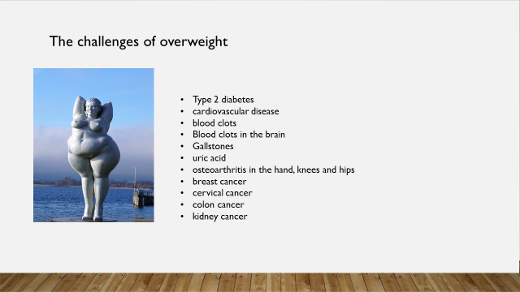

YOU COULD SAY:

Let’s start talking a little bit about weight.
Let’s make it clear from the very beginning. We are not going to recommend huge changes of lifestyle.
We know that it is very difficult at our age. We will talk about some adjustments that have a quite huge effect.
We don`t need to talk much about it, because I think we are all aware that there are complications and challenges the bigger we are physically.
In obese adults and seniors, more diseases occur far more often than normal.
- type 2 diabetes
- cardiovascular disease
- blood clots
- blood clots in the brain
- gallstones
- uric acid
- osteoarthritis in the hand, knees and hips
- breast cancer
- cervical cancer
- colon cancer
- kidney cancer

Overall, it also means that overweight, especially severe overweight, costs a shortening of longevity for several years. Overweight also increases the risk of a number of disorders that you do not usually associate with obesity. For example, back pain and asthma.
And of course it challenge our stamina – reduce our condition.

Nevertheless, opposite the life period up to 60+ the biggest challenge for senior citizens seems to be underweight and the following risk of malnutrition.

++++++++++++++++++++++++++++++++++++++++++++
ADD YOUR OWN COMMENTS AND IDEAS FOR SPEAK AND PRESENTATION:

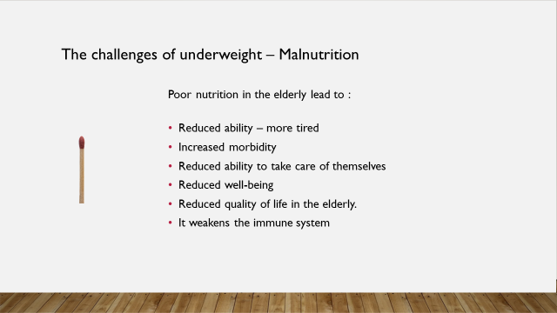

YOU COULD SAY:

The challenges of underweight – Mal Nutrition

Poor nutrition in the elderly lead too:
- Reduced ability – more tired
- Increased morbidity
- Reduced ability to take care of themselves
- Reduced well-being
- Reduced quality of life in the elderly.
- It weaken the immune system
++++++++++++++++++++++++++++++++++++++++++++
ADD YOUR OWN COMMENTS AND IDEAS FOR SPEAK AND PRESENTATION:

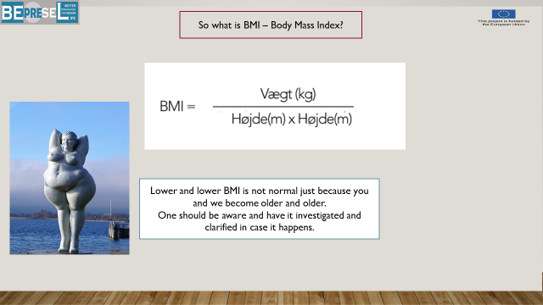

YOU COULD SAY:

Now we will introduce a new term BMI.

Body Mass Index.

Some of you will know the term – but to make sure that we all know.
BMI is a figure telling the correlation between our height and our weight.
Our weight divided with
(Our Height in metre x our height in metre) = BMI figure.
Having calculated your BMI once and for all you are able to follow how you develop the years to come.
Most of us can just looking at our paints or dress size and leave BMI out.

++++++++++++++++++++++++++++++++++++++++++++
ADD YOUR OWN COMMENTS AND IDEAS FOR SPEAK AND PRESENTATION:

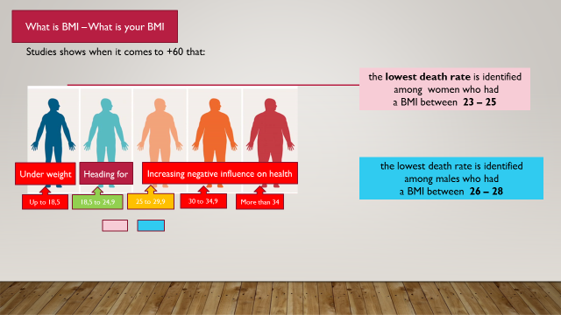

YOU COULD SAY:

Based on experiences people are in general recommended by health authorities to be at
A level between 18,5 to 24,9.

But at the same time researches show that
- the lowest dead rate among females were among females having a BMI between 23 to 25 and

- Among males having a BMI between 25 to 27.

++++++++++++++++++++++++++++++++++++++++++++
ADD YOUR OWN COMMENTS AND IDEAS FOR SPEAK AND PRESENTATION:

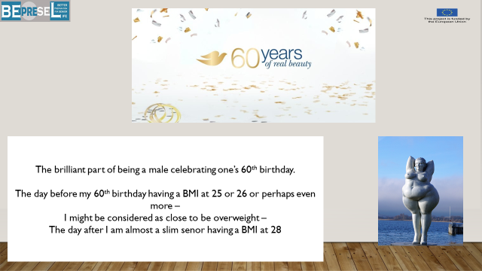
YOU COULD SAY:

The brilliant part of being a male celebrating your 60 years birthday is that the day before our 60 years birthday having a BMI at 27 we are considered to be over weighty.

The day after I am almost a slim senior having a BMI at 27 – at least I will statistical potential live longer

++++++++++++++++++++++++++++++++++++++++++++
ADD YOUR OWN COMMENTS AND IDEAS FOR SPEAK AND PRESENTATION:

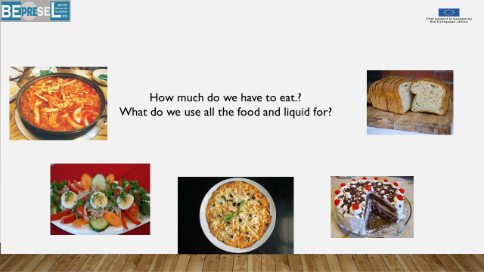

YOU COULD SAY:

How much do we need to eat and drink?
How much we need to eat depends of course of who we are. How we look, how tall we are and what is our present weight is.
++++++++++++++++++++++++++++++++++++++++++++
ADD YOUR OWN COMMENTS AND IDEAS FOR SPEAK AND PRESENTATION:

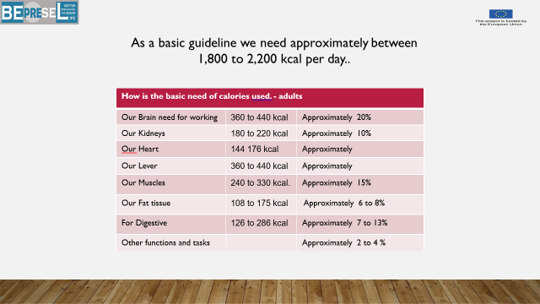

YOU COULD SAY:

Most of us will need between 1.800-2.200 kcal per day as a minimum.

We basically use what we eat for 2 things.

Most of what we eat
- 2/3 of what we eat is to make the “machine operate” – named basic need.

- 1/3 of what we eat is used as “gasoline” for our muscles to do what we need to do.

It might surprise you how much of the total daily need of kcal is used by our brain, our kidney and other internal organs.

++++++++++++++++++++++++++++++++++++++++++++
ADD YOUR OWN COMMENTS AND IDEAS FOR SPEAK AND PRESENTATION:

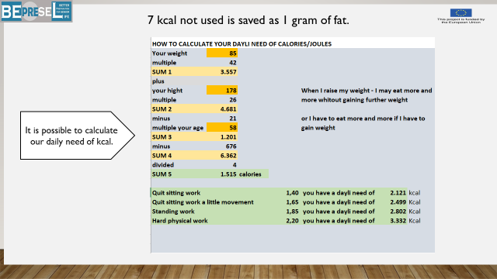

YOU COULD SAY:

It is a good idea to get to know
- How many kcal you/we need on a daily basis according to my present way of living.

- How many kcal do I get on average by my present way of living and the food I on average eat day by day?

It is quite easy to do, in the same way as you calculate your intake of protein.
All it need is a pen, paper and a weight. You are able to read on all food the number of kcal per 100 gram.
A more precise personal estimating is possible.
We can also offer you a calculator as presented here.
- You multiple your weight with 42 = sum
- Your multiple your height with 26 = sum
- You multiple your age with 21 = sum
- Minus a standard of 626
- 1 + 2 - 3 – 4 = sum
- Sum of no 5 divides with 4
- Sum of 4 is multiplied with the profile (the green options) that fits you.
++++++++++++++++++++++++++++++++++++++++++++
ADD YOUR OWN COMMENTS AND IDEAS FOR SPEAK AND PRESENTATION:

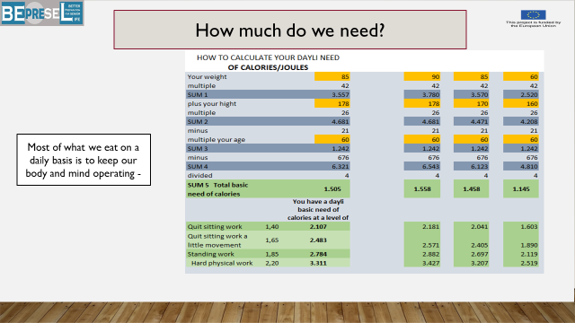

YOU COULD SAY:

Examples of the need of 3 different profiles
Examples of different weight and height.
The higher weight we represent – the more calories we can take in before it contribute to raise our weight. It is caused by the fact that it require more to heat 80 kg than it require to heat 60 kg to the level of 37 degrees 24 hours a day – 7 days a week 365 days a year.

Let the learners calculated their daily need of Calories – by using the formal and the excel model.
++++++++++++++++++++++++++++++++++++++++++++
ADD YOUR OWN COMMENTS AND IDEAS FOR SPEAK AND PRESENTATION:

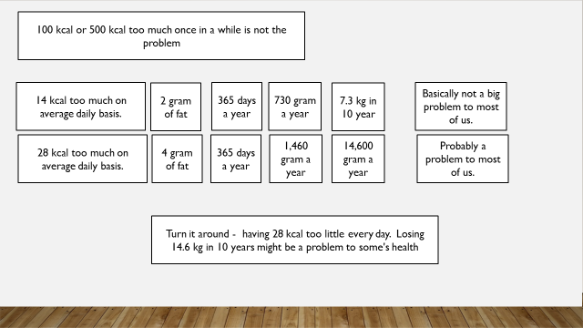

YOU COULD SAY:

TO MUCH or TO LITTLE ON EVERY DAY BASIS.
The challenge is not that we eat too much once in a while, it is more if we on daily basis eat a little too much or a little too less without knowing.
The challenges are that too many of us it works so slowly that we hardly recognize whether we are building up weight or we are losing weight.
7 kcal is equal to 1 gram of fat
A deficit of 14 kcal a day = 1 g of body fat per day or 730 gram per year – 7,3 kg per 10 year – that will not be a problem for most of us, no matter if it increase or decrease the present weight.
But a deficit of 28 kcal per day = 4 g per day or 1.460 gram per year – 14,6 kg per 10 year – will not be good to many of us.
And as it is “a little too much” or “a little to less” it is also easy to handle on daily basis. We can all eat 28 kcal more a day if we have to. But to catch up with a not wanted weight loss of suddenly 5, 10 or even 15 kg will be a challenge to most of us.
And our food habits change while we retire – going from one life situation of work to another life situation of retirement.
REMEMBER the resent research among 1.300 elderly more than 65 years and at an average age of 85 years, by Swedish health authorities, showed that up to 73% of elderly with chronicle diseases were in risk group. They might not be malnourished, but for sure, they had too little on the body.
After 3 years, there was a correlation between malnutrition, low BMI and death.
++++++++++++++++++++++++++++++++++++++++++++
ADD YOUR OWN COMMENTS AND IDEAS FOR SPEAK AND PRESENTATION:

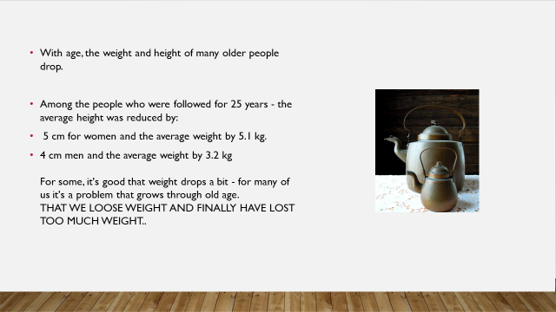

YOU COULD SAY:

Another issue that “helps” some of us growing older – is the fact that we become smaller during life and for many of us this particularly happens in the last period of our life.
A longitudinally research following a huge group of people through 25 years shows that:
- females on average become 5 cm shorter and lose on average 5,1 kg and
- males on average become 4 cm shorter and lose on average 3,2 kg.

++++++++++++++++++++++++++++++++++++++++++++
ADD YOUR OWN COMMENTS AND IDEAS FOR SPEAK AND PRESENTATION:

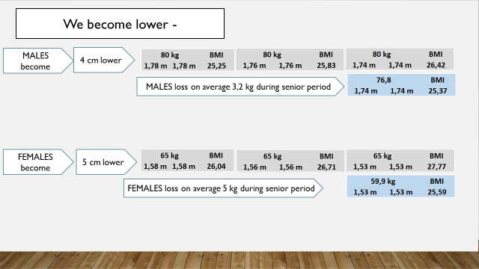

YOU COULD SAY:

IMPACT ON BMI
Becoming smaller over the years to come, might cheat what we know about our BMI. As the following examples show – our BMI will of course raise
Males: A male of 80 kg and a height of 1,78 cm
- if we only get smaller(4 cm) but don’t lose weight, the BMI will slowly raise to BMI = 26,42.

Females: A lady of 65 kg and a height of 1,58 cm
- if we only get smaller(4 cm) but don’t lose weight, the BMI will slowly raise to BMI = 27,77.

++++++++++++++++++++++++++++++++++++++++++++
ADD YOUR OWN COMMENTS AND IDEAS FOR SPEAK AND PRESENTATION:

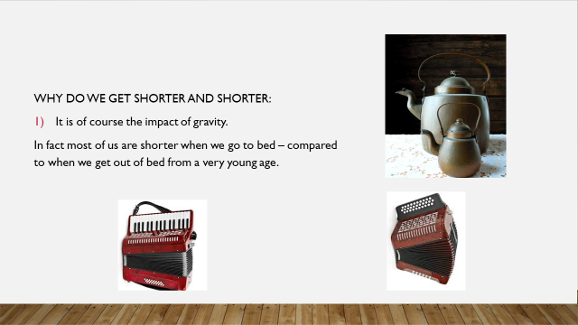
YOU COULD SAY:

The reason why we become shorter is in fact a reality from very early life. It is normal to become shorter when we go to bed in the evening than we were in the morning when we get up from bed.
It is caused by the impact of gravity and weight pressing us “together”.
But as long as we keep up our strength of our muscles through enough daily physical activity – the muscles are able partly to protect our joints and protect the discus in our back. Meaning that we do not get as short as we would be, not having enough muscle power, and we are able to stretch out again during the night.
But due to the fact that many of us lose the strength in our muscles and particularly the muscles around our back, caused by a lower level of physical activity in daily life. The daily shortening of us increases, and too much to repair/to stretch out during night and our “shortness” becomes more and more stationary.

We have to be aware that 5 cm for females and 4 cm for males are average figures. It means that some lose more cm.
++++++++++++++++++++++++++++++++++++++++++++
ADD YOUR OWN COMMENTS AND IDEAS FOR SPEAK AND PRESENTATION:

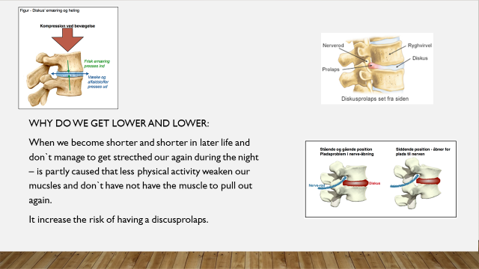

YOU COULD SAY:

When we become shorter and shorter in later life and don`t manage to get stretched our again during the night – is partly caused that less physical activity weaken our muscles and don`t have not have the muscle to pull out again.
It increase the risk of having discus problems.

RISK
This increase of pressure 24/7 will of course bring us in a higher risk of having problems with our skeleton.
When the discus doesn`t get stretched out anymore during the night – because it became too pressed during the day – the risk of having a discus prolapse will increase.
If we lose too much strength in our muscles around our different joints, especially around our hips and knees, the muscles are not able to protect our joints anymore and we end up hanging on our skeleton.
Many of us have some level of osteoarthritis entering senior life, but no pain so far.
We might not have pain so far because we have enough muscles around our joints protecting our hips and knees. But as our muscles become weaker due to a decreasing level of physical activity, the muscles are no longer strong enough and are not anymore able to keep the bones away from each other, and we start to feel pain or more pain, due to the fact that the ends of bones now gets closer to each other.
LETS MEAUSURE and calculate HOW IT LOOKS WHEN IT COMES TO OUR BMI.
++++++++++++++++++++++++++++++++++++++++++++
ADD YOUR OWN COMMENTS AND IDEAS FOR SPEAK AND PRESENTATION:

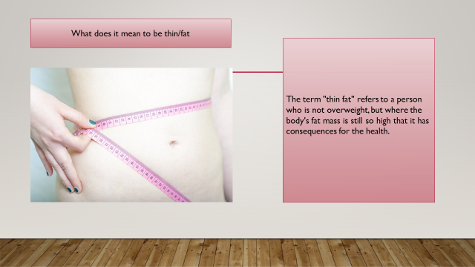
YOU COULD SAY:

“BEING THIN FAT”

It is important to known the term "to be thin fat".

Polemical.
If I keep my BMI at a level of 24 as a females and 26 as male,
than everything is ok – or……..???

Sorry to say - it is not the case.
++++++++++++++++++++++++++++++++++++++++++++
ADD YOUR OWN COMMENTS AND IDEAS FOR SPEAK AND PRESENTATION:

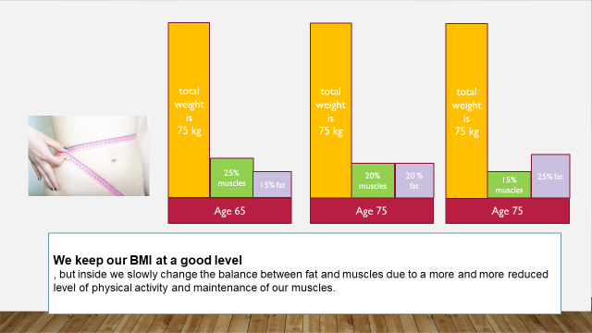

YOU COULD SAY:

Due to a slowly declining level of physical activity some of us accept becomes our reality, we also accept a slowly change of what we are caring at our body, what we have inside our skin, without knowing it.

Basic physical rule:
If we on a daily basis bring in more calories than we burn for heating our body, to make the organs and muscles work, our body change the excess intake into fat. That’s the way our body save and hide energy. As fat.
So having a case – where we slow down our level of burning – mostly by reducing our level of physical work and activities and we might even at the same time eat a little less then we used to – but still more than we burn and use for our daily activities.
The less physical activity will slowly reduce the amount of muscles and the extra to much we eat will be hide and saved as fat.
Then we will end up in a situation where many of us will be able to calculate a stabile BMI, but our weight is now more based on the weight of fat in our body than on the weight of muscles in our body.
We might change from having most muscle and less fat inside our body to the opposite – more fat and less muscle.
++++++++++++++++++++++++++++++++++++++++++++
ADD YOUR OWN COMMENTS AND IDEAS FOR SPEAK AND PRESENTATION:

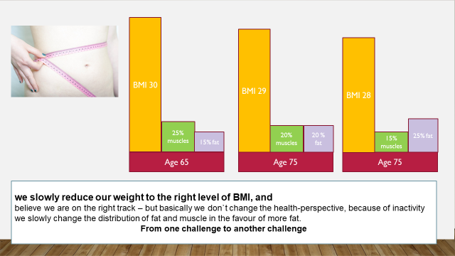

YOU COULD SAY:

Too many of us end up in one of 2 situations:
- We slowly reduce our weight to the right level of BMI, and believe we are on the right track – but basically we don`t change the health-perspective, because we of inactivity slowly change the distribution of fat and muscle to the favor of more fat.

- We keep our BMI at a good level, but also in this case slowly change the balance between fat and muscles due to too more and more reduced level of physical activity and maintenance of our muscles.

++++++++++++++++++++++++++++++++++++++++++++
ADD YOUR OWN COMMENTS AND IDEAS FOR SPEAK AND PRESENTATION:

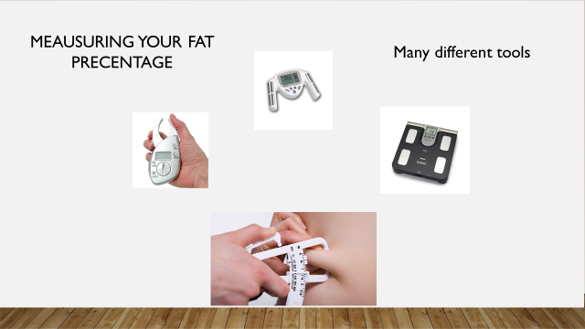

YOU COULD SAY:

HOW TO MEAUSURE OUR THIN FAT POSIITION

How can you check if you are thin-fat?
Thin people have high fat percentage. There are many ways to determine the fat percentage, including special bath weights and handheld gauges.

Unfortunately, these are very inaccurate to measure the fat percentage of the individual. A precise determination of fat percentage requires advanced and expensive scanning, which is available only in few places, for example, at certain hospital departments. In addition, even though it is accurately measured, the fat percentage does not account for the distribution of fat, which is crucial to the health risk.

++++++++++++++++++++++++++++++++++++++++++++
ADD YOUR OWN COMMENTS AND IDEAS FOR SPEAK AND PRESENTATION:

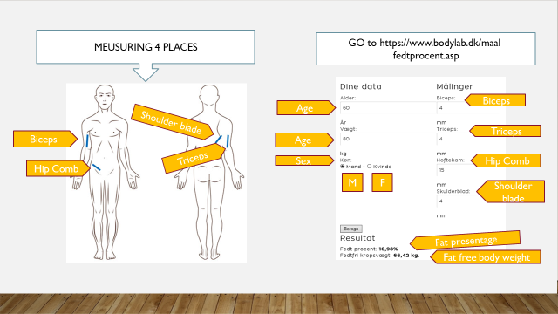

YOU COULD SAY:

Using the handhold tool we measure 4 places.
- Biceps – the front of your arm
- Triceps – the back of your upper arm
- On the lowest part of your should blade.
- Front on your hip
++++++++++++++++++++++++++++++++++++++++++++
ADD YOUR OWN COMMENTS AND IDEAS FOR SPEAK AND PRESENTATION:

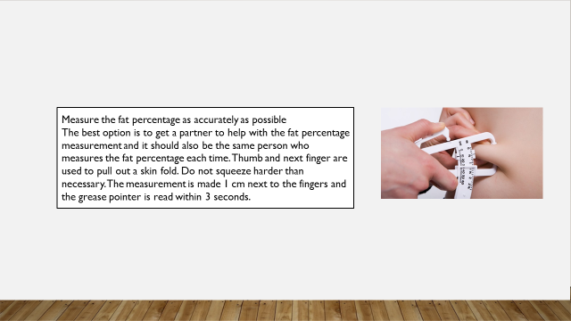

YOU COULD SAY:

Measure the fat percentage as accurately as possible
The best option is to get a partner to help with the fat percentage measurement and it should also be the same person who measures the fat percentage each time. Thumb and next finger are used to pull out a skin fold. Do not squeeze harder than necessary. The measurement is made 1 cm next to the fingers and the grease pointer is read within 3 seconds.

Then you go to if you are not able to identify a seminal calculator in national language:
https://www.bodylab.dk/maal-fedtprocent.asp

to type your figures – press calculate and read your fat percentage. Below the fat percentage, you will see the number of kilos for a fat free body.

++++++++++++++++++++++++++++++++++++++++++++
ADD YOUR OWN COMMENTS AND IDEAS FOR SPEAK AND PRESENTATION:

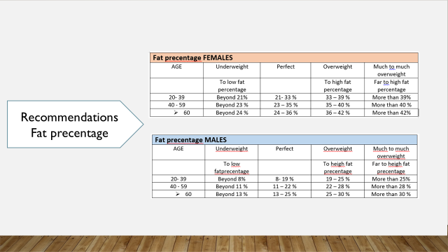

YOU COULD SAY:

Here you can read the recommendations regarding our fat percentage.

Knowing your fat percentage – you put your figure into your Senior Health Profile template

LETS MEAUSURE HOW IT LOOKS WHEN IT COMES TO THIN – FAT?
++++++++++++++++++++++++++++++++++++++++++++
ADD YOUR OWN COMMENTS AND IDEAS FOR SPEAK AND PRESENTATION:

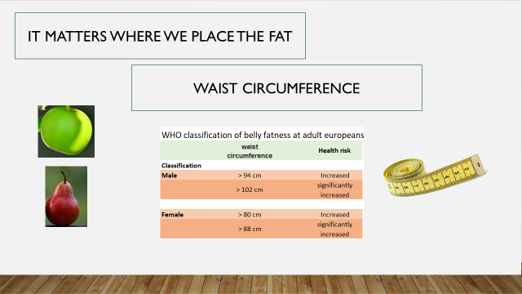

YOU COULD SAY:

OUR HIP circumferences
It matters were we hide the fat. It is better to be pear formed than apple formed. Because it is better to have too much fat placed on the hips, our back and thighs than around our inner organs.
Another way, and better way to check if you're thin, is the degree of belly fatness using a simple measuring tape.
There is, as for BMI, a classification of belly fatness, which is based on the waist circumference (Table).
The classification has limitations as factors such as ethnicity, age and total body size affect health risk. In addition, the displayed limit values ​​can be discussed and work is being done to develop better health classifications based on the speech target.
Later, we will use both the measuring tape and the hand held equipment.

LETS MEAUSURE HOW IT LOOKS WHEN IT COMES TO OUR HIP CIRCUMFERENCES

Be aware to measure the same every time – so it is good to measure just about our hip or cross our navel.

Knowing your HIP circumferences – you put your figure into your Senior Health Profile template
++++++++++++++++++++++++++++++++++++++++++++
ADD YOUR OWN COMMENTS AND IDEAS FOR SPEAK AND PRESENTATION:

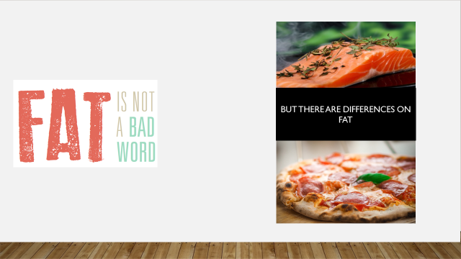

YOU COULD SAY:

We are not supposed to make fat an enemy. We need fat and it is essential for us.
Fat is made up of different fatty acids, and it is a necessary nutrient for the body, as it is important as an energy source and as a storage for energy storage. But too much fat on the body increases the risk of cardiovascular diseases.
Fat is included in the body tissue structure and is a carrier for some of the vitamins. Some fatty acids in fat are essential and cannot be replaced by others. It is therefore important that you are aware of how much fat you eat and what kind of fat your food includes.
Fat contains more energy than other nutrients.
1 gram of fat thus contains 37 kJ,
Which is more than twice as much energy as 1 gram of carbohydrate or 1 gram of protein.
Fat is a course in itself – there are so many different types of fat. We will not focus too much only say that we need to pay attention to the recommended % of daily nutrient and especially 1 type of fat.
Total fat content in the diet should be 25-40% of total energy intake. So be aware if you buy half or whole prefabricates. They have a very high fat %.
++++++++++++++++++++++++++++++++++++++++++++
ADD YOUR OWN COMMENTS AND IDEAS FOR SPEAK AND PRESENTATION:

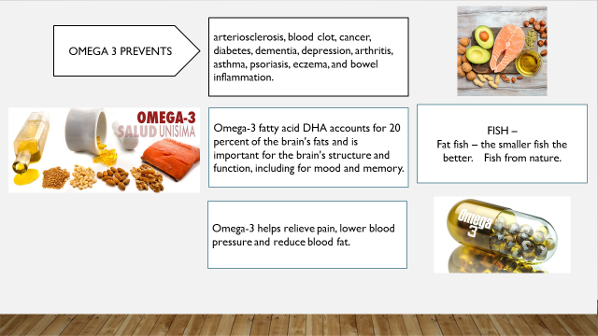

YOU COULD SAY:

The fat named OMEGA 3 is important to be aware of – it is important
It is difficult to have enough of the fat acids named Omega 3.

It requires fresh fish at least twice a week and farmed fish is not that good, because they are not feed up with natural food but with substitutes.

We know that the Omega 3 plays a role in preventing:
- arteriosclerosis,
- blood clot,
- cancer,
- diabetes,
- dementia,
- depression,
- arthritis,
- asthma,
- psoriasis,
- eczema and
- bowel inflammation.

Omega-3 helps relieve pain, lower blood pressure and reduce blood fat.
Omega-3 fatty acid DHA accounts for 20 percent of the brain's fats and is important for the brain's structure and function, including for mood and memory.
It requires fresh fish at least twice a week and farmed fish is not that good, because they are not feed up with natural food but with substitutes. So it is it a good idea to take capsules containing Omega 3
++++++++++++++++++++++++++++++++++++++++++++
ADD YOUR OWN COMMENTS AND IDEAS FOR SPEAK AND PRESENTATION:

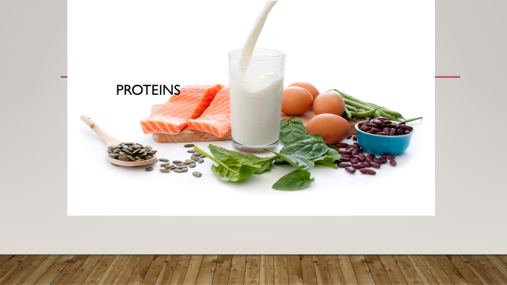

YOU COULD SAY:

Let`s talk a little about the importance of protein and having enough protein.

++++++++++++++++++++++++++++++++++++++++++++
ADD YOUR OWN COMMENTS AND IDEAS FOR SPEAK AND PRESENTATION:

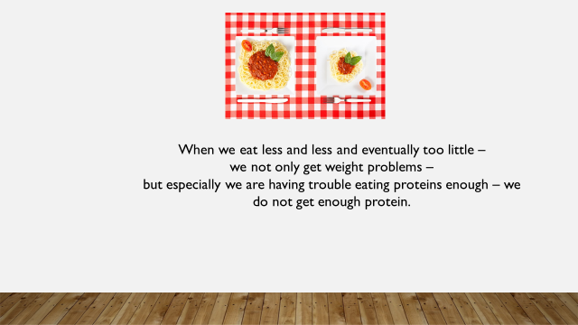

YOU COULD SAY:

If and when we eat less and at the end too little, we will as told before especially face problems with protein deficit.
Poor nutritional status is implicated in the development and progression of chronic diseases that commonly affect the elderly. Lack of protein is a key issue in poor nutritional status.
++++++++++++++++++++++++++++++++++++++++++++
ADD YOUR OWN COMMENTS AND IDEAS FOR SPEAK AND PRESENTATION:

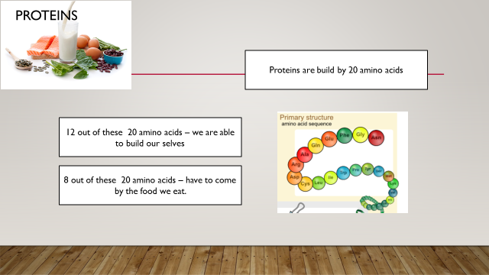

YOU COULD SAY:

Proteins are the body building blocks. Hair growth, nails and continuous development, reconstruction or repair of muscles, tendons, organs, etc.
Proteins are built up of about 20 different amino acids. We can form the 12 of these amino acids by the diet we consume, but we should get 8 of these amino acids directly via diet.
Essential amino acids are the amino acids to be supplied with the diet's proteins in humans because the enzymes necessary to form them are lacking. They include phenylalanine, histidine, isoleucine, leucine, lysine, methionine, threonine, tryptophan and valine.
Plants can form all amino acids that are necessary for the formation of proteins. Animals and humans lack the enzymes that form and build these last 8 amino acids.
These must be fed with the diet and are therefore called the essential (essential) amino acids. The rest can be formed in the organism from glucose and nitrogen derived from others.
++++++++++++++++++++++++++++++++++++++++++++
ADD YOUR OWN COMMENTS AND IDEAS FOR SPEAK AND PRESENTATION:

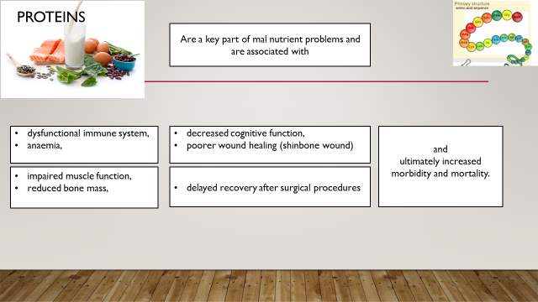

YOU COULD SAY:

Lack of protein (energy – malnutrition) is associated with:
- dysfunctional immune system,
- anemia,
- impaired muscle function,
- reduced bone mass,
- decreased cognitive function,
- poorer wound healing (shinbone wound)
- delayed recovery after surgical procedures and
- ultimately increased morbidity and mortality.

++++++++++++++++++++++++++++++++++++++++++++
ADD YOUR OWN COMMENTS AND IDEAS FOR SPEAK AND PRESENTATION:

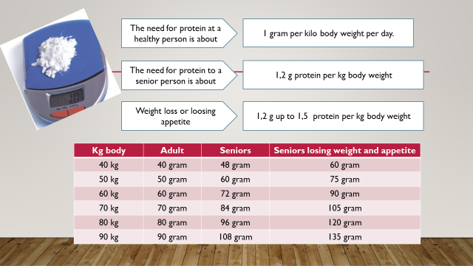

YOU COULD SAY:

As a minimum, we need 1,2-1,5 gram of protein per kg body per day during our ageing life.
To get these amounts of proteins might be a challenge to many. A lot of people don`t know if the daily food contains this amount of protein and will by that slowly contribute to:
- Reduced muscle function,
- Reduced bone mass,
- Dysfunctional immune system,
- Anemia,
- Decreased cognitive function,
- Poorer wound healing (shinbone wound)
- Delayed recovery after surgical procedures and
- Ultimately increased morbidity and mortality.

It is a good idea to use a little time to check how one’s protein accountancy look according to our ordinary daily intake of food.
It is not difficult. On all products it is presented how much protein the product contains per 100 gram.
All you need is a kitchen scale, a piece of paper, a pen and maximum 5 minutes per day in one week or 2 weeks or alternative you may use the model presented at the BEPRESEL homepage.
++++++++++++++++++++++++++++++++++++++++++++
ADD YOUR OWN COMMENTS AND IDEAS FOR SPEAK AND PRESENTATION:

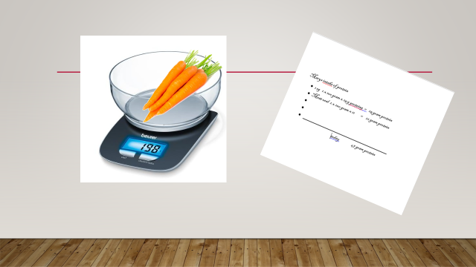

YOU COULD SAY:

It is worth doing a check up on one’s daily intake of protein. It can be done quite simply – just using a piece of paper and a scale.
Do it for a week or 14 days?
After weighing a food item once - you also know what to write tomorrow. We eat many of the same things every day. It's not that difficult. Have the scale standing on the table for 1 or 2 weeks, maybe once a year.

Bring in some items to show the learners how to read content of protein in different food items and how they calculate it.
++++++++++++++++++++++++++++++++++++++++++++
ADD YOUR OWN COMMENTS AND IDEAS FOR SPEAK AND PRESENTATION:

YOU COULD SAY:

If you are familiar with a computer and how to use the program named excel we will offer you this model of calculating your daily, weekly and monthly intake of protein.
Show the learners how it is used. Bring in your own figures for one week.
++++++++++++++++++++++++++++++++++++++++++++
ADD YOUR OWN COMMENTS AND IDEAS FOR SPEAK AND PRESENTATION:

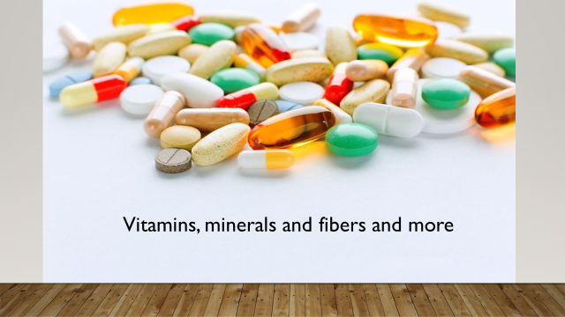

YOU COULD SAY:

Let`s here at the end focus a little on vitamins and fibers.
++++++++++++++++++++++++++++++++++++++++++++
ADD YOUR OWN COMMENTS AND IDEAS FOR SPEAK AND PRESENTATION:

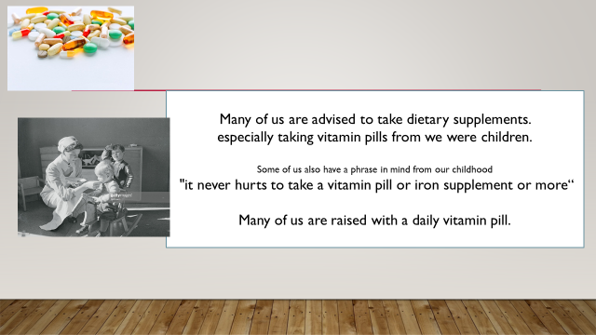

YOU COULD SAY:

Many of us are advised to take dietary supplements.
Especially taking vitamin pills from we were children.
Some of us also have a phrase in mind from our childhood
"It never hurts to take a vitamin pill or iron supplement or more“
Many of us are raised with a daily vitamin pill.

++++++++++++++++++++++++++++++++++++++++++++
ADD YOUR OWN COMMENTS AND IDEAS FOR SPEAK AND PRESENTATION:

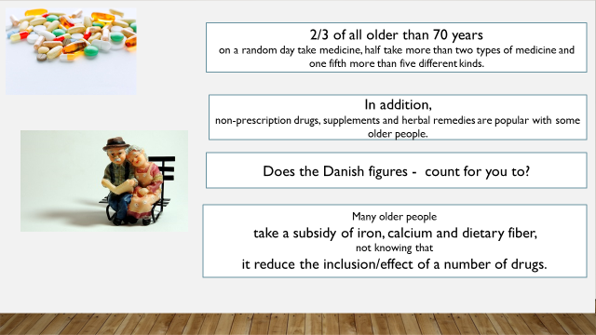

YOU COULD SAY:

Studies in Denmark have shown that 2/3 of all older people than 70 years old on a random day take medicine; half take more than two types of medicine and one-fifth more than five different kinds.
Does the Danish figures count for you to?
In addition, non-prescription drugs, supplements and herbal remedies are popular with some older people.

Many older people take a subsidy of iron, calcium and dietary fiber, not knowing that it reduces the inclusion/effect of a number of drugs.

++++++++++++++++++++++++++++++++++++++++++++
ADD YOUR OWN COMMENTS AND IDEAS FOR SPEAK AND PRESENTATION:

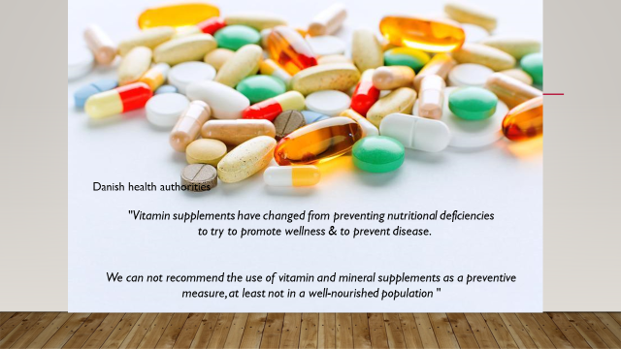

YOU COULD SAY:

Danish health authorities

"Vitamin supplements have changed from preventing nutritional deficiencies to try to promote wellness & to prevent disease.
We cannot recommend the use of vitamin and mineral supplements as a preventive measure, at least not in a well-nourished population".
++++++++++++++++++++++++++++++++++++++++++++
ADD YOUR OWN COMMENTS AND IDEAS FOR SPEAK AND PRESENTATION:

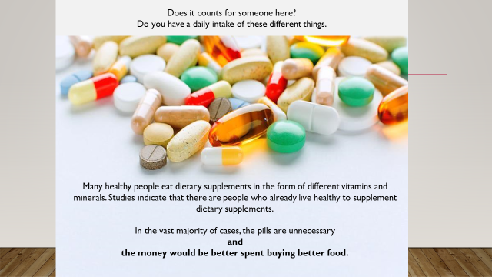

YOU COULD SAY:

Many healthy people eat dietary supplements in the form of different vitamins and minerals. Studies indicate that there are people who already live healthy to supplement dietary supplements.
In the vast majority of cases, the pills are unnecessary and the money would be better spent buying healthy food.

Does it counts for anyone here?
Do you have a daily intake of these different things?

++++++++++++++++++++++++++++++++++++++++++++
ADD YOUR OWN COMMENTS AND IDEAS FOR SPEAK AND PRESENTATION:

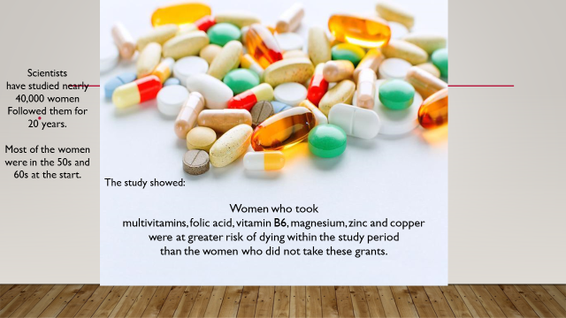

YOU COULD SAY:
Scientists have studied nearly 40,000 women and followed them for 20 years.
Most of the women were in the 50s and 60s at the start
The study showed:
Women who took multivitamins, folic acid, vitamin B6, magnesium, zinc and copper were at greater risk of dying within the study period than the women who did not take these grants.
++++++++++++++++++++++++++++++++++++++++++++
ADD YOUR OWN COMMENTS AND IDEAS FOR SPEAK AND PRESENTATION:

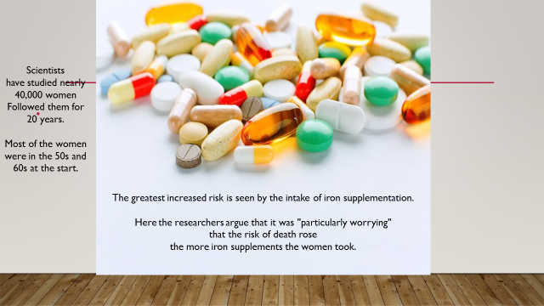

YOU COULD SAY:

Scientists have studied nearly 40,000 women and followed them for 20 years.
Most of the women were in the 50s and 60s at the start
The greatest increased risk is seen by the intake of iron supplementation.
Here the researchers argue that it was "particularly worrying" that the risk of death raised the more iron supplements the women took.
++++++++++++++++++++++++++++++++++++++++++++
ADD YOUR OWN COMMENTS AND IDEAS FOR SPEAK AND PRESENTATION:

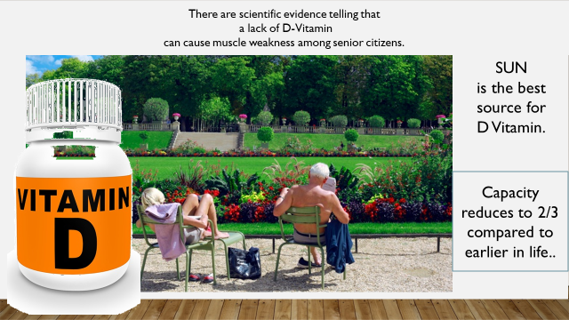

YOU COULD SAY:

There is scientifically evidence telling that a lack of D-Vitamin can cause muscle weakness among senior citizens.

In practice, it is difficult for many seniors to reach the recommended amount of vitamin D through food and drinks.
Vitamin D is formed in the skin when the skin is exposed to sunlight. In seniors, the effectiveness of the skin decreases to 3/4 of what it is in the younger.
At the same time, many older people isn’t exposed to sunlight as much as younger people.

++++++++++++++++++++++++++++++++++++++++++++
ADD YOUR OWN COMMENTS AND IDEAS FOR SPEAK AND PRESENTATION:

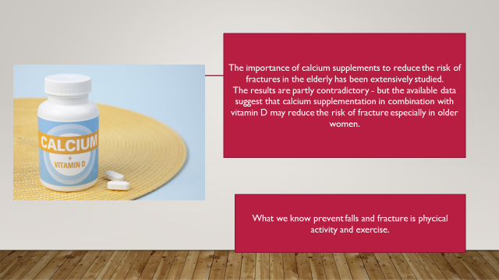

YOU COULD SAY:

The importance of calcium supplements to reduce the risk of fractures in the elderly has been extensively studied.
The results are partly contradictory - but the available data suggest that calcium supplementation in combination with vitamin D may reduce the risk of fracture especially in older women.

Remember we know that physical activity and exercise prevents falls and fracture and reduces developing osteoporosis.
++++++++++++++++++++++++++++++++++++++++++++
ADD YOUR OWN COMMENTS AND IDEAS FOR SPEAK AND PRESENTATION:

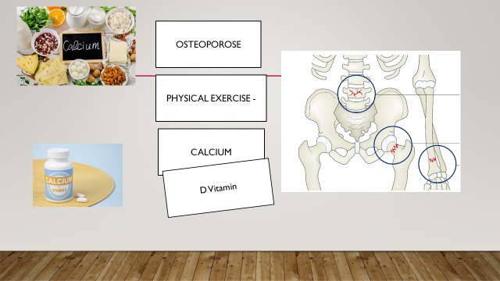

YOU COULD SAY:

We have been talking about the challenge of osteoporosis. It is a challenge many of us face and have to deal with. A bigger challenge to more females than males but we are all in risk.
We will not go deeper into it here except pointing out again, that physical exercise is an important preventive issue to minimize delaying the process of osteoporosis.
But most of us will benefit of taking extra calcium.
Calcium and vitamin D are closely linked to the health of the bones. Taking calcium without vitamin D corresponds to serving soup without a spoon - you do not get that much out of it. Calcium is poorly absorbed from the intestine when vitamin D lacks. However, there are no foods that contain both in larger quantities. Calcium is obtained almost exclusively from dairy products, whereas vitamin D is obtained from the so-called fatty fish (herring, mackerel, salmon, etc.) and from sunlight.
++++++++++++++++++++++++++++++++++++++++++++
ADD YOUR OWN COMMENTS AND IDEAS FOR SPEAK AND PRESENTATION:

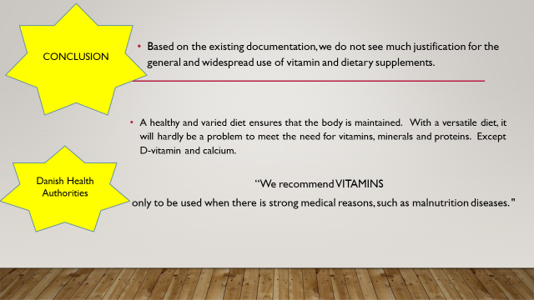

YOU COULD SAY:

Based on the existing documentation, we do not see much justification for the general and widespread use of vitamins and dietary supplements.

A healthy and varied diet ensures that the body is maintained. With a versatile diet, it will hardly be a problem to meet the need for vitamins, minerals and proteins. Except vitamin D and calcium.
Danish health authorities:
“We recommend VITAMINS only to be used when there is strong medical reasons, such as malnutrition diseases".
++++++++++++++++++++++++++++++++++++++++++++
ADD YOUR OWN COMMENTS AND IDEAS FOR SPEAK AND PRESENTATION:

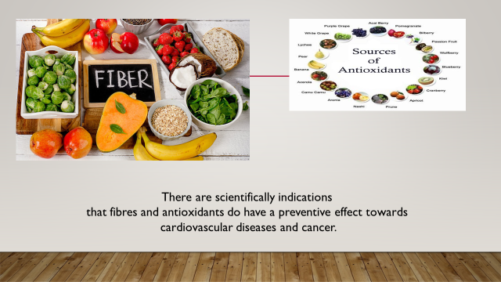

YOU COULD SAY:

There are scientifically indications that fibres and antioxidants do have a preventive effect towards cardiovascular diseases and cancer.

Therefore, it's always good to eat coarse and fiber-based food products - it also helps the digestion.

++++++++++++++++++++++++++++++++++++++++++++
ADD YOUR OWN COMMENTS AND IDEAS FOR SPEAK AND PRESENTATION:

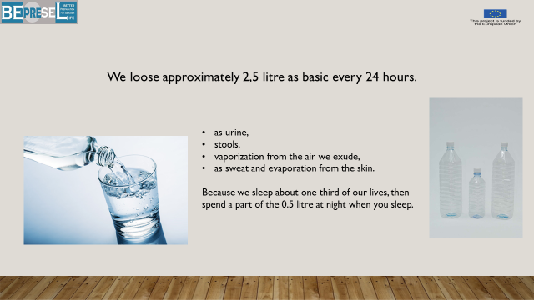

YOU COULD SAY:

The human body is made of 50-60% of water.

How much fluid do you spend in a day?
One's body actually releases approximately 2,5 liter fluids a day. This fluid is released from the body as urine, stools, vaporization from the air we exude, as well as sweat and evaporation from the skin. Out of the 2,5 liters, sweat and evaporation from the skin count for about 0,5 liter. Because we sleep about one third of our lives, then spend a part of the 0,5 liter at night when we are asleep.

Due to the fact that the thirst center in our brain seems to be challenged by age, it is a good idea to find a way of measuring how much we drink every day. 2,5 liter is in fact quite a lot if we don`t feel thirst. So make yourself aware of how you reach this amount on a daily basis. It is a tee cup (2 dl) 12 times a day – almost every 1 hour and 15 minutes.

++++++++++++++++++++++++++++++++++++++++++++
ADD YOUR OWN COMMENTS AND IDEAS FOR SPEAK AND PRESENTATION:

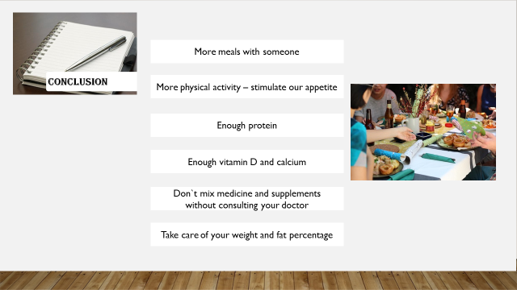

YOU COULD SAY:

WHAT to DO:
Are we able to conclude anything?

You can or others might take initiatives to make it more common to have lunch and dinner together with other people.

In DK it has become a central focus for NGOs and municipalities to offer more opportunities to meet and eat together.

Increase and keep a high physically level of activities create a natural hunger.

Be aware of your protein intake.
Be aware your intake of D-vitamin and calcium
Be aware that you don`t mix substitutes with medicine without talking to your doctor
Be aware of your weight and fat percentage.
++++++++++++++++++++++++++++++++++++++++++++
ADD YOUR OWN COMMENTS AND IDEAS FOR SPEAK AND PRESENTATION:

