TEACHERS GUIDELINE:
MODULE 3 – MAINTAIN STRENGTH IN HANDS AND ARMS
THE BEPRESEL COURSE

Project title: Bepresel
Grand Agreement Number: KA204-2017-012
Publisher: The partnership of the ERASMUS+ project Bepresel
For the publisher: Niels Vestergaard
Editing: The partnership of the ERASMUS+ project Bepresel

OVERALL COMMENTS TO THE TEACHER

This English version is the final revised overall manual of the educational material developed by Erasmus+ BEPRESEL project implemented during the periode of 1st of October 2017 to the 30th of September 2019.
This final version is not identically to the draft versions, developed as background and to inspire the developing off the different national educational content to be implemented and tested during 2 test courses in each partner country.
The 8 test courses was implemented during the period of February-June 2019, by various methodologies and pedagogical approaches.
In the same way be believe it is important future users adapt this material to their national contexts, to your own methodology and especially to the specific profile of the senior learners to be educated.
There might be differences in how power points are to be illustrated in different countries and to different learner groups. You are free to change the pictures & illustrations used at the power points. In the same way you are of course free to change or supplement with national statistical figures, if they are aviable.
It is not the intention providing this material for this module , that you have to or shall use all the slides presented.
The intention is, you pick out the most relevant slides that, that fits
- the time frame you have available for the presentation of this module and
- match the specific profile of the seniors you are going to educate.
In the same way you are free to change the order of the powerpoints.

The text, the suggestions of »what could be said« in connection with the individual power point are for inspiration. As you will see, there are room at the different pages, so you may to write:
- Your own ideas how you will like to present the different slides.
- How you will like to put the facts and documentation into words.
- What you will like to tell the seniors.
- What questions you believe could be good for you to ask the senior learners
  - to answer,
  - to discuss a little,
  - to reflect about.
It is important you make your presentation in your own words.
Create your own personal presentation but please stick to the facts as they are presented and avoid to present your own version of what you think ageing and what ageing period is about.
We believe the pedagogical intention should be, to establish a dialogue with your senior learners based on the slides you present.

Make sure you have time for that.
It is important to be aware using power point very easily speed up the presentation, which might not be beneficial for all senior learners
If it is possible to you, try to remember some of the information you are going to present. It might be a good idea to present some of the information, by chalk and blackboard or at a flip over.
Make sure the seniors have time to think, time to reflect. Time to ask questions.
It is serious to educate seniors have to avoid loosing their independent living later in life, howewer it is still important to have a good laugh once a while during the lessons.
Consider have you might be able to present some of the statements the material provide, with a little humorous approach and a smile

Prepare your self for a little resistance from some among your learners. You will probably meet resistance related to some of the results – statistics and the conclusions to make. To many senior learners some of the info and conclusions will be controversial as they don`t confirms or match, what many seniors believe, what many seniors assume as facts and what they have noticed and know from “their own experiences”.

Try to avoid entering into long discussions – just refer to what science tells – what the statistics show.

Some will also be critical. Make clear from the very begining that they overall frame of what you going to tell and show during the lessons to come, is:

»We aren’t going to talk about training and exercising to become a participant for the next Olympics. You are going to talk about, what it takes, what it require of a little weekly effort, training and ongoing exercises to maintain or develop the daily activities that will make us stay independent for longer later in life.

If any have ambition about making a world record it shold have been redeemed in our younger years.«

SPECIFIC OBJECTIVES OF THIS PART.
You find what the BEPRESEL partnership believe should be the objectives of this modul in the Curriculum: Senior Health Education – a BEtter PREparation for SEnior Life.

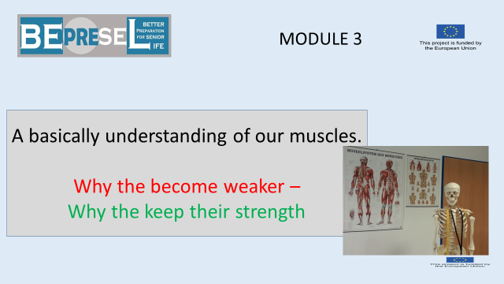

YOU COULD SAY:

We will move on to look into our muscles and our muscle power and have we look after it

++++++++++++++++++++++++++++++++++++++++++++
ADD YOUR OWN COMMENTS AND IDEAS FOR SPEAK AND PRESENTATION:

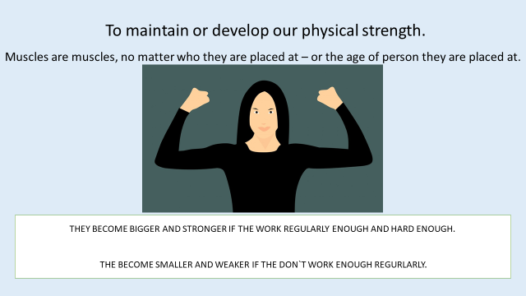

YOU COULD SAY:

The 2nd important factor, out of the 8 factors to be aware of, is our muscle power including the strength in our arms.
Let`s get stuck;
Muscles don’t care, muscles don`t know
whether they are placed on a person aged 30, 50, 80 or 95 years.

Muscles as most of our body: React only according to the physical laws.

The physical laws say:
- A muscle that is stimulated and used regularly (means daily or at least on weekly basis) at its maximum capacity, level or close to its maximum level of strength
  - Will slowly build up extra strength.
  - It doesn’t matter whether the muscle is place on a body being 20 or 85-year-old.

- A muscle that isn’t stimulated or used regularly (daily or minimum on weekly basis) at or close to its maximum capacity level of strength
  - Will slowly reduce its strength and adapt to the lower required level of strength.
Lets have these two very basic rules in mind -
++++++++++++++++++++++++++++++++++++++++++++
ADD YOUR OWN COMMENTS AND IDEAS FOR SPEAK AND PRESENTATION:

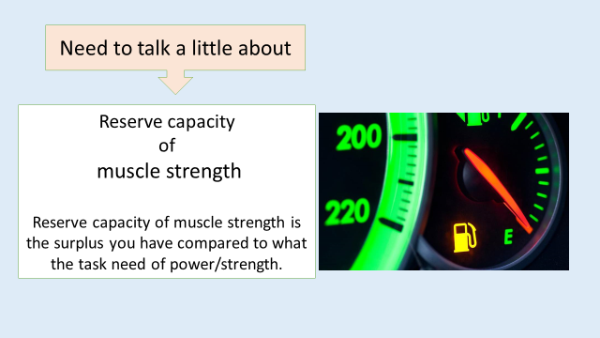

YOU COULD SAY:

We need to look into and understand the term and meaning of reserve capacity.

++++++++++++++++++++++++++++++++++++++++++++
ADD YOUR OWN COMMENTS AND IDEAS FOR SPEAK AND PRESENTATION:

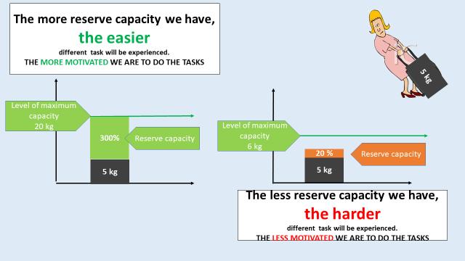

YOU COULD SAY:

Let’s look at lifting 5 kg.
If I am able to lift 20 kg with my fingers, hands and arms,
it will be easy and I will feel it easy to lift 5 kg.
My reserve capacity is “15 kg” or 75%.

Because I know it will not be a big issue to me to lift 5 kg`s, I won’t hesitate to do it – I will not face any problem with my motivation to go and lift 5 kg.
Because I have a quite big reserve capacity.

If I only are able to lift 6 kg as my maximum, with my fingers, hands and arms, it will be very challenging to me to lift a bag of 5 kg.
My reserve capacity is only “1kg” or 16 %.
Because I know that it will be very challenging for me to lift 5 kg I will hesitate and try to avoid it – I will face problems with my motivation to lift 5 kg.
Because I have a quite a small reserve capacity.
Starting to avoid lifting the 5 kg – means that I not even try to maintain my capacity to lift 6 kg – my new maximum will slowly become lower.
That’s the slide to lose everything.

Most of us are or were able to lift 20 - 15 – or 5 kg when we were age 55 or 60 (or are we).
Many of us did it regularly on weekly basis as a part of our work and much more kilos.

Because we don’t continue regularly to lift this number of kg on a weekly basis, we lose the present capacity.

If our muscles feel over time experience that the maximum, the muscles need to lift is 5 kg, the muscles will think (no it won`t) –
“Oh, there is no reason for us to be so big”
No it won`t – it will experience – that there is no reason to have the present capacity.
As stated earlier – it is bad business for the body to use resources to maintain a capacity that`s never used.
The muscles will slowly reduce their strength and adapt to the expected and used level of 5 kg.
- The muscles will slowly reduce their Reserve capacity.
The result is that we slowly feel that 5 kg become heavier and heavier eventually we will start to avoid lifting 5 kilos and start to lift 3 kg because we find it easier.
Then we have set a new maximum of 3 kilos and the muscles will continue to adapt to this lower and lower maximum.
ADD YOUR OWN COMMENTS AND IDEAS FOR SPEAK AND PRESENTATION:

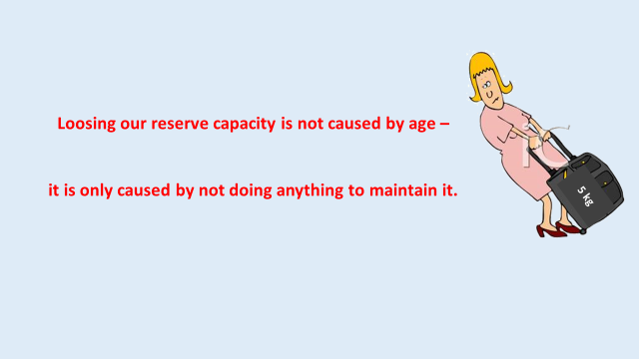

YOU COULD SAY:

Losing our reserve capacity is not caused by age.
It is only caused by not maintaining the strength of our muscles.

ADD YOUR OWN COMMENTS AND IDEAS FOR SPEAK AND PRESENTATION:

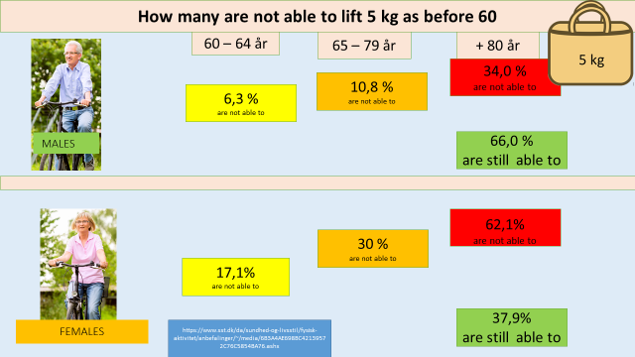
YOU COULD SAY:

What do we know?
A research carried out in Denmark showed that when it came to males
- 6,3% of males had already lost their ability to lift 5 kg
  - The way they were able to at age 60, when they reached 64.

- This number will slowly increase to
  - 10,8% during age 65 to 79 and

- the number of how many will lose their ability will speed up and more than
  - 34% of males will not be able to lift 5 kg after age +80.

Regarding females

- 17,1% of females had already lost their ability to lift 5 kg
  - the way they were able to before age 60, when they reached 64
- This number will slowly increase to
  - 30% during age 65 to 79 and
- the number who will lose this ability will speed up – more than
  - 62,1% of females will not be able to lift 5 kg after age +80.

The seniors did not lose this ability because of age.
If age and the ageing process was the explanation, why is 66% of males older than 80+ still able to do it?
ADD YOUR OWN COMMENTS AND IDEAS FOR SPEAK AND PRESENTATION:

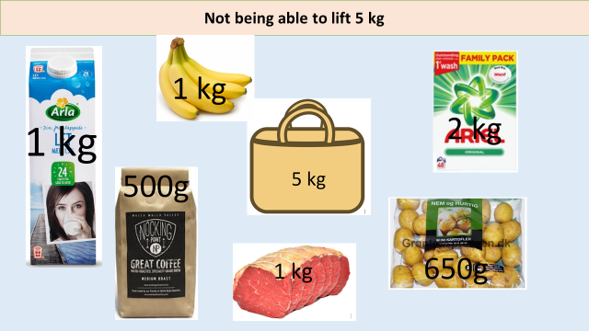
YOU COULD SAY:

Consequences in daily life?

Not being able to lift 5 kilos means not being able to go to the grocery store to buy e.g.
- 1 l of milk
- A pound or 500 grams of coffee
- 1 kg of meat
- 650 grams of potatoes
- 2 kg packet of washing powder
- 1 kg of bananas
- Or something else
They will slowly become depending on someone
- To transport them to the grocery store or
- To bring the goods to the car – lift the goods into the car
- Someone who will go to the store for them.
- And son on
ADD YOUR OWN COMMENTS AND IDEAS FOR SPEAK AND PRESENTATION:

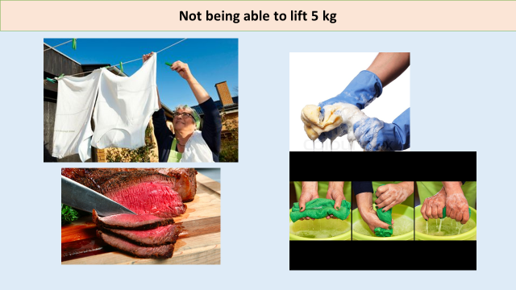
YOU COULD SAY:

More consequences in daily life?
When our ability lift 5 kg is lost, we lose the ability to do and solve many tasks in our daily life, all small contributions and small essential parts of being an independent and self-governing senior.
All small contributions and small essential parts of being an independent and self-governing senior,
- who can choose and make their own decisions, when and how they
  - want to dry their clothes by hanging it on the clothesline,
  - cut the meat ourselves or
  - wash the floor when they think it need to be washed.
Not being depending on when others fine it suitable to do these things – and how they do it.
ADD YOUR OWN COMMENTS AND IDEAS FOR SPEAK AND PRESENTATION:

YOU COULD SAY:

More consequences in daily life?
It is obvious that our hand and arm strength play a crucial role in being an independent individual.

You may say that the cap on glasses and bottles seems to be another important measuring tool.

Have many already face problems opening
- A bottle using only their fingers?
- A glass using only their fingers?
- Food packaging

How do to many of us react - to often?
We accept the loss and reduction of freedom and
- Begin to hand over unopened bottles to someone else to do it.

- Start to buy and use aid equipment to help us open items. Many have already kitchen drawers filled with this kind of equipment. Then we have to use time to find all these different aid equipment.
- Start to avoid buying hard-to-open items and find alternative solutions

It seems that we adapt step by step and many do it without reflecting – that all these “small daily life situations” tells us again and again, that our fingers and arm are becoming weaker.

This is what staying independent and self-governing is about.
This is just examples because on the way to lose the ability to lift 5 kg – we have lost the ability to do a lot of activities and tasks that make us an independent citizen.
Have any considered how much strength – how many kilo we need to pull up our trousers button them and close your zipper? Every morning?
ADD YOUR OWN COMMENTS AND IDEAS FOR SPEAK AND PRESENTATION:

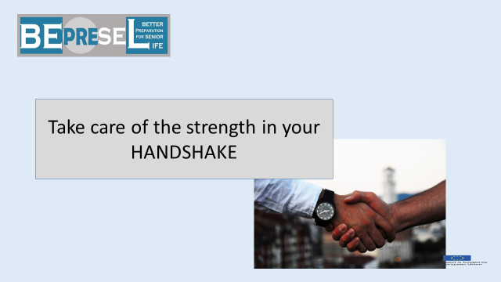

YOU COULD SAY:

Intro to the next part
ADD YOUR OWN COMMENTS AND IDEAS FOR SPEAK AND PRESENTATION:

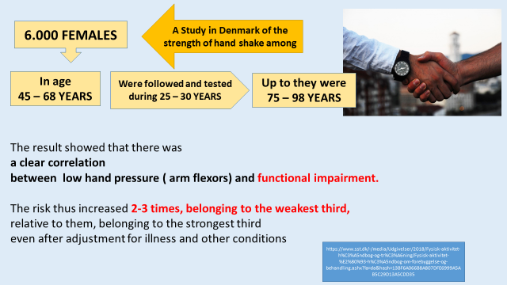
YOU COULD SAY:

Research show a direct correlation between the level of strength in our handshake and our physical functionality later in life.
In a longitudinal research,
- 6.000 females aged 48 to 68 were monitored during a period of 25 to 30 years.
- It means that some of the youngest had turned 78 years old (48 + 30) and some 98 (68 + 30) at the end of this research.
The reason why some were only measured for 25 years and not the whole period of 30 years, were because they died or moved far away.
The results showed that there is
- a clear correlation between low hand pressure (arm flexors) and functional impairment later in life.

The risk increased
- 2 to 3 times, belonging to the weakest third,
relative to them,
- Belonging to the strongest third

Even after adjustment for illness and other conditions.

ADD YOUR OWN COMMENTS AND IDEAS FOR SPEAK AND PRESENTATION:

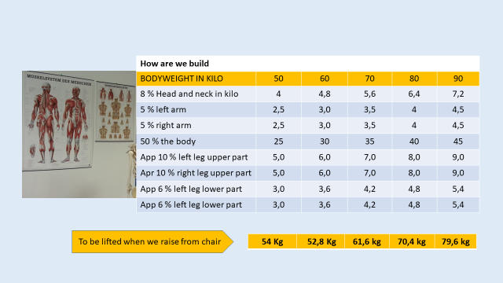
YOU COULD SAY:

Some figures to keep in mind.
If you notice, the number of kilos per arms it is clear having a lifting capacity of 5-6 kilos – most of the capacity will be used only to lift the weight of our arms
- That’s a part of why it becomes a increasing challenge to put our clothes on the line to dry even though the clothes might not be so heavy.

ADD YOUR OWN COMMENTS AND IDEAS FOR SPEAK AND PRESENTATION:

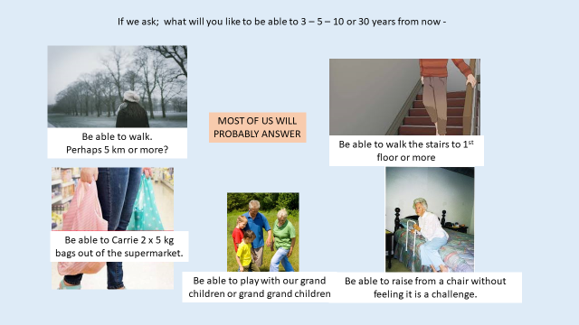

YOU COULD SAY:

Things we will like to do – things we will like to avoid.

Several surveys shows that what worries people and particularly seniors mostly?
- is to lose the ability to walk.
We connect very much our independency and being self-governing with our ability to stay mobile.

Too many of us let this so highly valued competences - skill slowly disappear.

ADD YOUR OWN COMMENTS AND IDEAS FOR SPEAK AND PRESENTATION:

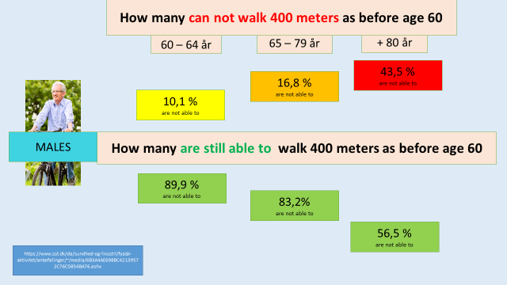

YOU COULD SAY:

What do we know?
We have previously looked at these figures when talking about losing stamina and reduced condition.
Walking 400 meters is not only based on our condition and stamina but also our ability to carry our own weight.
Having our understanding of “RESERVE CAPACITY” in mind, it is clear that:
- It is harder if we have to carry a bodyweight of 70 kilos – if our legs only have a maximum capacity of lifting 80 kilos.
  - The reserve capacity will only be approximately 12%
Compared to
- A person who has the maximum capacity in their legs to lift 105 kg
  - and have a reserve capacity of 50 %

If the muscles in our legs only have to carry our own body weight
as the maximum challenge –
the muscles will slow reduce to this level..

ADD YOUR OWN COMMENTS AND IDEAS FOR SPEAK AND PRESENTATION:

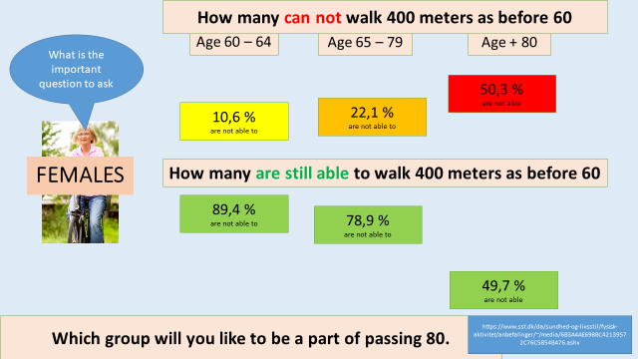
YOU COULD SAY:

And for the ladies we remember it looked like this.

To all:
- One of the first signals to look for is when we are not able to raise from a chair directly without using our arms placed on the armrests.

- The next signal is when we need to use the table to push our self up from the chair.

Can anyone recognize this – can you recognize someone you know already do it this way?
ADD YOUR OWN COMMENTS AND IDEAS FOR SPEAK AND PRESENTATION:

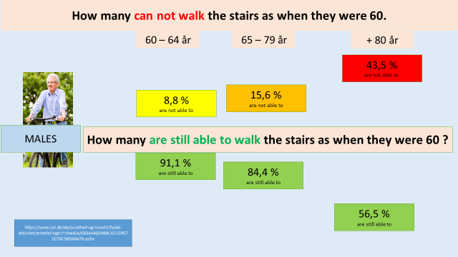

YOU COULD SAY:

Lifting our own weight 2,5 meter when walking upstairs is heavy.
It not only requires condition and stamina to go for the first floor – it also requires the muscle power to lift our weight perhaps 15 or 16 times – depending on the number of stairs.
ADD YOUR OWN COMMENTS AND IDEAS FOR SPEAK AND PRESENTATION:

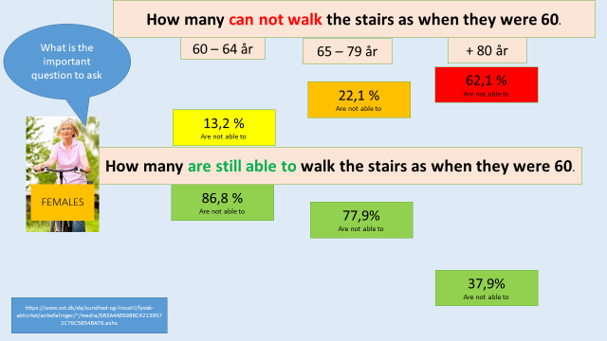
YOU COULD SAY:

Why can almost 22,1% of us not walk to the first floor when 77,9% can? Why are 37,9 still able after age 80 when the majority of 62,1 are not able to.

The green group is green because they do something during their daily life that maintains their ability to be green – also when they have passed 80.
ADD YOUR OWN COMMENTS AND IDEAS FOR SPEAK AND PRESENTATION:

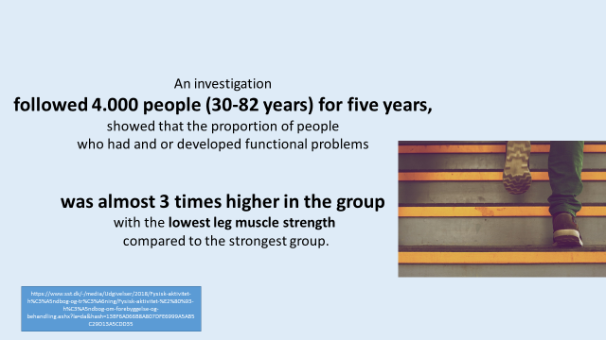

YOU COULD SAY:

A research following 4.000 people (30-82 years) for five years,

Showed that the proportion of people
who had and/or developed functional problems

Was almost 3 times higher in the group
with the lowest leg muscle strength
compared to the strongest group.

ADD YOUR OWN COMMENTS AND IDEAS FOR SPEAK AND PRESENTATION:

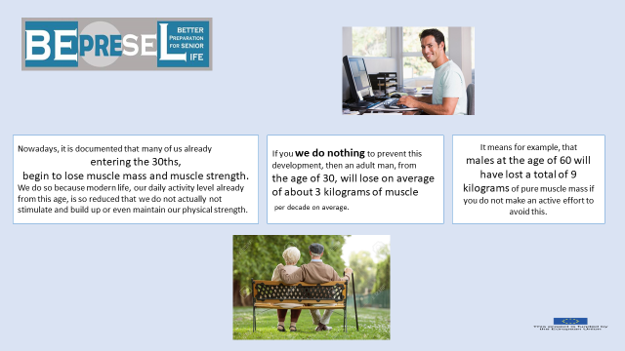
YOU COULD SAY:

It is documented that many of us entering the 30s begin to lose muscle mass and strength.

It happens because in modern life, our daily physical activity level is already so reduced, and we don’t build up or even maintain our physical strengths.

There is a big difference between the modern high technological societies and the low technological societies.
It varies very much from the previous generations. Previous generations were much more physical challenged by ordinary life. Maintaining physical muscles strength was given more or less for free too many.

ADD YOUR OWN COMMENTS AND IDEAS FOR SPEAK AND PRESENTATION:

YOU COULD SAY:

If we don’t do anything to prevent this development, an adult man from the age of 30, will lose about 3 kilograms of muscle per decade on average.

It means that males at the age of 60 will have lost a total of 9 kilograms of pure muscle mass if they do not make an active effort to avoid it.

For at person turning 60 having a loss of 9 kg muscle mass since age 30 will probably not have a huge impact on their daily life. The person will find it harder to do a lot of things – but will probably still be able to do them.
Another loss of 3 kg or perhaps even more per 10 years after age 60 – and another 3 to 5 kg before age 80 – as a consequence and because we become even more inactive - will slowly create consequences for our ability to take care of the things we connect with being an independent senior citizen, as described earlier.
ADD YOUR OWN COMMENTS AND IDEAS FOR SPEAK AND PRESENTATION:

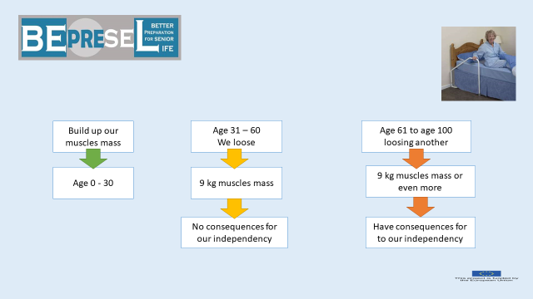

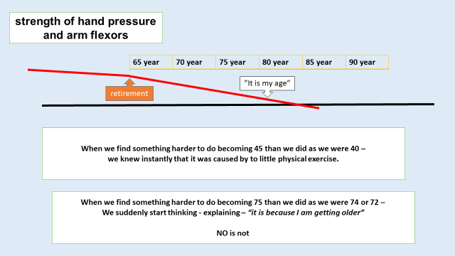
YOU COULD SAY:

Just a simple illustration.
The challenge is that:
- The reduction happens so slowly that we don’t recognize our reduced capacity until we suddenly can’t do the things we used to be able to do.

- When we can’t do something – we apologize or find excuses such as “I am getting older” and “It is normal that I can’t do it – I am 82”.

It has nothing to do with age – it is only caused by the fact that we didn’t do anything during the years to avoid losing our strength.
We didn’t take any preventive measures – didn`t do the need exercises and training of our muscles to maintain their strength and capacity.

The challenge is
- that we do not know or are not aware of, whether our daily life contains the required challenges that will maintain our muscle strength or not

- Have made it clear to our self, what is the required muscles strength that will make us able to do what we will like to do,
  - To solve the tasks we have to face and will like to solve all year-round also when we pass 80 – 85 and older.

  - The activities and experiences we will like to have all year-round – also when we pass 80 – 85 and older.
It is important to remember that it is “all year round”.

Final comment:

When we realized something was harder to do
at age 45 than when we were 40
we knew and recognised deep in our self
it was because we hadn’t exercised enough.

When we realize something is harder to do
at age 75 than when we were 74 or 72
to many of us suddenly start thinking
“it is because I am getting older”.

NO it is not.
It is because we have not maintained our physical strength
during the years preceded

ADD YOUR OWN COMMENTS AND IDEAS FOR SPEAK AND PRESENTATION:

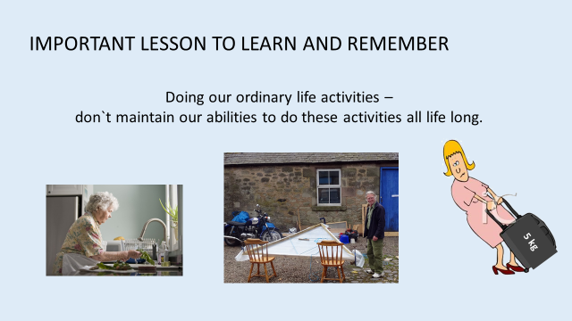

YOU COULD SAY:

An important lesson to understand and have in mind.
“DOING OUR ORDINARY DAILY LIFE ACTIVITIES –
DOESN’T MAINTAIN OUR ABLILITIES TO DO THESE ACTIVITIES
FOR THE REST OF OUR LIFE

Looking at the “rules of muscle physics” presented earlier – it is clear that we are active – that we do many activities every day and week all year.
However, even though we do these activities every day or twice a week we will slowly find it harder to do these activities –
Because our muscles power will reduce and adapt
to match the physical requirements.

But with a lower and lower reserve capacity.

If I will like to be able to lift 10 kgs and feel it is easy and affordable,
5, 10, 15 or 20 years from now –
I have to exercise by lifting as a minimum 15 to 20 kg`s twice a week
ADD YOUR OWN COMMENTS AND IDEAS FOR SPEAK AND PRESENTATION:

