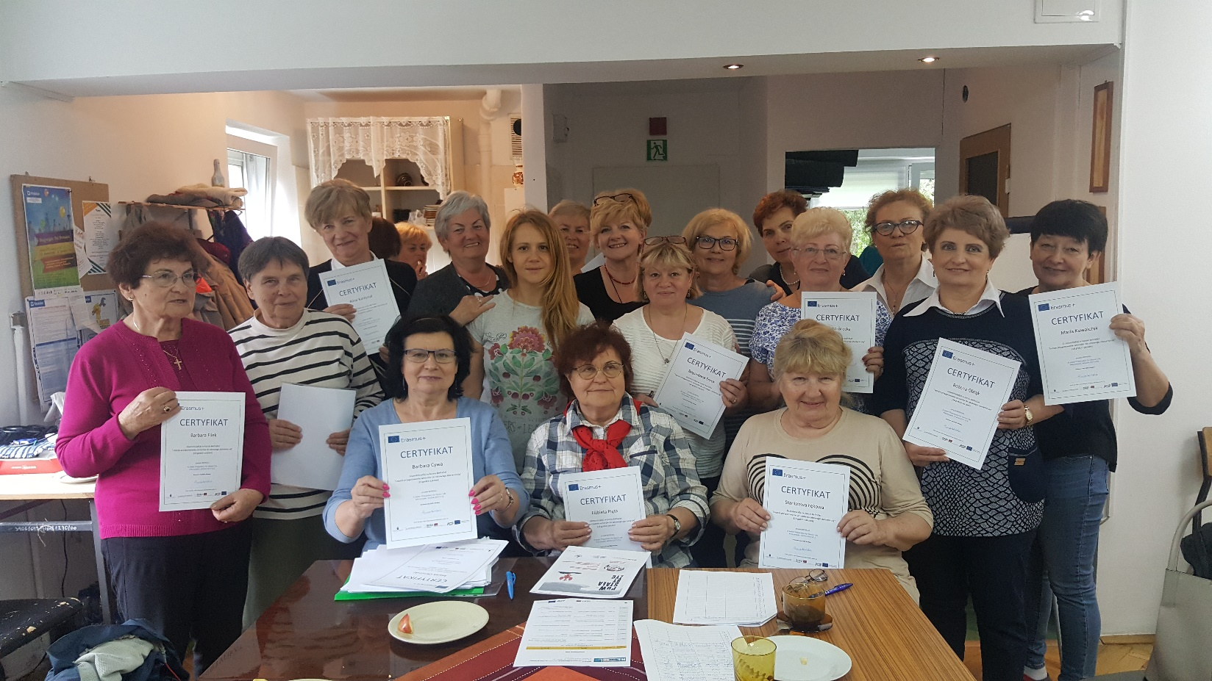

RESULTS OF SENIOR LEARNER EVALUATION OF COURSES

BETTER PREPARATION FOR SENIOR LIFE

KA204-2017-012

Evaluation of the training course
After completing the Bepresel Testing Course - Better Preparation for Senior Life , conducted in Kraków from April to June 2019, we distributed questionnaires to the participants to obtain feedback on the quality of the program. The Bepresel course program was completed in Kraków by 33 seniors between the ages of 62 and 80 (mean age: 70). The course was attended by 27 women and 6 men. Meetings were held on Wednesday (group A) Tuesdays (group B) in the morning, for 8 weeks. After the completion of the lectures (8 modules), we conducted an evaluation test of the participants. We wanted to find out if the seniors gained new knowledge of the aging process through the program and what they think about the usefulness of the course and its content. In total, 33 persons participated in the evaluation of the BEPRESEL program. Over 54% of people (n = 28) indicated that thanks to participation in the program their knowledge about the health of seniors has improved significantly. The participants rated the classes on physical activity the best - nearly 70% of respondents said that these classes were comprehensive.

About 20-30% of participants indicated that they would like to learn more about nutrition in old age. Nearly 90% of people indicated that thanks to the program they understood how they can maintain or improve their physical condition as well as body balance. About 82% of participants (n = 27) thought that thanks to the program their knowledge about the importance of proper nutrition in old age has expanded. In turn, 85% of seniors (n = 28) declared that they would pay more attention to the type of protein in their diet. Also 85% of people indicated that the program pointed to various aspects related to condition and physical strength. About 64% of people (n = 21) indicated that the course duration was optimal, 24% (n = 8) that it could take longer and only one person indicated that it was too long. Most people (n = 28, 85%) indicated that the proposed meeting schedule (one meeting per week lasting 1.5 hours) was optimal. About 45.5% (n = 15) of participants indicated that if they had to pay for the course they would not take part in it. In turn, 18.2% of people (n = 6) would be willing to pay for participation in the course PLN 65, 24.2% (n = 8) PLN 100 and one person indicated that they would be willing to pay PLN 175 for classes (i.e. PLN 11 for every 45 minutes of class). Over 88% of participants (n = 29) would recommend the course to their friends. 1/3 people (n = 10) assessed that their financial situation was rather bad, 39.4% (n = 13) that it is average and 21% (n = 7) that it is good. Nearly 50% (n = 19) people had higher education and 36% (n = 12) had secondary education.

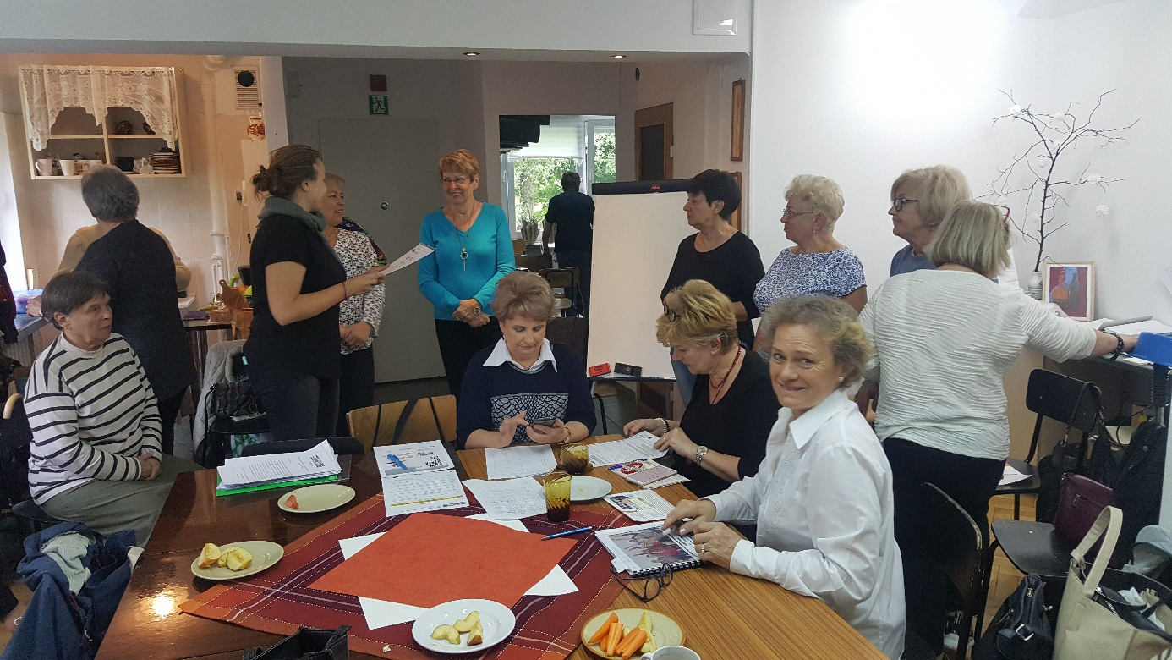

FEED BACK ON THE COURSE: BEPRESEL

Now you have completed a course of 16 lessons including time for testing.

Have you learned anything new about the ageing process?

You have now finished a course build up by 8 modules. We will kindly ask you to comment them 1 by 1 according to the length of the individual modules.

Now you have finished the course, do you then have a clear understanding of how you may maintain or even improve the following physical competences?

Now that you have finished the course, you have a clear idea of the importance of blood pressure:

Do you think you want to buy or want a blood pressure monitor and check your blood pressure from time to time - for example, a couple of times a year.

After completing the course, do you have a clear idea of why it is important to keep an eye on your BMI, your fat percentage and your hip target?

Have you become more aware of the importance of diet in senior life?

Do you think you will be more active in participating in common eating?

Do you think you will occasionally check if you get the proteins you really need?

Do you think the course will give you more attention, to train and maintain your various physical skills

If you will not start to train in order to maintain or develop – what do you think will be the reason?

If you have let yourself be tested, do you think that having a number of different physical competencies and areas means something to your motivation to strengthen these figures?

Has the course organization with 8 meetings was comfortable?

Has the course organization once a week and morning hours -comfortable?

This course was free - but now you know what it contains - what would you think it has value? How much will you pay for the knowledge you have today?
You may try to relate your answer to what you otherwise pay for courses with other content.

Do you think the course and course have had a content and a quality that will make you recommend your acquaintances to participate if it is re-launched?

Where will you place your self according to these categories?

Educational background/Highest graduation:

My last position/job type before I retired (number of participants).

