TEACHERS GUIDELINE:
MODULE 2 STAMINA
THE BEPRESEL COURSE

Project title: Bepresel
Grand Agreement Number: KA204-2017-012
Publisher: The partnership of the ERASMUS+ project Bepresel
For the publisher: Niels Vestergaard
Editing: The partnership of the ERASMUS+ project Bepresel

OVERALL COMMENTS TO THE TEACHER

This English version is the final revised overall manual of the educational material developed by Erasmus+ BEPRESEL project implemented during the periode of 1st of October 2017 to the 30th of September 2019.
This final version is not identically to the draft versions, developed as background and to inspire the developing off the different national educational content to be implemented and tested during 2 test courses in each partner country.
The 8 test courses was implemented during the period of February-June 2019, by various methodologies and pedagogical approaches.
In the same way be believe it is important future users adapt this material to their national contexts, to your own methodology and especially to the specific profile of the senior learners to be educated.
There might be differences in how power points are to be illustrated in different countries and to different learner groups. You are free to change the pictures & illustrations used at the power points. In the same way you are of course free to change or supplement with national statistical figures, if they are aviable.
It is not the intention providing this material for this module , that you have to or shall use all the slides presented.
The intention is, you pick out the most relevant slides that, that fits
- the time frame you have available for the presentation of this module and
- match the specific profile of the seniors you are going to educate.
In the same way you are free to change the order of the powerpoints.

The text, the suggestions of »what could be said« in connection with the individual power point are for inspiration. As you will see, there are room at the different pages, so you may to write:
- Your own ideas how you will like to present the different slides.
- How you will like to put the facts and documentation into words.
- What you will like to tell the seniors.
- What questions you believe could be good for you to ask the senior learners
  - to answer,
  - to discuss a little,
  - to reflect about.
It is important you make your presentation in your own words.
Create your own personal presentation but please stick to the facts as they are presented and avoid to present your own version of what you think ageing and what ageing period is about.
We believe the pedagogical intention should be, to establish a dialogue with your senior learners based on the slides you present.

Make sure you have time for that.
It is important to be aware using power point very easily speed up the presentation, which might not be beneficial for all senior learners
If it is possible to you, try to remember some of the information you are going to present. It might be a good idea to present some of the information, by chalk and blackboard or at a flip over.
Make sure the seniors have time to think, time to reflect. Time to ask questions.
It is serious to educate seniors have to avoid loosing their independent living later in life, howewer it is still important to have a good laugh once a while during the lessons.
Consider have you might be able to present some of the statements the material provide, with a little humorous approach and a smile

Prepare your self for a little resistance from some among your learners. You will probably meet resistance related to some of the results – statistics and the conclusions to make. To many senior learners some of the info and conclusions will be controversial as they don`t confirms or match, what many seniors believe, what many seniors assume as facts and what they have noticed and know from “their own experiences”.

Try to avoid entering into long discussions – just refer to what science tells – what the statistics show.

Some will also be critical. Make clear from the very begining that they overall frame of what you going to tell and show during the lessons to come, is:

»We aren’t going to talk about training and exercising to become a participant for the next Olympics. You are going to talk about, what it takes, what it require of a little weekly effort, training and ongoing exercises to maintain or develop the daily activities that will make us stay independent for longer later in life.

If any have ambition about making a world record it shold have been redeemed in our younger years.«

SPECIFIC OBJECTIVES OF THIS PART.
You find what the BEPRESEL partnership believe should be the objectives of this modul in the Curriculum: Senior Health Education – a BEtter PREparation for SEnior Life.

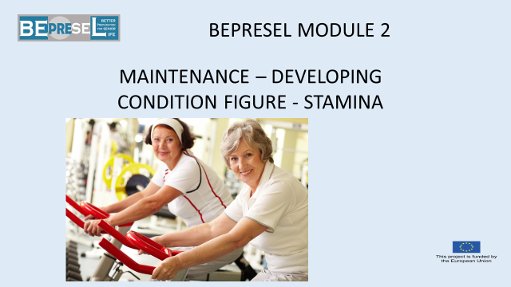

YOU COULD SAY:

Next – lets look into our stamina – condition and what a condition figure is and tells us.

++++++++++++++++++++++++++++++++++++++++++++
ADD YOUR OWN COMMENTS AND IDEAS FOR SPEAK AND PRESENTATION:

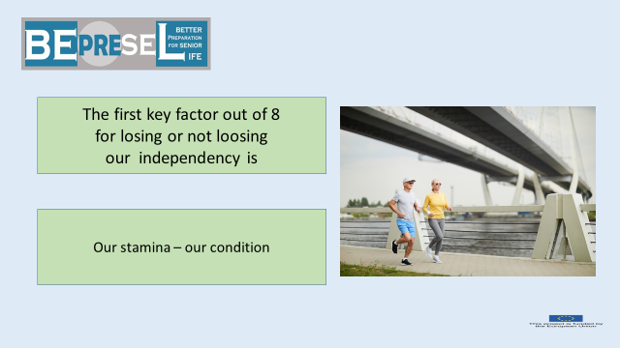

YOU COULD SAY:

A key factor for losing or not losing our independency later in life is our condition, our stamina
to do what we will like to do, to have the good experiences to maintain our, life quality.
More crucially, continuously be able to do what we need to do on daily and weekly basis the years to come in order to stay independent and self-governing through our entire life.

Now it becomes a little technically.
Technically, our condition and condition figure, (our stamina), show our ability
- to absorb oxygen and
- to transport the oxygen via our blood to our muscles.
Oxygen is the gasoline that ensure that our muscles can work and produce the power we need to perform the activities, the daily tasks that makes us independent.
If we slowly lose this power – our stamina and our condition (figure) slowly reduce –
Then will our independency slowly turns into dependency as years pass by.
++++++++++++++++++++++++++++++++++++++++++++
ADD YOUR OWN COMMENTS AND IDEAS FOR SPEAK AND PRESENTATION:

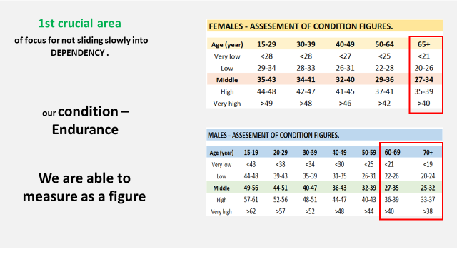

YOU COULD SAY:
Our condition and stamina can be measured as our condition figure, and by that, we can make a table of what is expected on average for different age groups.
It is a fact that to most peoples’ and particularly to most senior citizens that what we do during our daily life, is not enough to maintain our condition - our level of stamina.
Most people slowly slides down the hill of condition during most life – if they haven`t taken any actions to maintain their condition.
It is not a big problem going from a condition figure at 40 to 39 at age 55.
But if it continuous to a certain level it will have consequences.
To most of us, the consequences show up in senior life – after being sliding down many years with limited consequences.
But suddenly it is people’s independency which is on stake.

Give examples of: What the table at the slide tell:
E.g. that females age 65+ at least have a conditions figure of 27 to 34 to be a part of the middle group.
The higher our condition figure is - there more easily we solve many daily tasks:
Experienced heavy tasks of today
- Will feel less heavy one month from now if we raise our condition figure.
- Will feel even more heavy and challenging one more from now if our condition figure continuous slowly to decrease and we will finally start to give up doing different tasks – one by one.
++++++++++++++++++++++++++++++++++++++++++++
ADD YOUR OWN COMMENTS AND IDEAS FOR SPEAK AND PRESENTATION:

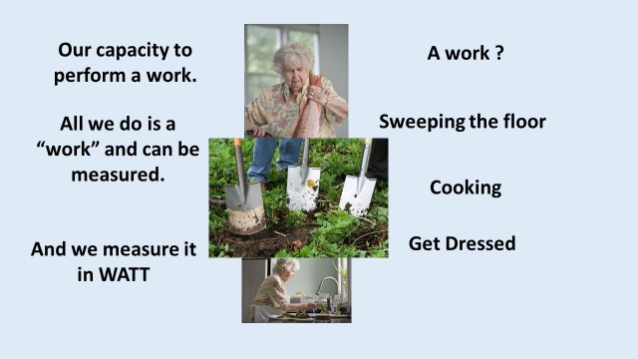

YOU COULD SAY:
All kind of work can be measured in watt.
Those of us who feel interest in bicycling – Tour de France know that the riders are very focused on how many WATT they need to produce to hang on – or to climb the mountains. Not to pass their limit and go dead.
This is not our challenge.
Therefore, the question we all should ask our self is:
How much watt do I need to do, to overcome the challenge and task I will like to handle all life – to stay independent and self-governing.
++++++++++++++++++++++++++++++++++++++++++++
ADD YOUR OWN COMMENTS AND IDEAS FOR SPEAK AND PRESENTATION:

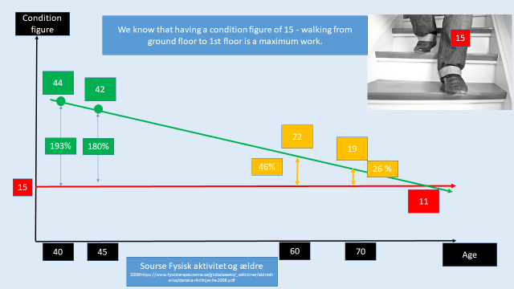

YOU COULD SAY:
Let`s see how it looks.
As mentioned before;
- It is not a problem for most people when our stamina, measured as condition figure, slowly reduces from 44 to 42 in age 40 to 45, when it comes to being able to manage their daily tasks needed for an independent living.
  - There are still a quit big surplus and reserve capacity (we will come back to what “reserve capacity is) to do all daily tasks without any problems. The person might not be able to run as long as he could and as fast as he could when the person were at a condition figure level 44. It does not mean anything to our daily life – whether we are able to run 22 km in 2 hours or we only are able to run 20 km in 2 hours.
However, the person will experience that it becomes a little harder to do some different activities at level 42 than the person did at level 44.
The difference between
- what the task requires
and
- the max watt (power) we are able to produce,
is named “Reserve capacity”.

Let’s look at what we know:
- We know having a condition figure of 15
  - Walking the stairs from ground floor to 1st floor is a maximum challenge – a maximum work.
We place the level of 15 into our diagram – we have age at the bottom and level of condition at the vertical line.
Putting in the person from before, having a condition of 44, the person will have a reserve capacity of 193% - that is a huge “reserve capacity” climbing the stair to first floor. It is this huge reserve capacity that cause that it feels very easy to climb the stairs. It is not because he is young.

Even though the person, during the next 5 years, will drop to 42 the person will still have quite a huge “reserve capacity” at 180 %. The person will probably not even notice that it has become a little harder to go for 1st floor.
This might be the real problem. We don`t notice small changes – and suddenly, 15 or 20 years later, the persons’ condition figure is 22.
What else do we know?
- We know from huge test and surveys that the average condition figure of
  - females in Denmark is 22.
Now the person will only have
- a reserve capacity of 46%.
The person will still be able to climb the stairs for 1st floor – but will feel a little out of breath.
Continuously declining and sliding down to a level of a having a condition figure at 19
- the reserve capacity is now only 26%
and the person will feel much more out of breath, and the person will start to prioritize, when going for 1st floor. Will start to avoid stairs.
And by that decision the person of course will accelerate the speed of losing condition – because we start to avoid challenges that could stimulate our condition. We avoid because it feel uncomfortable to have these experiences – of not being able to

At a level of
- condition figure of 15 it is final call for 1st floor
and most of us will avoid it. Now we have lost freedom – now we have become dependent;
- that there is an elevator.
- have to ask other people to go and get something we need on first floor.
- We will start to say “no thanks” when people invite us for a trip – invites us to take part in activities that contributes to our life quality. Only because it requires to much walk or a little climb
The negative circle will speed up.

++++++++++++++++++++++++++++++++++++++++++++
ADD YOUR OWN COMMENTS AND IDEAS FOR SPEAK AND PRESENTATION:

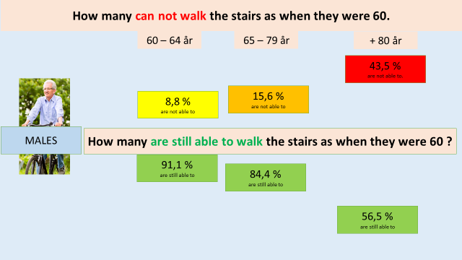

YOU COULD SAY:
What do we know?
- We know from science that
  - 8,8% of males already have lost their ability to walk the stairs to the first floor in the same way as we were able to before age 60 when we reach age 64.

- The number will slowly increase so
  - 15,6% of us - males will not be able to walk the stairs to first floor in the same way we were able to before age 60, when we reach age 79 and

- Then quite rapidly speed up so more than
  - 43,5% of us will not be able to walk for 1st floor after age +80.

The explanation of why so many seniors face a reduction and lose their ability is not age. It is not because these seniors become older.
If age and the ageing process was the explanation, why are 56,5% of males older than 80+ still able to climb the stairs as they did when they were age 60?
++++++++++++++++++++++++++++++++++++++++++++
ADD YOUR OWN COMMENTS AND IDEAS FOR SPEAK AND PRESENTATION:

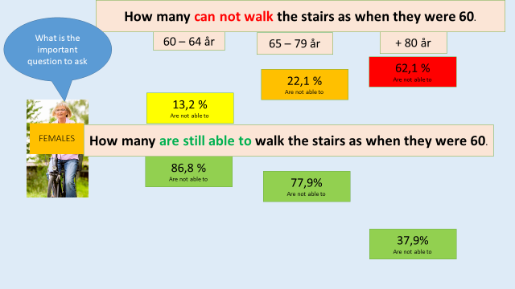

YOU COULD SAY:

To females it even looks worse:
- 13,2% of females
  - Have already lost their ability to walk the stairs to the first floor in the same way as we were able to before age 60 when we reach age 64.

- This number slowly will increase to
  - 22,1% during age 65 to 79, and

- the number of females who will lose this ability will speed up to more than

  - 62,1%, who will not be able to walk to the 1st floor after age +80.

The explanation of all the females slowly losing this ability is still not age.
It is not because these females become older.
If age and the ageing process was the explanation, why are 56,5% of females older than 80+ still able to do it?
++++++++++++++++++++++++++++++++++++++++++++
ADD YOUR OWN COMMENTS AND IDEAS FOR SPEAK AND PRESENTATION:

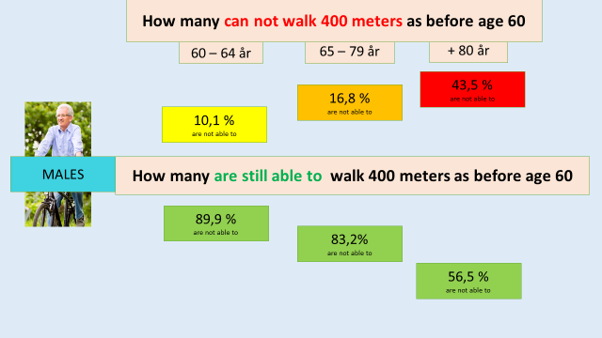

YOU COULD SAY:

Another examples:
- 10,1% of males
  - Have already lost their ability to walk 400 meters in the same way as they were able to at age 60 before we reach age 64.

- This number will slowly increase to
  - 16,8% during age 65 to 79 and

- then the number who lose this ability will speed up to more than
  - 43,5% of elderly more than +80 have lost this ability.

We repeat:
The explanation of all the males who lose this ability is not age. It is not that these seniors become older.
If age and the ageing process was the explanation, why are 56,5% of males older than 80+ still able to do it?

++++++++++++++++++++++++++++++++++++++++++++
ADD YOUR OWN COMMENTS AND IDEAS FOR SPEAK AND PRESENTATION:

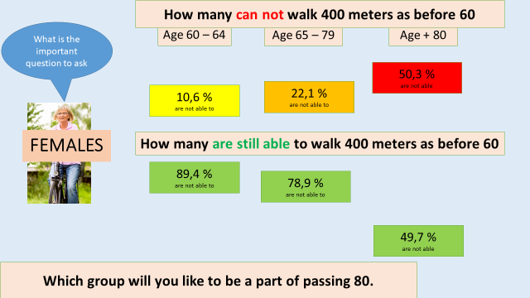

YOU COULD SAY:

To females it even looks worse, again
- 10,6% of females
  - Have already lost their ability to walk 400 meters in the same way as they were able to at age 60 before they reach age 64.

- This number slowly increase to
  - 22,1% during age 65 to 79 and

- then the number who lose this ability will speed up so more than
  - 50,3% of elderly more than +80 have lost this ability.

The explanation of all the seniors who lose this ability is not age. It is not that these seniors become older.
If age and the ageing process was the explanation, why are 56,5% of males older than 80+ still able to do it?
++++++++++++++++++++++++++++++++++++++++++++
ADD YOUR OWN COMMENTS AND IDEAS FOR SPEAK AND PRESENTATION:

YOU COULD SAY:

That was the bad news but also the fact of what becomes reality to much too many of us, if we don`t act.

The good news is
that seniors

have exactly the same positive effect
of taking care of our condition, our stamina,

as young people have.
If we take care? If we take action.
++++++++++++++++++++++++++++++++++++++++++++
ADD YOUR OWN COMMENTS AND IDEAS FOR SPEAK AND PRESENTATION:

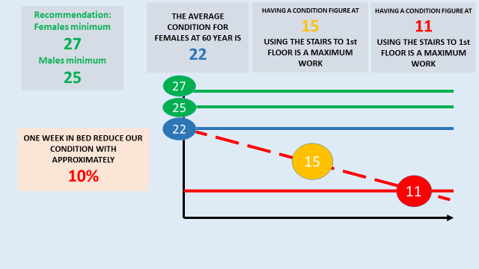

YOU COULD SAY:

Let’s continue to look at what we know:
- We know, from testing senior females in Denmark, that
  - the average condition figure of females age 60 is 22.

- We know that walking the stairs from ground floor to 1st floor is a maximum challenge to people who have
  - a condition figure at a level of 15.

- We know that reaching
  - a condition level of 11 – we are no longer able to take care of our self – we have lost our independency.

- Finally, we know that one week of illness staying in bed – reduce our condition, our stamina,
  - with approximately 10% per week. It could be a flu.
++++++++++++++++++++++++++++++++++++++++++++
ADD YOUR OWN COMMENTS AND IDEAS FOR SPEAK AND PRESENTATION:

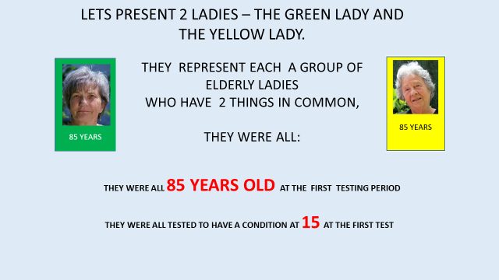

YOU COULD SAY:

This was the bad story.
But we also know scientifically, that there is a good story.
The good story is that our condition and our stamina is very prepared to be maintained and even developed no matter our age.
That seniors responds just as good as younger people do if, and when, we start just a little training.

Let’s look at an example.
A group of ladies in Denmark were identified and selected according to two similarities.
- They were all age 85
&
- They were all tested/measured to have a condition figure of 15.

As we remember:
- Having a condition figure of 15,
- Walking the stairs to first floor is a task – a task that will require an absolutely maximum effort for these ladies.
Being at a level of 15 and being in a speeding up process of losing and going down the hill, due to increasing inactivity, these ladies
- Are expected to reach the level of 11, in quite a short time – probably in a year or 2. We remember what level 11 means?
At a condition level of 15 these ladies are already in a position where they probably have given up a number of daily tasks.
They have probably already given up, are not able to take part in many good events and experiences with other people, with family and with grandchildren.
They are already semi-dependent in many aspects.

++++++++++++++++++++++++++++++++++++++++++++
ADD YOUR OWN COMMENTS AND IDEAS FOR SPEAK AND PRESENTATION:

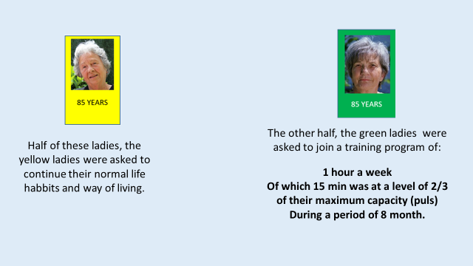
YOU COULD SAY:

The identified group of senior ladies of age 85 and a condition figure of 15 were divided into 2 groups.
- The Yellow ladies were asked to go home and asked not to do more than they normally did in daily life. – Asked to continue the normal way of living perform the normal daily activities they used to do. Nothing less nothing more

- The green ladies were offered only

  - 1-hour training per week
  - during a period of 8 month.

    - Out of this 1-hour weekly training

    - the intensity was for only 15 minutes at a level of 2/3 of their maximum capacity, measured as 2/3 of their maximum pulse.
We will be back to explaining what our maximum pulse is and talk about how we come to know our maximum pulse.
Right here we can say that an intensity of 2/3 is not a very high intensity.
++++++++++++++++++++++++++++++++++++++++++++
ADD YOUR OWN COMMENTS AND IDEAS FOR SPEAK AND PRESENTATION:

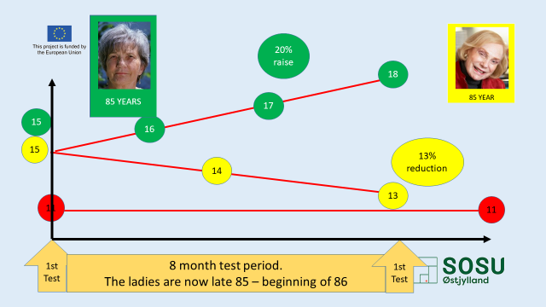

YOU COULD SAY:

So what happened?
8 months later, all the ladies were tested again – some of them had turned age 86 by this time.
- The green ladies were now measured to have raised their condition
  - To an average condition figure of 18.

- It means that some of them were even better than 18 and some a little lower than 18.
  - On average a raise of 20% in 8 months.
They have strengthened their independency – and exceeding their independent living.
They will be able to do things – participate in things they were not able to do 8 months earlier.
If they continue with another 8 months of training, some of them will before they celebrate their 87th anniversary – will reach a condition figure level of approximately 21.
What is 21 close to? (The average of females age 60 was 22)

- During the same 8 month the yellow ladies dropped, on average,
  - to a level of condition figure at 13 or
    - a decrease and reduction on average of 13%.
++++++++++++++++++++++++++++++++++++++++++++
ADD YOUR OWN COMMENTS AND IDEAS FOR SPEAK AND PRESENTATION:

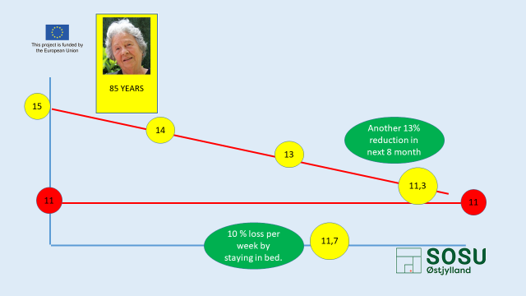

YOU COULD SAY:

It is clear, knowing we at a condition figure of 11 are becoming dependent.
- We are no longer able to take care of ourselves anymore.
The fact that the yellow ladies during the same 8 months, ended at a condition figure of 13 bring them in a position where they will soon lose their independency and in high risk to face the moment where they will be in need of home care services – or a potential resident at a care home.
Another 8 months of losing at the same speed, will place them at a level of 11,3.
However, it might go much quicker as a period of 1-week illness and in bed reduce their condition and stamina with approximately
- 10% per week.
- After only 1 week in the nearest future they might be at
  - a condition level of 11,7.

Many seniors start their career as dependent citizen and as customer or client to care service providers, after a shorter or longer period of illness.
They are simply not able to restitute from such a low level of condition.
++++++++++++++++++++++++++++++++++++++++++++
ADD YOUR OWN COMMENTS AND IDEAS FOR SPEAK AND PRESENTATION:

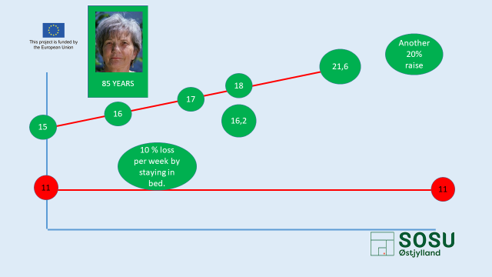

YOU COULD SAY:

If the green ladies were offered another 8 months of 1-hour weekly training, some of them will become age 87, and reach a level approximately around 21 or 22 – far away from level 11 and
- Will now have the force to resist several weeks in bed and still raise and restitute.
++++++++++++++++++++++++++++++++++++++++++++
ADD YOUR OWN COMMENTS AND IDEAS FOR SPEAK AND PRESENTATION:

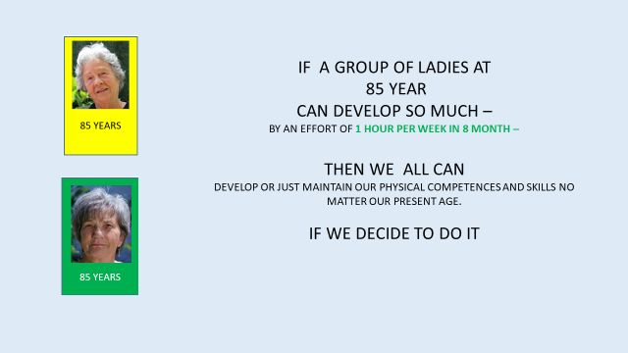

YOU COULD SAY:

It should be clear to all of us,
- if ladies at age 85, with a very small effort of 1 hour training a week – 15 minutes training at 2/3 of their maximum - can improve so much.
We can all maintain and improve our condition and stamina.

However, the personal objectives we all should have, is of course not to end up in a situation as all the ladies ended up in, the day they were tested
Of course, we should all aim not to slide into a condition level of 15 when we reach age 85.
Knowing that e.g. females at age 60, on average were measured to have a condition figure level of 22, which is a quite a low level, as we remember, the table at the beginning told us, that we should be
- at level of 29 to 36 being in age group 50 to 64 and
- Then minimum be at a level of 27 to 34 entering 65+.
Means probably that most of us have room for development and
- are in a need to improve if we will stay independent, and
And in a need to improve
- If we would like to be able to take part in all the fun, all the good events and opportunities in later life, also when we pass age 85 and +90.
++++++++++++++++++++++++++++++++++++++++++++
ADD YOUR OWN COMMENTS AND IDEAS FOR SPEAK AND PRESENTATION:

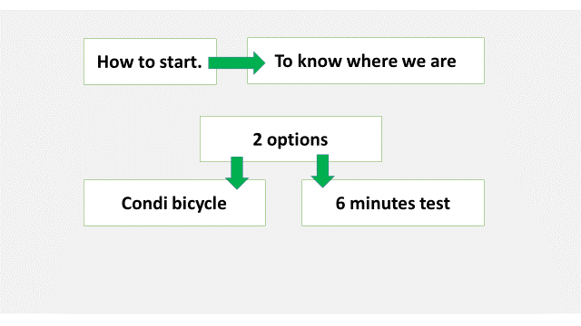

YOU COULD SAY:

We will introduce you to 2 more simple methods, but still very useful.
- The 6 minutes’ walk test
- To test and calculate your condition figure by condition- bicycle.

++++++++++++++++++++++++++++++++++++++++++++
ADD YOUR OWN COMMENTS AND IDEAS FOR SPEAK AND PRESENTATION:

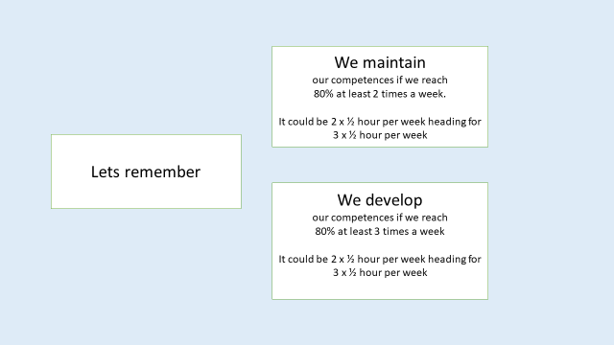

YOU COULD SAY:

We repeat:
We maintain
our competences if we reach
80% of our maximum pulse at least 2 times a week.
It could be 2 x ½ hour per week heading for
3 x ½ hour per week

We develop
our competences if we reach
80% of our maximum pulse at least 3 times a week
It could be 2 x ½ hour per week heading for
3 x ½ hour per week

- Any questions? No
  - Do anyone know what your maximum pulse is today?

++++++++++++++++++++++++++++++++++++++++++++
ADD YOUR OWN COMMENTS AND IDEAS FOR SPEAK AND PRESENTATION:

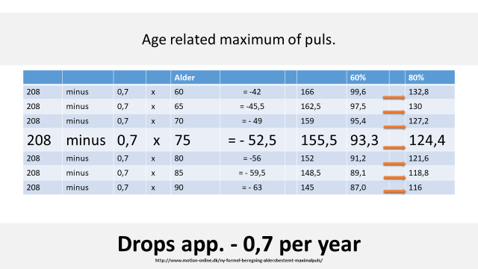

YOU COULD SAY:

Your maximum pulse is age related as you can see here.
We will come back to it later
++++++++++++++++++++++++++++++++++++++++++++
ADD YOUR OWN COMMENTS AND IDEAS FOR SPEAK AND PRESENTATION:

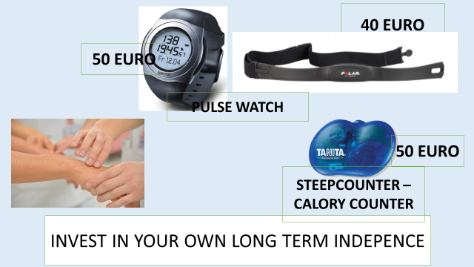

YOU COULD SAY:

To know our pulse require we know how to measure it.
- We can all exercise, practice and become good to measure and count our pulse at our hand wrist and other places.
  - The intention is when you make physical exercise and have to measure your pulse – you have to count it for 1 minute.
  - Many count it immediately after exercise for 15 seconds and then multiply with 4.

- However, you should consider buying a pulse watch or make a wish for a pulse watch for the next birthday. It is a good investment in one’s health and an important tool to be aware of once physical condition in general and in particularly to work with maintaining once stamina and condition.
++++++++++++++++++++++++++++++++++++++++++++
ADD YOUR OWN COMMENTS AND IDEAS FOR SPEAK AND PRESENTATION:

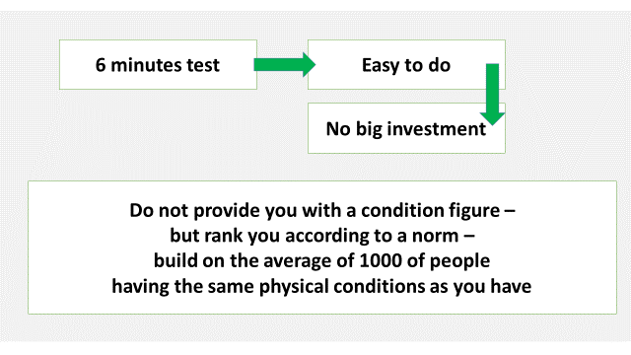

YOU COULD SAY:

How to measure once stamina – condition.
The 6 minutes test is easy to implement, to do regularly and more over it is a cheap test to do.
6 minutes test does not provide you with a condition figure, but
- it ranks you according to a norm, made from the average of thousands of people all over the world having the same physical conditions and age as you have.
++++++++++++++++++++++++++++++++++++++++++++
ADD YOUR OWN COMMENTS AND IDEAS FOR SPEAK AND PRESENTATION:

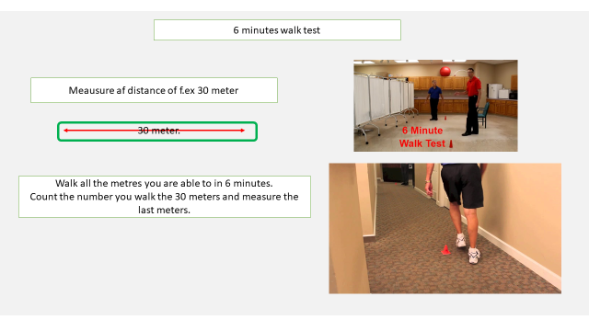

YOU COULD SAY:

What to do:
- Measure a distance of e.g. 30 meters but in fact it can be any distance but not shorter than 20 meters – because you have to turn to often. But anything between 20 and as long as you are able to.
- The important part is that you know the exact distance. You may mark the distance with 2 chairs or 2 kinds of anything. You have to be a little accurate with the distance.
- It is good if you make a lane – so you are able to walk around e.g. 4 marks. It can be indoor – at a corridor as shown on the picture or in the dining room. It can be outdoor. It could be in your garden, someone’s garden or in the park.
7 meters

4 meters
4 meters

7 meters

- Look at your watch – start your stopwatch

- Walk as long a distance as you are able to, walk all the metres you are able to in 6 minutes.

- Count the number of rounds you walk and measure the last number of meters to where you stopped after exactly 6 minutes.

Comment to teacher:
(If you as teacher have a group for testing, you may make more routes, so more people can walk at the same time. It is a good idea not to start at the same time. People to be tested are not supposed to compete.
We are not competing with anyone else but ourselves.

++++++++++++++++++++++++++++++++++++++++++++
ADD YOUR OWN COMMENTS AND IDEAS FOR SPEAK AND PRESENTATION:

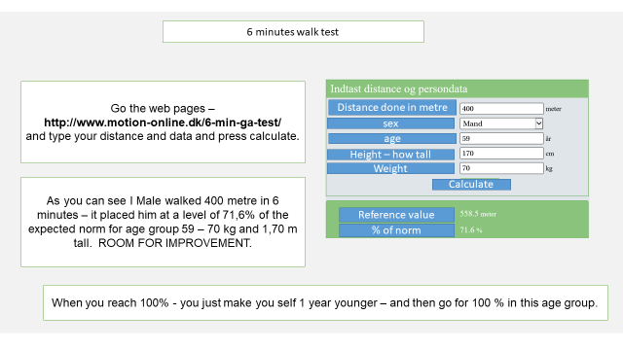

YOU COULD SAY:

Go the web pages –
http://www.motion-online.dk/6-min-ga-test/
and type your distance and your data and press calculate. (try to identify a national version)

As you can see, one male age group 59 walked 400 metres in 6 minutes.
It placed him at a level of 71,6% of the expected norm for age group 59, 70 kg and 1,70 metre tall.
IT TELLS THAT HE HAS ROOM FOR IMPROVEMENT.

When you become the best in your age group, reach the top 100% in your age group
- You make yourself 1 year younger – and then go for the next 100 % in this one year younger age group.
- And so on…. Compare yourself with younger and younger groups.

Notice the % and your placement and bring these numbers into your Senior Health profile.
Then repeat your test 3 month later and so on.
++++++++++++++++++++++++++++++++++++++++++++
ADD YOUR OWN COMMENTS AND IDEAS FOR SPEAK AND PRESENTATION:

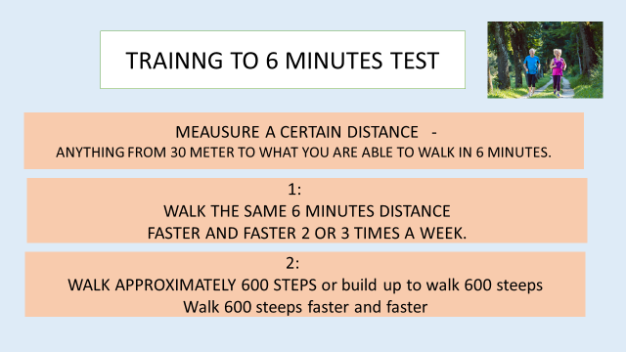

YOU COULD SAY:

Model 1
- Find a certain distance in your neighbourhood.
- It could be in a park or the distance to the grocery store.
You basically don`t need to know exactly how long it is, but make it a minimum of 300 m, and no longer than 500 metres at a start.
- Have a watch so you are able to count the minutes and seconds it takes to walk the distance.

- Walk this distance by ordinary speed for the first time to dicide where your final destination is.

- The walk the distance 2 or 3 times a week – and try to do it a little faster every week you walk.

Model 2
- Walk and measure on your watch/stopwatch how long the time it takes you to walk 500 steps.
- Then slowly build up and walk the 500 steeps a little faster week by week.

Model 3:
- Walk as long as you are able to by ordinary speed in 6 minutes, from a certain position at your home address and to where to reach after the 6 minutes.
- Next walk – the same route with the intention of reaching a little longer and pass the first destination.

If you are a Starter or never have trained specific to improve your condition and stamina.

At the same time as you measure the distance and time – you also have to remember to measure your pulse.
No matter which model you choose then start at a pulse level of 60% of your max related pulse and then slowly push yourself to a level of 80% of your max related pulse.

Don`t stress your self – as stated earlier – we are not training and exercising for the Olympics – we exercise to improve our physical capacity – and we have time for a slow improvement so we won`t feel bad about doing the exercise.
++++++++++++++++++++++++++++++++++++++++++++
ADD YOUR OWN COMMENTS AND IDEAS FOR SPEAK AND PRESENTATION:

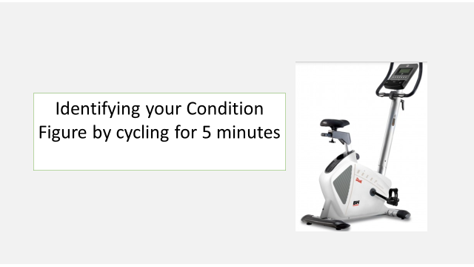

YOU COULD SAY:

Measuring your condition figure by cycling for 5 minutes.
++++++++++++++++++++++++++++++++++++++++++++
ADD YOUR OWN COMMENTS AND IDEAS FOR SPEAK AND PRESENTATION:

Comment to the teacher:
It is good to calculate approximately 10 minutes on average per person for the first test.
If you don`t have the bike – consider to make an agreement with a fitness center.

YOU COULD SAY:

HOW DO WE TRAIN AND IMPROVE OUR CONDITION AND STAMINA?
As mentioned before, we need to know our maximum when it comes to be able to calculate our condition figure.
Our maximum is age-related, and it is very good that some clever people have made a table so we all can identify our maximum.
As you can see this formula (there are more formulas) is based on:
- a maximum pulse at 208, in general.
- Then you multiply your age with 0,7
- The result of your age x 0,7 is withdrawn from 208 and the result is your age-related maximum.
It means that to a person of age 75 the maximum pulse is approximately 155,5.
When you look at 60% and 80%, it is because all training starts at 60% if you are not used to training, and then it goes up, until you train at a level of 80%.
Remember, the ladies were training 15 minutes at a level of 2/3 (67%) of their maximum. It means, with a work pulse at a level close to 100, you can read from the table that, to age 85: 60 % = 89,1 and 80% is = 118,8.
We should all, at any time, know our age-related maximum pulse. Notice that it drops 0,7 per year. So, if you know it now, you know it in the years to come as well.
++++++++++++++++++++++++++++++++++++++++++++
ADD YOUR OWN COMMENTS AND IDEAS FOR SPEAK AND PRESENTATION:

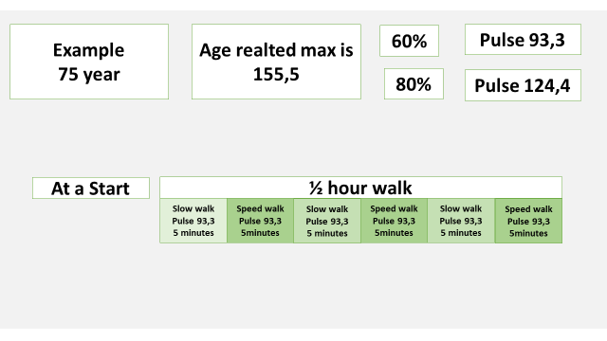

YOU COULD SAY:

EXAMPLE:
Knowing that the age-related pulse at age 75 is 155,5,
Then:
- 60% of maximum is 93,3 and
- 80% of maximum is 124,4.
No matter what method you choose for training, it could be
- walking,
- running,
- cycling or swimming,
Because they are activities that are easy to control.
Many seniors are “physically active” – some play golf, some play badminton, some play tennis and they are all good physical activities for many reasons and people shall continue doing them.
The problem is that these kinds of activities are not so easy to control and measure at – because it is a little off and on.
Doing these kinds of activities, you have to be sure that you, for a period of at least 15 minutes x 2 times a week or even better x 3 times a week, play at an intense level that bring up your pulse up –
- for a start to 60% and raising to 80% later on.
If you don`t reach these levels for at least 15 minutes per hour, you might play many hours of badminton, tennis, evening walk or something else without any impact on our condition or stamina.

It is not enough to dress for badminton or tennis and walk around on the lane for 1 hour. You have to be exhausted for at least 15 minutes before you benefit from playing. – 2 or even better 3 times a week.
++++++++++++++++++++++++++++++++++++++++++++
ADD YOUR OWN COMMENTS AND IDEAS FOR SPEAK AND PRESENTATION:

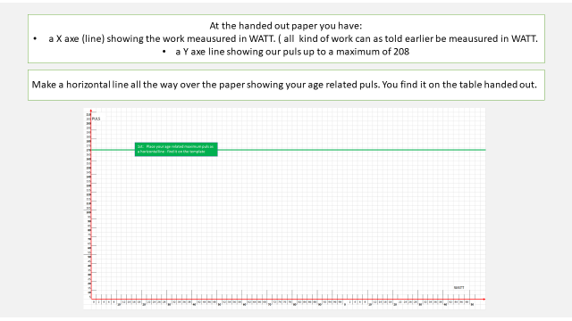

YOU COULD SAY:

Nevertheless, if you already do something - or not – it is a good start to know where, and how, we are positioned.

There are more ways of testing our condition and stamina.
- The most accurate methods require special equipment – with mask and oxygen and much more. But very complicated – and we are still not going for the Olympics.
- We only need to know if we maintain – or improve to a level where we will not become a dependent citizen caused by a loss of our condition and stamina.

MEAUSURING YOUR CONDITION FIGURE.
You will all receive this paper with:
- an x axis (line) showing the work in WATT (all kind of work - measured in what it takes in watts)

- A Y axis showing the pulse.

- Make a horizontal line (the green line) all the way across the paper, showing your age-related pulse. You find it on the table handed out.
  - Remember to change it once a year.
++++++++++++++++++++++++++++++++++++++++++++
ADD YOUR OWN COMMENTS AND IDEAS FOR SPEAK AND PRESENTATION:

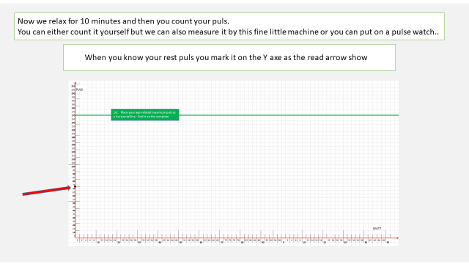

YOU COULD SAY:

- Now we relax for 10 minutes and then you count your pulse.
- You can either count it yourself, but we can also measure it by this fine little machine ( blood pressure monitor),
- or you can put on a pulse watch.

  - When you know your resting pulse, you mark it on the Y axis as the red arrow shows.
It is very good to measure it once and for all as the first thing in the morning – still lying in bed after a good nights sleep.
++++++++++++++++++++++++++++++++++++++++++++
ADD YOUR OWN COMMENTS AND IDEAS FOR SPEAK AND PRESENTATION:

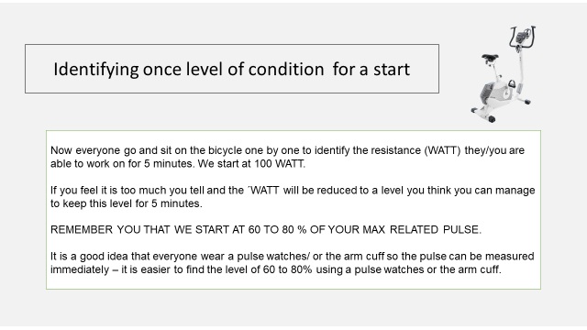

YOU COULD SAY:

- Now everyone have to go and sit on the bicycle one by one, to identify the precise resistance, the work, the number of WATT, we all are able to work and overcome for 5 minutes.
  - We start at 100 WATT and see what happens.

- The pulse is register and we aim a pulse level of approximately 110 and 120 – no more

If you feel it is too much and the pulse raise to more and do not become stabile around 110 – 120 the WATTs within one minute the number of WATT shall be reduced to a lower level than 100 WATT.
- Try 75 and measure again to test if this no of Watt brings a pulse at 110 – 120 and stabile in approximately 1 minute.
If so, then continue and keep this level and speed for 5 minutes.

It is a good idea if everyone wears a pulse watch/ or the arm cuff so their pulse can be measured immediately – it is easier to find the level of 60% to 80% using a pulse watch or the arm cuff.
++++++++++++++++++++++++++++++++++++++++++++
ADD YOUR OWN COMMENTS AND IDEAS FOR SPEAK AND PRESENTATION:

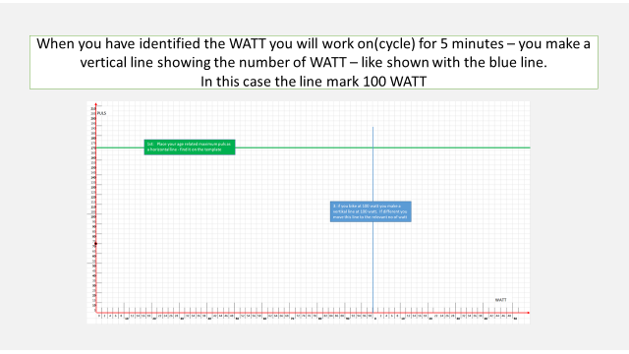

YOU COULD SAY:

- When you have identified the WATT, you will work (cycle) for 5 minutes.
- After 5 minutes you stop and draw a vertical line showing the number of WATT you have been working at.
  - Shown with the blue line.
  - In this case the line marks 100 WATTs.

++++++++++++++++++++++++++++++++++++++++++++
ADD YOUR OWN COMMENTS AND IDEAS FOR SPEAK AND PRESENTATION:

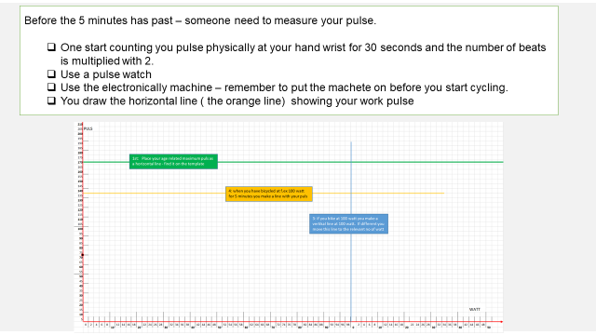

YOU COULD SAY:

- But before you draw this blue WATT line and
- Shortly before the 5 minutes have past, someone needs to measure your pulse.
  - Some bikes will show your pulse.

But otherwise
- Use a pulse watch
- Use the electronically machine – remember to put the band on before you start cycling.

- Begin by counting you pulse physically on your wrist for 30 seconds and the number of counted heart beats is multiplied with 2.

- Then you draw the horizontal line (the orange line) showing your work pulse after 5 minutes.
++++++++++++++++++++++++++++++++++++++++++++
ADD YOUR OWN COMMENTS AND IDEAS FOR SPEAK AND PRESENTATION:

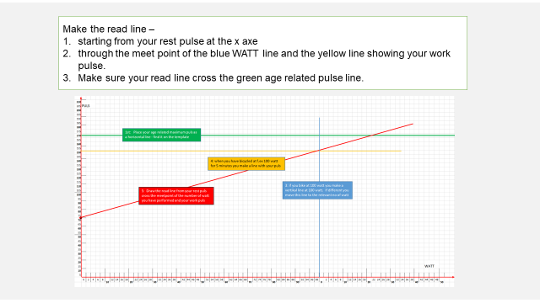

YOU COULD SAY:

- Make the red line –
  - starting from your rest pulse at the x-axis through
  - the meeting point of the blue line (WATT) , and the yellow line showing your work pulse.

  - Make sure your red line crosses the green age-related pulse line.
++++++++++++++++++++++++++++++++++++++++++++
ADD YOUR OWN COMMENTS AND IDEAS FOR SPEAK AND PRESENTATION:

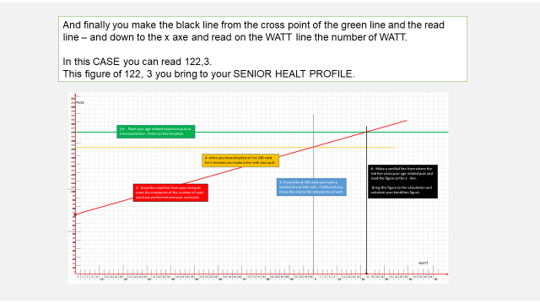

YOU COULD SAY:

And finally,
- you draw the black line from
  - the meeting point of the green line and the red line,
  - down to the x-axis and read on the Y-axis the WATT line the number of WATT.

  - In this CASE you will read the figure: 122,3.
  - This figure of 122,3 you bring to your SENIOR HEALTH PROFILE.
++++++++++++++++++++++++++++++++++++++++++++
ADD YOUR OWN COMMENTS AND IDEAS FOR SPEAK AND PRESENTATION:

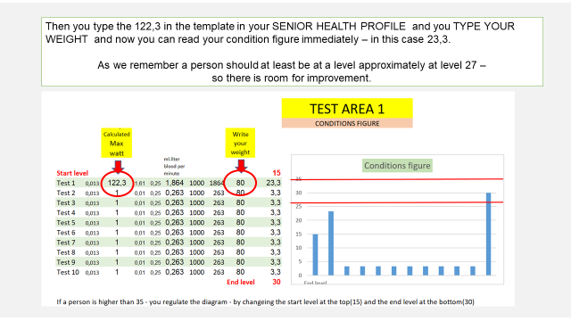

YOU COULD SAY:

- Then you type 122,3 into the template in your SENIOR HEALTH PROFILE and you type YOUR WEIGHT –
  - Now you can read your condition figure immediately. In this case 23,3.

At the beginning, we presented different levels of condition figures related to different age groups and check what a condition figure express.

Very low - Low – middle – high – very high
As we remember, a person of should at least be at an approximate level of 27 – so there is room for improvement here.

++++++++++++++++++++++++++++++++++++++++++++
ADD YOUR OWN COMMENTS AND IDEAS FOR SPEAK AND PRESENTATION:

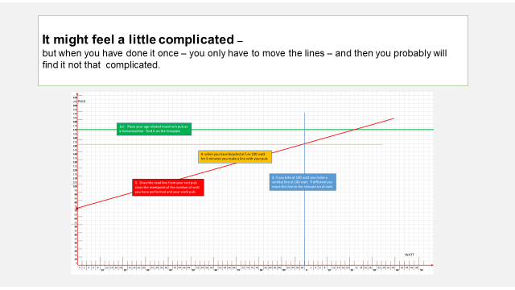

YOU COULD SAY:

- It might feel a little complicated –
But remember that the green line (age related pulse) and the blue line (the watt) will be the same for quit a long period.
What differs is the yellow (work pulse) and the rea
But when you have done it once, you only have to move the lines – and then you probably will find, that it is not that complicated.
++++++++++++++++++++++++++++++++++++++++++++
ADD YOUR OWN COMMENTS AND IDEAS FOR SPEAK AND PRESENTATION:

YOU COULD SAY:

SOME TIPS
HOW TO START TRAINNG OR QUALIFYING WHAT YOU ALREADY DO:

It could be the evening walk – or any other walk we do regularly.
It could be a ride on the bike or swimming.

LET’S REMEMBER THE BASIC RULES:
We maintain:
- 2 x per week at 80% of our maximum
We develop:
- 3 x per week at 80% of our maximum

++++++++++++++++++++++++++++++++++++++++++++
ADD YOUR OWN COMMENTS AND IDEAS FOR SPEAK AND PRESENTATION:

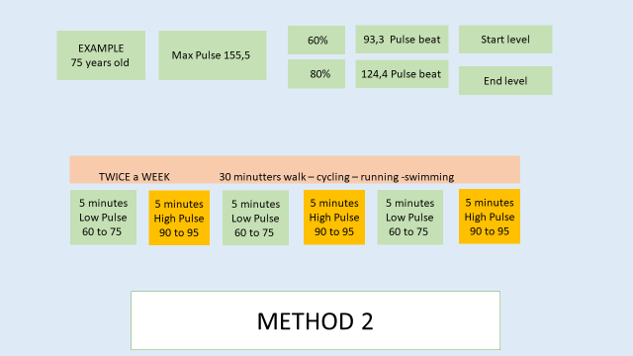

YOU COULD SAY:

A person in this e.g.
- aged 75 should start and make sure that the pulse will reach
  - 93,3 or 60 % for at least 15 minutes no matter if you walk, cycle, run or swim
    - one hour or half an hour twice a week,
&
  - Then slowly week by week speed a little up so the pulse slowly raise and finally reach a pulse of 124 or 80%
    - For at least 15 minutes twice a week.

It could look like presented at the slide:
Start walking for 30 minutes twice a week.
- 5 minutes at a low normal pulse –
  - then 5 minutes at a higher pulse (60% in the beginning)
- then 5 minutes at a low pulse
  - then 5 minutes at high pulse (60% in the beginning)
- then 5 minutes at low pulse (60% in the beginning)
  - Finally 5 minutes at high pulse. (60% in the beginning)
Some weeks later – you push yourself a little and the high pulse shall now increases to more than 60% - a pulse of 93) – to a pulse of 95. Later to 97 – 100 and so on.

Buy yourself a pulse watch – it is an extremely important tool for a good life. Or wish for it for your next birthday.
++++++++++++++++++++++++++++++++++++++++++++
ADD YOUR OWN COMMENTS AND IDEAS FOR SPEAK AND PRESENTATION:

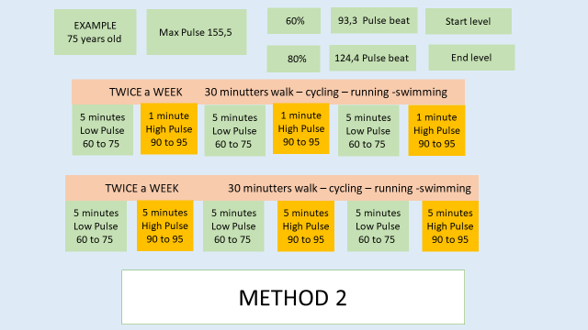

YOU COULD SAY:

You might not be able to start doing 3 x 5 minutes at 60%.
If not, then start with less minutes – 1 minute x 3.
The important part is to start and then, week after week, slowly build up – improve so you finally reach the level of 80%.
Remember we have time to build up slowly.
++++++++++++++++++++++++++++++++++++++++++++
ADD YOUR OWN COMMENTS AND IDEAS FOR SPEAK AND PRESENTATION:

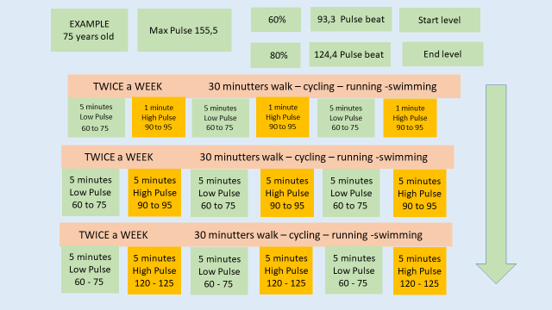

YOU COULD SAY:

Don’t force or stress yourself, we all have plenty of time. The important part is that we become aware of the challenge, and that we come to know and understand;
- whether we already do something at a level that contribute to maintain our condition, our stamina or
- What it takes if we want to improve our condition and stamina for later life.
And then slowly build up, by challenging yourself, week by week.
++++++++++++++++++++++++++++++++++++++++++++
ADD YOUR OWN COMMENTS AND IDEAS FOR SPEAK AND PRESENTATION:

