TEACHERS GUIDELINE:
MODULE 1 – INTRODUCTION Part 1
THE BEPRESEL COURSE

Project title: Bepresel
Grand Agreement Number: KA204-2017-012
Publisher: The partnership of the ERASMUS+ project Bepresel
For the publisher: Niels Vestergaard
Editing: The partnership of the ERASMUS+ project Bepresel

OVERALL COMMENTS TO THE TEACHER

This English version is the final revised overall manual of the educational material developed by Erasmus+ BEPRESEL project implemented during the periode of 1st of October 2017 to the 30th of September 2019.
This final version is not identically to the draft versions, developed as background and to inspire the developing off the different national educational content to be implemented and tested during 2 test courses in each partner country.
The 8 test courses was implemented during the period of February-June 2019, by various methodologies and pedagogical approaches.
In the same way be believe it is important future users adapt this material to their national contexts, to your own methodology and especially to the specific profile of the senior learners to be educated.
There might be differences in how power points are to be illustrated in different countries and to different learner groups. You are free to change the pictures & illustrations used at the power points. In the same way you are of course free to change or supplement with national statistical figures, if they are aviable.
It is not the intention providing this material for this module , that you have to or shall use all the slides presented.
The intention is, you pick out the most relevant slides that, that fits
- the time frame you have available for the presentation of this module and
- match the specific profile of the seniors you are going to educate.
In the same way you are free to change the order of the powerpoints.

The text, the suggestions of »what could be said« in connection with the individual power point are for inspiration. As you will see, there are room at the different pages, so you may to write:
- Your own ideas how you will like to present the different slides.
- How you will like to put the facts and documentation into words.
- What you will like to tell the seniors.
- What questions you believe could be good for you to ask the senior learners
  - to answer,
  - to discuss a little,
  - to reflect about.
It is important you make your presentation in your own words.
Create your own personal presentation but please stick to the facts as they are presented and avoid to present your own version of what you think ageing and what ageing period is about.
We believe the pedagogical intention should be, to establish a dialogue with your senior learners based on the slides you present.

Make sure you have time for that.
It is important to be aware using power point very easily speed up the presentation, which might not be beneficial for all senior learners
If it is possible to you, try to remember some of the information you are going to present. It might be a good idea to present some of the information, by chalk and blackboard or at a flip over.
Make sure the seniors have time to think, time to reflect. Time to ask questions.
It is serious to educate seniors have to avoid loosing their independent living later in life, howewer it is still important to have a good laugh once a while during the lessons.
Consider have you might be able to present some of the statements the material provide, with a little humorous approach and a smile

Prepare your self for a little resistance from some among your learners. You will probably meet resistance related to some of the results – statistics and the conclusions to make. To many senior learners some of the info and conclusions will be controversial as they don`t confirms or match, what many seniors believe, what many seniors assume as facts and what they have noticed and know from “their own experiences”.

Try to avoid entering into long discussions – just refer to what science tells – what the statistics show.

Some will also be critical. Make clear from the very begining that they overall frame of what you going to tell and show during the lessons to come, is:

»We aren’t going to talk about training and exercising to become a participant for the next Olympics. You are going to talk about, what it takes, what it require of a little weekly effort, training and ongoing exercises to maintain or develop the daily activities that will make us stay independent for longer later in life.

If any have ambition about making a world record it shold have been redeemed in our younger years.«

SPECIFIC OBJECTIVES OF THIS PART.
You find what the BEPRESEL partnership believe should be the objectives of this modul in the Curriculum: Senior Health Education – a BEtter PREparation for SEnior Life.

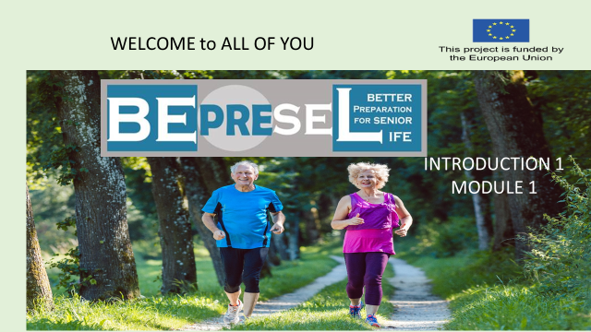

YOU COULD START:
Intro and opening slide
Welcome to all of you to this senior educational program – named BEPRESEL
It stands for BEtter PREparation for SEnior Life.

++++++++++++++++++++++++++++++++++++++++++++
ADD YOUR OWN COMMENTS AND IDEAS FOR SPEAK AND PRESENTATION

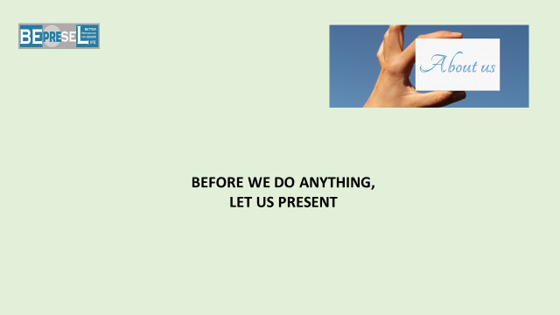

YOU COULD CONTINUE:

Before we start, I think it would be good to present ourselves, very shortly.
We don’t need a long presentation – we will have lot of opportunities to get to know each other during the program.
Let us only have your names and if you don`t mind – your ages, educational background and last profession.
Then we will find out the rest and what else to know of importance later.
My name is ………… and my background to be here is……………

++++++++++++++++++++++++++++++++++++++++++++
ADD YOUR OWN COMMENTS AND IDEAS
FOR SPEAK AND PRESENTATION HERAFTER:

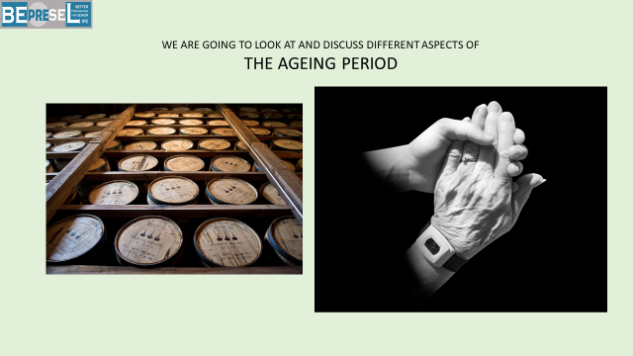

YOU COULD SAY:
We are going to talk about many different aspects of becoming older – and old.
We will put a little attention to the challenges we might face later in life - but mostly we will put attention to have we are able to minimize these potential challenges later in life.
It is good to remember that there are many things that just become better year after year like the wine in these barrows.
We might have the biggest experience in life – the finest hours ahead of us.

++++++++++++++++++++++++++++++++++++++++++++
ADD YOUR OWN COMMENTS AND IDEAS
FOR SPEAK AND PRESENTATION HERAFTER:

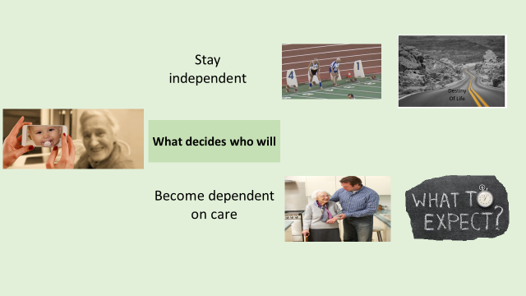

YOU COULD SAY:
The intentions and objectives of offering this course are to make all aged 65+ and those who are about to become a member of this exclusive group, more informed and more knowledgeable about what we scientifically know about the ageing process.
We will put attention to:
- The challenges that might occur later in senior life and why they occur.
- Why much to many of us much too soon and totally unnecessary, almost unnoticed and without taking action to avoid it, lose our physical abilities and competences day by day, week by week, month by month and year by year.

A slow almost invisible process, which at the end will take away many seniors independent way of living and reduce our ability to stay self-governing later in life.
Much to many of us will still be unnecessarily dependent on either family, friends or professional caregivers employed at home care or at care homes later in life.
It happens probably because too many seniors still believes it is a part of normal ageing, to lose – to slide down the hill.

But we will put much more attention to how we all with a very little effort:
- Can avoid that this sliding process happens.

- Are able to make sure that many more of us will stay active, have many more brilliant experiences and funny hours in the years to come;

  - as an independent self-governing senior citizen and family member.

I will try to present to you, what very basically decides;
- Who will slide slowly into dependency and who will stay independent later in life.

- Who and why some are able to run a 100 meter competition when they are +90 and who will not be able to do that? B
  - Because they are dependent on help either from family, the homecare service or are a resident at a care home.

- What decides who will end up in need of homecare services and/or institutional care at a care home and who will not?
  - Is it luck? Is it genetic? Is it destiny?
    - I can tell you already now - no it is not.

- Is it part of the “NORMAL AGEING” that we become dependent the last years of our life – and more depending the older we get.”
    - I can tell you already now - no it is not.

In Denmark only 3,7 seniors out of 10 seniors are in a condition where they need institutional care and 5 senior out 10 in need of care and support after age 90+
- What does that tell us?
++++++++++++++++++++++++++++++++++++++++++++
ADD YOUR OWN COMMENTS AND IDEAS
FOR SPEAK AND PRESENTATION HERAFTER:

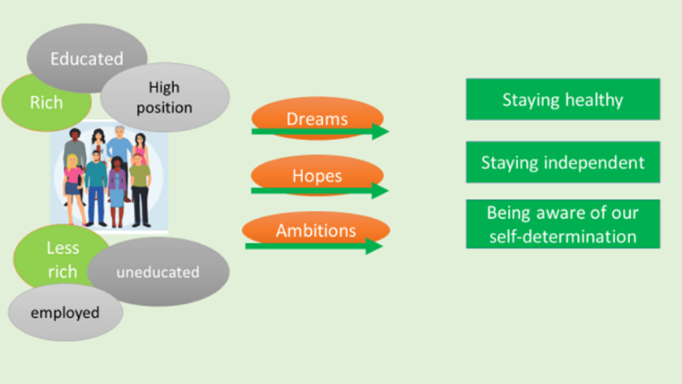

YOU COULD SAY:

Let`s start with this little point of view.
We are all different – we are all very individual. However it seems as our dreams, hopes and values are much more different in our younger years than in our senior years. To some we become more alike.
Research’s shows that no matter our social status or level of income during life, some fundamental issues become more similar and identical in senior life when it comes to:
- What we hope for – what we dream of – what we would like to achieve in life the older we become.
  - This counts for both rich and less rich people. For educated and non-educated people and all other kind of profiles when we reach and pass age 60 – 65 – 70.
These 3 following “wishes” become more and more our strongest wishes and hopes for our future. And it is not a bigger house or a fancy car – but:
- To stay independent for as long as possible.
- To live on our own conditions for as long as possible.
- To maintain our right of self-determination for as long as possible.
In the same way research shows asking senior citizens;
- That our ability to walk and maintain our ability to keep walking is what we rank highest when we are asked about pointing out the most important thing in later life.
We would like to have good experiences and enjoy the company of our families and friends.
These 3 or 4 goals for later life become more and more important to us.
Do you agree?
++++++++++++++++++++++++++++++++++++++++++++
ADD YOUR OWN COMMENTS AND IDEAS FOR SPEAK AND PRESENTATION:

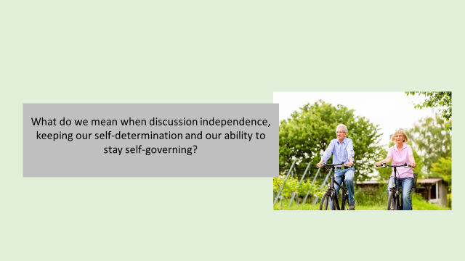

YOU COULD SAY:
It might be a good idea to make it clear what do we actually mean talking about staying independent and selfgoverning.
Examples of what we believe staying independent in later life means:
It means to keep our ability to:
- Get out of bed – to decide for ourselves when we want to get out of bed and not be dependent on when the care services have the time to help
- To take a bath – when I want a bath and not when the care services have time for me
- To get dressed – when I want to get dressed and not when the care services have time for me
- To make fresh coffee when I want to have coffee and not have to drink what the care service people made 5 hours ago and put in the thermos.
- To go shopping when I need to shop – because I will like to choose my own groceries and not have what the care service have chosen.
- To cut my hedge (if I have one) when I think it needs to be cut and not when my children have time to do it
- To travel when I want to
- To see people when I want to see people
- To take part in activities I like to take part in – not to only take part in activities because they are the only options

Ask the participants what they connect with– staying independent and selfgoverning
++++++++++++++++++++++++++++++++++++++++++++
ADD YOUR OWN COMMENTS AND IDEAS FOR SPEAK AND PRESENTATION:

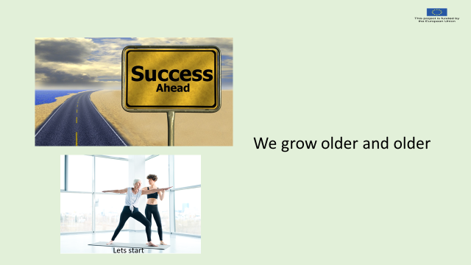

YOU COULD SAY:
Let’s start with something very positive – we grow older and older and it might never ends

I imagine you have experienced the same – when you look into your family history – generations back.

++++++++++++++++++++++++++++++++++++++++++++
ADD YOUR OWN COMMENTS AND IDEAS FOR SPEAK AND PRESENTATION:

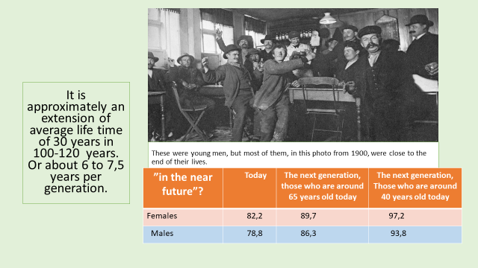

YOU COULD SAY:
On average, we live longer. Much longer
Look at this picture of hard working males having a good time at a bar.
They look young – they were young compared to us, but most of the males at the photo from 1900, were in fact close to the end of their life.
- These males could be our great-great-grandparents to those of us who are age 60 today and
- Grandparents to those of us who are at age 80 today.
In the beginning of 1900 Danish, Norwegian and Swedish males had the longest average lifetime in Europe at approximately 50 years.
English and French males had an average life time at 45 years.

The average lifetime has expanded with almost 30 years during the last 4 generations –
During a period of only 120 years.
Or 6 – 7,5 years longer per generation
++++++++++++++++++++++++++++++++++++++++++++
ADD YOUR OWN COMMENTS AND IDEAS FOR SPEAK AND PRESENTATION:

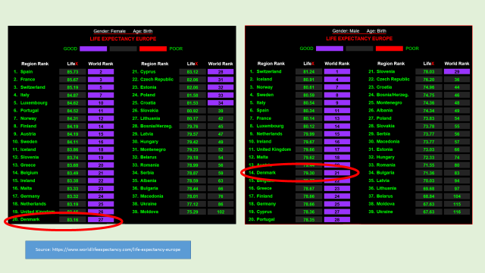

YOU COULD SAY:
If we look at the partner countries in the BEPRESEL project, Poland, Denmark, Slovenia and Italy it is clear that the 3 of us have to look at Italy to find inspiration.
Females
- Italy no.4 in the world
- Slovenia no.12
- Denmark no.20
- Poland no.24
Males
- Italy no. 5 in the world
- Denmark no. 14
- Slovenia no. 21
- Poland no. 27
And we all need to improve to reach the Spanish level or the level of Switzerland.
Perhaps we can make a shortcut and arrange that all females moves to Spain and all males moves to Switzerland.
It might surprise some – but all the European countries are beaten by a number of countries, lookin on the world ranking list.
People in a number of Asian countries lives much longer than we do. We can tell much about the Asian countries, but they are not on average more rich than us.
So what can we learn from them – from this information?
- We can mention that they eat more fish than we do.
We will look into nutrient and food habits later.
++++++++++++++++++++++++++++++++++++++++++++
ADD YOUR OWN COMMENTS AND IDEAS FOR SPEAK AND PRESENTATION:

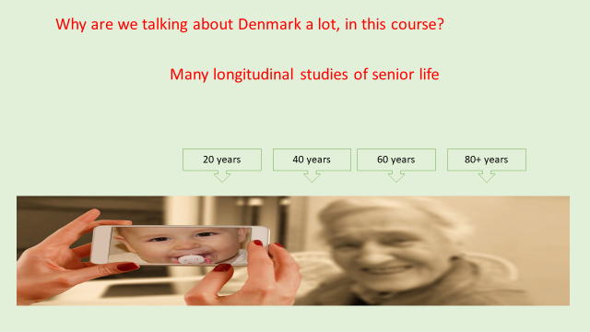

YOU COULD SAY:
In the presentations and the information to come there will be references to scientific results from many countries. Research and scientific work relating to ageing has become more and more up-scaled and important in many contries.
However, there will be a lot of references to Danish figures. Denmark is one of the countries who have had scientifically focus on the ageing process for the longest time and on implementing a huge number of preventive measures targeting many different health issues and aspects of senior life.
Denmark has a number of longitudinal researches. What is that?

It is a survey method, based on repeated measurements of the same investigative object, e.g. the same group of people during many many years. Following a huge group of people from young age to old age.
The investigated people, areas of focus or events are measured in the same way.
An example, is the Østerbro study in the capital of Denmark; Copenhagen. The longitudinal research included 24.000 people, all older than 20 when it started. They have been continuously examined according to the same areas of focus 5 times since the start in 1974 - 76.
Those who were 20 years old when the study started in 1974-76 are 65 years old in 2019. Those who were 40 years old when it started are now 85 years old.
It means that we know a lot about their previous life – what they have been eating – working – did they smoke, did they exercise and so on – evaluating them to day.
++++++++++++++++++++++++++++++++++++++++++++
ADD YOUR OWN COMMENTS AND IDEAS FOR SPEAK AND PRESENTATION

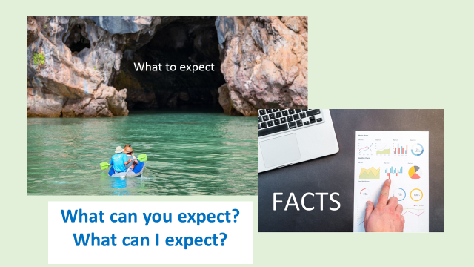

YOU COULD SAY:
Let’s look at some facts, about how the future might look if nothing changes and we will end up, in the same way as our predecessors did.

In public discussions focusing on elderly and elder there is an overwhelming focus on “treatment and care of the elderly”.
So much focus, that it might lead someone to believe that we all ends up in need of care and perhaps in need of a room, an apartment at the care home.

To some of you it might be a surprise to see how it looks.

++++++++++++++++++++++++++++++++++++++++++++
ADD YOUR OWN COMMENTS AND IDEAS FOR SPEAK AND PRESENTATION

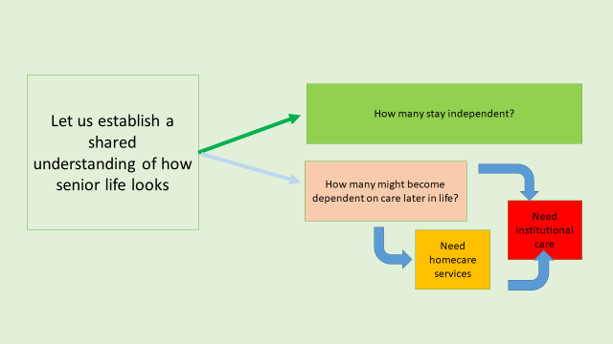

YOU COULD SAY:
Let us establish some shared knowledge and understandings of how it looks.
Two relevant question to ask?:
- How many seniors stay independent throughout life?

- How many might become dependent on personal and practical support – delivered either as homecare services or delivered to a resident at a care home.

++++++++++++++++++++++++++++++++++++++++++++
ADD YOUR OWN COMMENTS AND IDEAS FOR SPEAK AND PRESENTATION

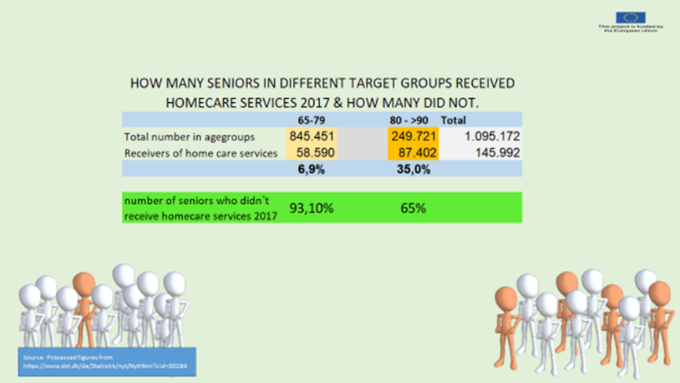

YOU COULD SAY:
We use Danish figures because all levels and kinds of eldercare is free in Denmark. Care and nursery is paid by the municipalities and by a quit high tax level.
The fact that care in later life is free in Denmark, makes us believe that there are no “dark figures” in Denmark.
It means it is an assumption that there are no elderly in Denmark in need of personal or practical support or in need of nursery;
- who doesn’t ask for it, because they don’t have to pay for relevant care and nursery services and
- receive the needed support and services

LETS LOOK INTO HAVE MANY ARE IN NEED FOR HOMECARE SERVICES IN DK.
The table shows and tells that:
- Presently, Denmark had 1.095.172 senior citizens (+65) at the end of 2017.

Divided into 2 age groups it shows that:
- 58.590 senior citizens or 6,9% of the entire age group age 65 to age 79 are in a life position, where they need and receive practical support, or personal care, or nursery – or a combination of it all.
So what can we conclude, what is the conclusion?
- We can conclude, that it is not “NORMAL” to be in a state of dependency for the huge majority (more than 9 out of 10) of seniors up to age 79

Further more:
The percentage of senior citizens ending up in a life situation where they need personal practical support in age group 80+ rise to 35%.
So what can we conclude, what is the conclusion?
We can conclude, that 2:3 senior citizens still do not receive support and stay independent even entering the life period from age 80 and to the end of life.
Question to the seniors:
Are you surprised that the number of elderlies up to age 80 who receive home care services is only 6,9% and that 2 out of 3 seniors still live on their own conditions in age group 80+ ?
THIS WAS THE SITUATION REGARDING HOMECARE SERVICES
Lets have this in mind, while we move on
++++++++++++++++++++++++++++++++++++++++++++
ADD YOUR OWN COMMENTS AND IDEAS FOR SPEAK AND PRESENTATION:

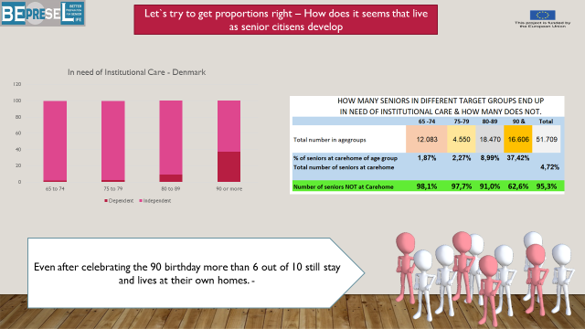

YOU COULD SAY:
When it comes to senior citizens in need for INSTITUTIONAL CARE:
- 51.709 seniors out of 1.095.172 or 4,72 % are in need of institutional care.
  - Less than 5:100 of seniors older than 65 lives at a care home.
It is NOT NORMAL ending up in a lifesituation where a carehome is needed
- In agegroup 65 to 74 years (10 year group),
  - 12.083 senior citizens or 1,87% live at a care home.
- In age group 75 to 79 (5 year group),
  - 2,27 % or 4.550 senior citizens live at a care home.
- In age group 80 to 89 (10 year group)
  - only 8,99 % or 18.470 senior citizens live at a care home.

Among the eldest seniors more than age 90
- only 37,42% = 1:3 or 16.606 senior citizens live at a care home.

Question to the seniors: Are you surprised:
- That the number of elderly older than 90 in need of the service and security at a care home is only 3,7 out of 10?
- That the statistics show that it is “normal” for a person older than 90 to live in their own house or flat?
(In Denmark it is not normal for old parents to live with their children, so there is no family care in Denmark)
Put attention to the figures marked with red.
++++++++++++++++++++++++++++++++++++++++++++
ADD YOUR OWN COMMENTS AND IDEAS FOR SPEAK AND PRESENTATION

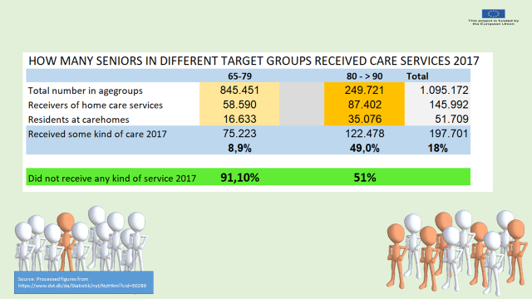

YOU COULD SAY:

If we combine the two tables, it shows that only
- 8,9% in age group 65 – 79 either receive homecare service or live at a care home.
  - 9:10 live independently and on their own conditions.

Looking into the figures of the oldest seniors, age group 80+, that
- It is just as common to have a daily life without support (51%)
- as having a daily life depending on support (49%).

Final conclusion:
There are many reasons
to end up in need of home care or as resident at a carehome

– but age is not a reason.
Today, we know a lot about what might lead to a lifesituation in need of care. There are many reasons – but age is not one of them.
It is not more normal to be in a life situation, when we enter agegroup 80+
- that requires personal and practical support.
Than being in a lifesituation when we enter agegroup 80+
- and still be independent, selfgoverning and in control of own life.
++++++++++++++++++++++++++++++++++++++++++++
ADD YOUR OWN COMMENTS AND IDEAS FOR SPEAK AND PRESENTATION.

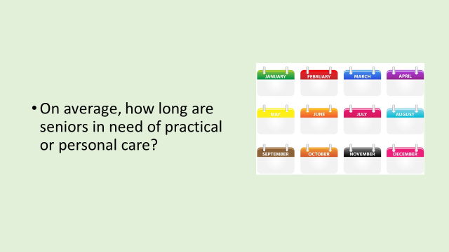

YOU COULD SAY:

Another way of looking into the challenges and opportunities of growing older, could be to take a look into what we know about the years we on average, can expect to live with and without functional limitations.
– After we have reached the age of 60.

++++++++++++++++++++++++++++++++++++++++++++
ADD YOUR OWN COMMENTS AND IDEAS FOR SPEAK AND PRESENTATION

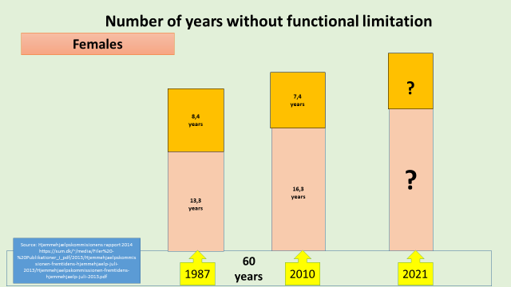

YOU COULD SAY:
How to read these figures.
In Denmark the number of years
- with functional limitations after celebrating onces 60 years aniviersary and
- without functional limitation are regular meusured among citizens.
This balance has been meausured regularly in Denmark and are still meausured occacionally
1987
Females celebrating their 60th birthday in 1987 could expect another 21,7 year on average.
- But out of these 21,7 year the females on average had to face
  - 8,4 years with functional limitation.
- It means more than 1 year per 3 year of the last periode of life on average was with functional limitations.
2010 - One generation later.
Females celebrating their 60th birthday in 2010 could expect another 23,7 year on average.
- 2 more years than 23 years earlier.
- But still out of these 23,7 years the females would have to face
  - 7,4 years with functional limitation.
- It means that femeales still had to face 1 year per 3 year on average with functional limitations.
2015.
Question the learners: How do you think it looks in 2021?
- Seniors in Denmak also practiced Active ageing in 2010.
++++++++++++++++++++++++++++++++++++++++++++
ADD YOUR OWN COMMENTS AND IDEAS FOR SPEAK AND PRESENTATION:

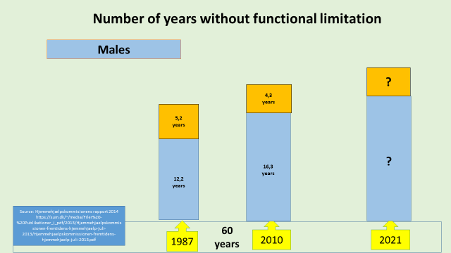
YOU COULD SAY:
When it comes to males it looks a little better.
Males have reduced the years with functional limitations from:
- almost 5 years out of 17,4 years = 1 out of 3 years to
- 4,3 out of 20,6 years. = to 1 out of 5 years.

Females have clearly the biggest challenge – but there is room for improvement among both females and males.

++++++++++++++++++++++++++++++++++++++++++++
ADD YOUR OWN COMMENTS AND IDEAS FOR SPEAK AND PRESENTATION

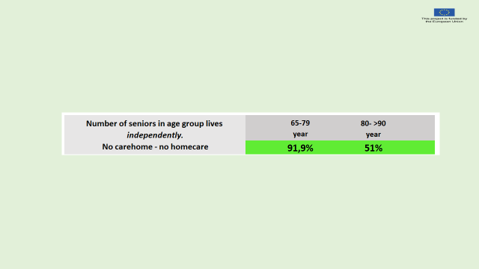

YOU COULD SAY:
Having these numbers of years with functional limitations in mind and knowing the total number of seniors receiving different kind of care services.
The big relevant questions are ONCE AGAIN:
What decides who ends up:
- as the 1 person out of 10 who need support & care during the period of 65 to 79 year.
and
- as one of the 9 seniors out of 10 seniors, who stay independent and do not need support and help during the period of 65 to 79 year.

What decides who ends up:
- as one of the 49 seniors who need suport and help after age 80
- as 1 of the 51 who stay independent and don`t need support and help after age 80.
Is it pure luck – destiny – or what decides?
Who will end up in need of care or not –and at what time in life it will start?

It is obviously not the age?
As more seniors don’t end up in need of care than seniors that do.
It is the aim of this course –
to try to give you some answers to these questions.
++++++++++++++++++++++++++++++++++++++++++++
ADD YOUR OWN COMMENTS AND IDEAS FOR SPEAK AND PRESENTATION:

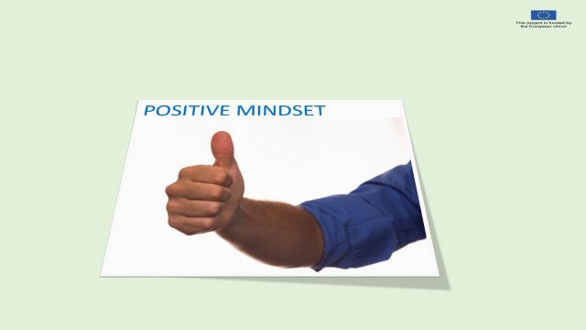

YOU COULD SAY:
We know that one big factor determine how it ends; is our mindset.
- Partly decided by our individual understanding of the ageing process ahead of us and our approach to the ageing process ahead of us.
  - No matter what age we have today.

- Partly caused by have many wrong myths and personal believes and wrong assumptions, explanations and bad excuses, we base our approach to and understanding of the ageing process..

++++++++++++++++++++++++++++++++++++++++++++
ADD YOUR OWN COMMENTS AND IDEAS FOR SPEAK AND PRESENTATION:

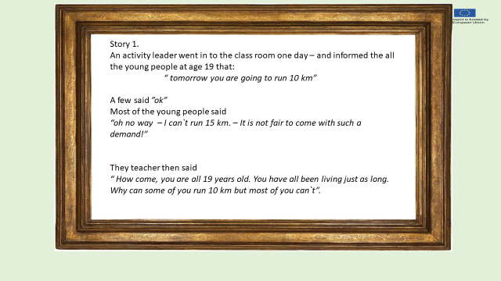

YOU COULD SAY:

Read the story for the learners.
Ask the senior learners
What is your explanation(s) and your answer(s) to the question?
Why are some of the young people not able to run 10 km.”

++++++++++++++++++++++++++++++++++++++++++++
ADD YOUR OWN COMMENTS AND IDEAS FOR SPEAK AND PRESENTATION:

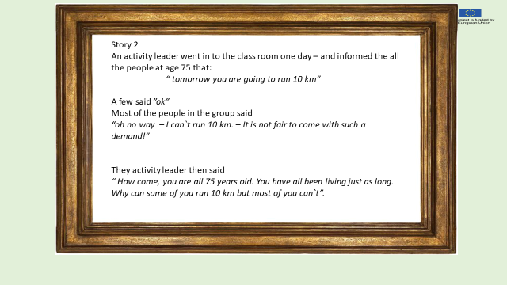

YOU COULD SAY:

Read the story for the learners.
Ask the senior learners
“what is your answer(s) and explanation(s) why some of the seniors at age 75 are not able to run 10 km”

Many seniors at age 75 are able to run 75 km.
Are you able to – and why – why not.

++++++++++++++++++++++++++++++++++++++++++++
ADD YOUR OWN COMMENTS AND IDEAS
FOR SPEAK AND PRESENTATION HERAFTER:

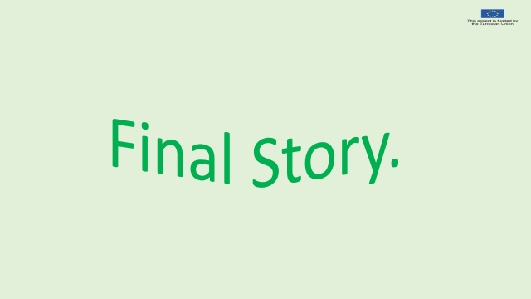

YOU COULD SAY:

FINAL STORY TELLING.
A man was going to celebrate his 85th birthday. The children and grandchildren had decided that they wanted to give their grandfather a very special present.

They realized, that if they themselves gave him this present, he would immediately go to the shop next day and ask for a payback of the money for the gift.
Therefore, they decided the present should be handed over by the grand-grandchildren.

When the man opened his present, he found a pair of running shoes.

Inside he was not that satisfied but smiled of course and gave the small once a kiss.
But at the same time he also realized that he had to put them on later – to make them a little dirty. He knew that next time he saw his grand-grandchildren they would ask him with big expecting eyes:
“Dear Grand-granddaddy – are you happy about the shoes we gave you?”.

Shortly after his birthday, he put the shoes on – and went for a walk in the rain to make them dirty.
He realized quit quickly that the shoes in fact was nice to wear and to walk in. And he found out that he could walk a little more faster in these shoes – than he could in the old ones.

Just before turning 87 the man ran his first marathon.

He has never been able to run a marathon before in his life.

Questions to the seniors: What is the learning outcome of this story?




