[](http://www.google.dk/url?sa=i&rct=j&q=&esrc=s&source=images&cd=&cad=rja&uact=8&ved=2ahUKEwjU-_bvxPrZAhWD3CwKHacKBKEQjRx6BAgAEAU&url=http://www.delmne.ec.europa.eu/code/navigate.php?Id%3D3873&psig=AOvVaw2vd0Uouawn_Nt5qnrQapL8&ust=1521622820596345)

FEED BACK ON THE BEPRSELS TEST COURSES

DENMARK.

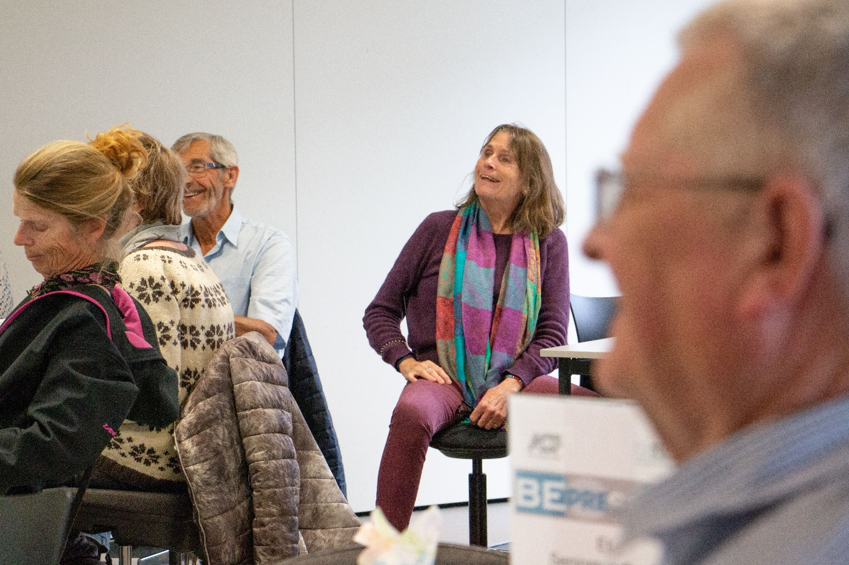



|  |  |  |  |  |  |  |
| --- | --- | --- | --- | --- | --- | --- |
| Now you have completed a course of 16 lessons including time for testing.  Have you learned anything new about the aging process? | | | | | |  |
| Please make only one mark. | | | | | |  |
| NO | Yes a little | Yes - some | Yes much | I am in fact surprised about how much knowledge there actually are about what makes a difference later in senior life. | No answer |  |
| 0 | 1 | 9 | 14 | 18 | 4 |  |
|  |  |  |  |  |  |  |
| 0 | 2% | 20 % | 30% | 39% | 9 |  |

* Some made more than 1 mark.
* Almost 90 % provide a very positive feed back.

|  |  |  |  |  |  |
| --- | --- | --- | --- | --- | --- |
| You have now finished a course build up by 8 modules. We will kindly ask you to comment them 1 by 1 according to the length of the individual modules. | | | | | |
|  | Good length of course | Could be more elaborate | Could be shorter | No Answer | Total responds |
| Module 1  Intro 1 | 32 | 1 | 0 | 2 | 35 |
| 91% | 3% | 0% | 6% |  |
|  |  |  |  |  |  |
| Module 1  Intro 2 | 31 | 3 | 0 | 1 | 35 |
| 89% | 9% | 0% | 3% |  |
|  |  |  |  |  |  |
|  |  |  |  |  |  |
| Module 2  Condition | 26 | 5 | 1 | 3 | 35 |
| 74,% | 14% | 3% | 9% |  |
|  |  |  |  |  |  |
| Module 3  Strength muscles power  in hands and arm. | 29 | 4 | 1 | 1 | 35 |
| 83% | 11% | 3% | 3% |  |
|  |  |  |  |  |  |
| Module 4  Strength muscles power in leg muscles. | 29 | 3 | 2 | 1 | 35 |
| 83% | 9% | 6 % | 3% |  |
|  |  |  |  |  |  |
| Module 5  Maintain the Balance | 29 | 5 | 0 | 1 | 34 |
| 83% | 14 % | 0% | 3% |  |
|  |  |  |  |  |  |
| Module 6  Blood pressure. | 31 | 3 | 0 | 1 | 35 |
| 89% | 9 % | 0% | 3% |  |
|  |  |  |  |  |  |
| Module 7  Nutrient | 29 | 5 | 0 | 1 | 35 |
| 83 % | 14 % | 0% | 3 % |  |

* Almost 8 out of 10 respond that the duration of the course was good.

|  |  |  |  |  |
| --- | --- | --- | --- | --- |
| Now you have finished the course, do you then have a clear understanding of how you may maintain or even improve the following physical competences? | | | | |
| Only one X | | | | |
|  | Yes | Yes partly | No | No Answer |
| Your condition | 27 | 6 | 1 | 1 |
| 77% | 17% | 3% | 3% |
|  |  |  |  |  |
| Your balance | 30 | 5 | 0 | 0 |
| 86% | 14 % | 0 |  |
|  |  |  |  |  |
| The strength in your arms and hands | 24 | 11 | 0 | 0 |
| 69% | 31% | 0 | 0 |
|  |  |  |  |  |
| The strength in your thighs muscles | 26 | 9 | 0 | 0 |
| 74% | 26% | 0 | 0 |

* 97% answer yes or partly yes to have a basic understanding of how they improve these competences.

|  |  |  |  |  |  |
| --- | --- | --- | --- | --- | --- |
|  | Yes | Either or | No | Have one | No Answer |
| Now that you have finished the course, you have a clear idea of the importance of blood pressure: | 29 | 2 | 2 |  | 2 |
| 83% | 6% | 6% |  | 6% |
|  |  |  |  |  |  |
| Do you think you want to buy or want a blood pressure monitor and check your blood pressure from time to time - for example, a couple of times a year. | 21 | 1 | 6 | 3 | 4 |
| 60% | 3% | 17% | 9% | 11% |

* 6 out of 10 who don`t have a unit to measure blood pressure respond they will go and buy one.

|  |  |  |  |  |  |
| --- | --- | --- | --- | --- | --- |
|  | Yes | Yes & no | No | Not now | No Answer |
| After completing the course, do you have a clear idea of why it is important to keep an eye on your BMI, your fat percentage and your hip target? | 33 | 1 | 0 | 0 | 1 |
| 94% | 3% | 0 | 0 | 3% |
|  |  |  |  |  |  |
| Have you become more aware of the importance of diet in senior life? | 33 | 0 | 0 | 0 | 2 |
| 94% | 0 | 0 | 0 | 6% |
|  |  |  |  |  |  |
| Do you think you will be more active in participating in common eating? | 10 | 3 | 18 | 2 | 2 |
| 29% | 9% | 51% | 6% | 6% |
|  |  |  |  |  |  |
| Do you think you will occasionally check if you get the proteins you really need? | 26 | 5 | 4 | 0 | 0 |
| 74% | 14% | 11% | 0 | 0 |

* 9 out of 10 respond they have become more aware of BMI and importance of diet in later life.
* Almost 3 out of 4 think they regularly will check their intake of protein.

|  |  |  |  |  |  |
| --- | --- | --- | --- | --- | --- |
| Do you think the course will give you more attention,  to train and maintain your various physical skills | | | | | |
| Only one X | | | | | |
| No | Yes a little | Yes some | Yes much | Yes. Right now, I believe I will start to train in order to **maintain** my physical strength and competences. | Yes. Right now I believe that I will start to train to **improve** my physical strength and competences. |
| 1 | 3 | 14 | 9 | 13 | 7 |
| 3% | 9% | 40% | 26% | 37% | 20% |

* 83% respond that the course have motivate them much and to start maintaining or to improving their physical skills.

|  |  |  |  |
| --- | --- | --- | --- |
| If you will not start to exercise in order to maintain or develop – what do you think will be the reason? | | | |
| Only one X | | | |
| I exercise already | It is difficult to keep up the motivation doing it alone | Have no access to training facilities – in which I feel comfortable. | No Answer |
| 25 | 7 | 0 | 3 |
| 71% | 20% | 0 | 9% |

|  |  |  |  |
| --- | --- | --- | --- |
| If you have let yourself be tested, do you think that having a figure of your different physical competencies and areas means something to your motivation to strengthen these figures? | | | |
| Only one X | | | |
| No | Do actually now know | Yes – I think so | I can already feel that it does. I want to improve any of my numbers |
| 1 | 2 | 29 | 3 |
| 3% | 6% | 83% | 9% |

* 92% think having exact figures for the present status will bring motivation to strength these figures.
* This responds is quit remarkable as 71% in the previous table, answered that they will not start to exercise as they already thing they exercise. Most of them were surprised about the present status according to the different test areas.

|  |  |  |  |
| --- | --- | --- | --- |
| Has the course organization with 4 Wednesdays/fridays been comfortable | | | |
| Only one X | | | |
| Yes - fine | It may have been a little longer | A little too long | The content could be sharpened. |
| 27 | 6 | 1 | 1 |
| 77% | 17% | 3% | 3% |

|  |  |  |  |
| --- | --- | --- | --- |
| Has the course organization with 4 mornings up to noon been comfortable | | | |
| Only one X | | | |
| Yes, it is fine with 4 mornings – there is a lot to listen. | I prefer 2 connected day’s fulltime and then the test. | I prefer 2 days - 1 day a week in two weeks. | No Answer |
| 32 | 2 | 0 | 1 |
| 91% | 6% | 0 | 3% |

|  |  |  |
| --- | --- | --- |
| This course was free. Now you know what it contains, what would you think it is worth.  How much will you pay for the knowledge you have today?  You may try to relate your answer to what you normally are ready to pay for courses with other content. | | |
| Only one X | | |
| 15 euro | 25 euro | 40 euro |
| 5 | 2 | 5 |
| 14% | 6% | 6% |

|  |  |  |
| --- | --- | --- |
| 50 euro | 70 euro | 80 euro |
| 10 | 5 | 1 |
| 29% | 14% | 3% |

|  |  |  |
| --- | --- | --- |
| No answer |  |  |
| 7 |  |  |
| 20% |  |  |

* Even though they have been extremely positive in evaluation of the course they have participated in and respond that they have learned a lot and become more motivated for maintaining or even improving their physical skills, only 17% respond they will pay 70 euro or more to have this motivation and only 46% will pay 50 euro or more.
* 50 euro is what they normally are expected to pay for any other creative course.
* It is remarkable that seniors are not willing to pay hundreds of euros to have the knowledge and motivation to extend the life period staying independent and self-governing.
* It is clear that the level of fee has to be considered very carefully introducing this kind of courses.

|  |  |  |
| --- | --- | --- |
| Do you think the course and course have had a content and a quality that will make you recommend your acquaintances to participate if it is re-launched? | | |
| Only one X | | |
| Yes | No | I don`t know |
| 34 | 0 | 1 |
| 97% | 0 | 3% |

* It seems as the content and form of the BEPRESEL senior health course, have a very high level of quality as 97% say yes to this question and gladly will recommend the course to their acquaintances.

|  |  |  |  |  |
| --- | --- | --- | --- | --- |
| Where will you place your self according to these categories.?. | | | | |
| Only one X | | | | |
| Not wealthy | I believe I belong in the middle income group among senior citizens | Something in between | I think I have a better economy than most senior citizens do. | No Answer |
| 4 | 18 | 3 | 9 | 1 |
| 11% | 51% | 9% | 26% | 3% |

* We chose the category “Not wealthy” to avoid using the word “poor”.
* We think the figures show that we managed to reach people of a very different economical position.

|  |  |  |  |
| --- | --- | --- | --- |
| Educational background  Highest graduation | Building technician  Engineer  Doctor secretary  Library assistant  2 Electrician  Financial Accounting  8th grade  Business College  Technical education | 2 Merconom  Physiotherapist  4 Teacher  3 Pedagogue | Diploma  Civil engineer  Surveyor  Longer higher education  2 University  Graduate and Master  Can pæd psych |

* The senior’s range from 8 grade (uneducated/unskilled) cross vocational educational background to bachelors and higher educated.

|  |  |  |
| --- | --- | --- |
| My last position/job type before I retired. | Office  Day Child Care  library  2 Bookkeeper  Medical Secretary  Turns and welds  Accountant  Technician  Communications Officer  Economy / salary  National directorate of Roads. | 3 Teacher  Pedagogue  Physiotherapist sanatorium  Special Pedagogue  Crisis centers for battered women  Upper Secondary teacher  Volunteer Coordinator  Project Manager  Engineer |
| Head in nursery  Operating manager  Group leader research laboratory  Store manager  2nd manager in day care  Headmaster primary school | 3 Company owner |

* Asking the participants to inform about the last occupation reflect that the course reached a quit big diversity of people.