[](http://www.google.dk/url?sa=i&rct=j&q=&esrc=s&source=images&cd=&cad=rja&uact=8&ved=2ahUKEwjU-_bvxPrZAhWD3CwKHacKBKEQjRx6BAgAEAU&url=http://www.delmne.ec.europa.eu/code/navigate.php?Id%3D3873&psig=AOvVaw2vd0Uouawn_Nt5qnrQapL8&ust=1521622820596345)

EVALUATION OF BEPRESEL TEST COURSES

ITALY

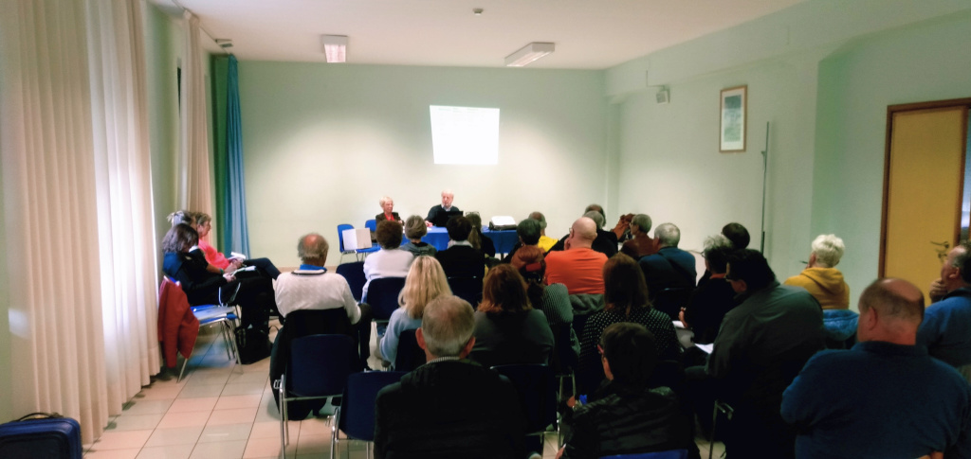



The answers of 23 participants.

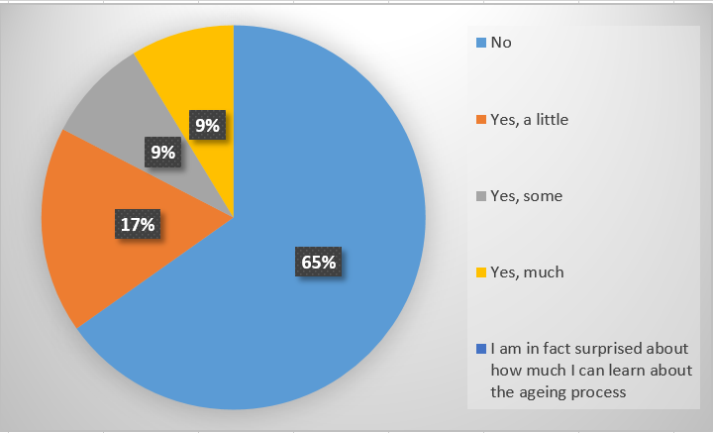Now that the course is over, have you learned anything new about the ageing process?

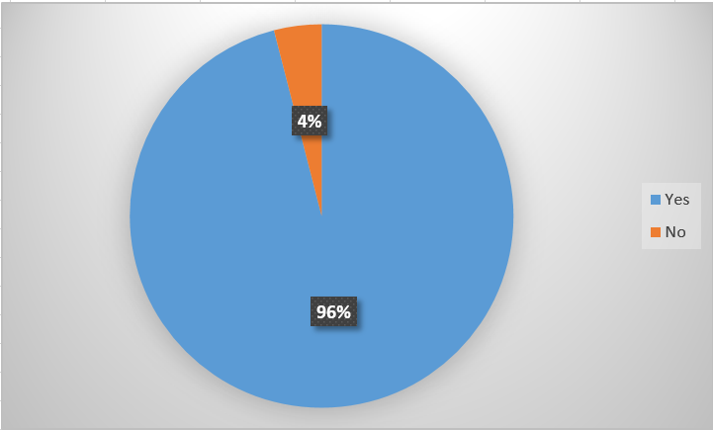Do you rate as important the value of blood pressure

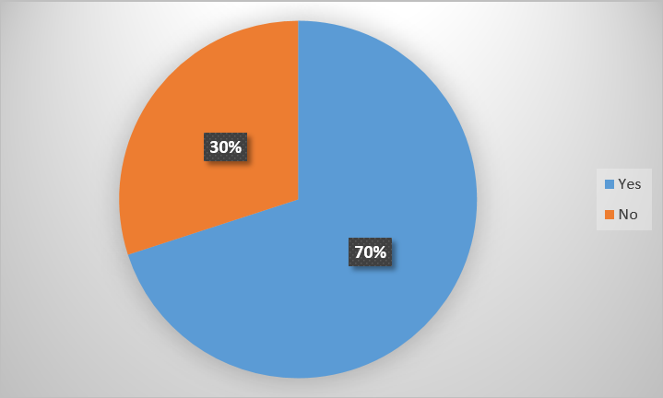Do you think you will start to check your blood pressure regularly after this course?

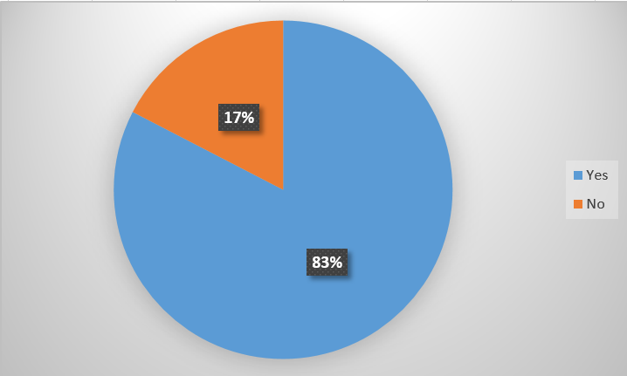After completing the course, do you have a clear idea of why it is important to keep an eye on your BMI, your fat percentage and measure your hip?

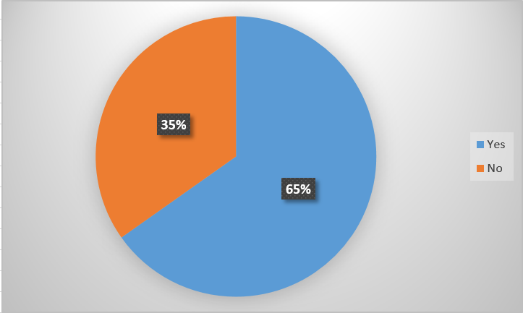Have you become more aware of the importance of nutrient/diet in senior life.

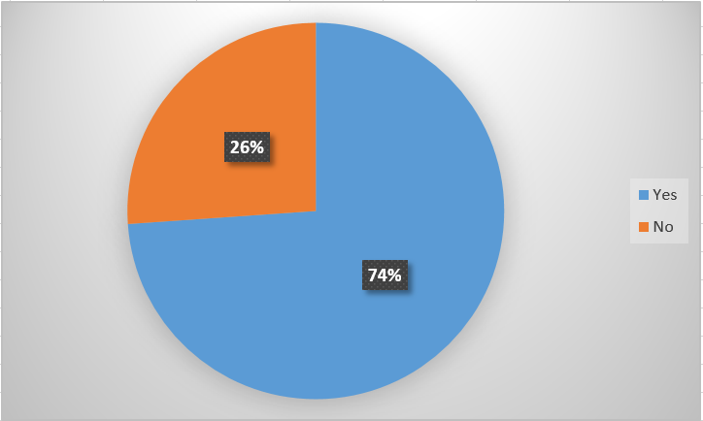Do you think you will occasionally check if you get the proteins you really need?

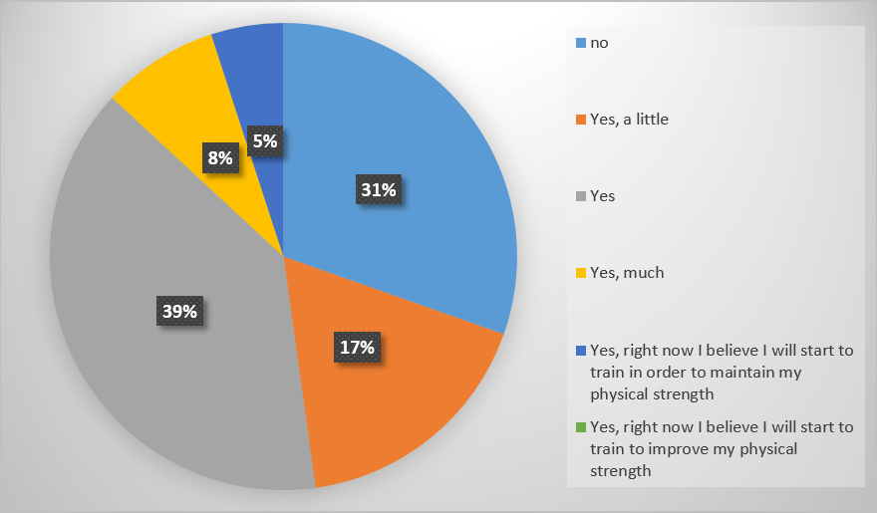Do you think this course will give more attention to train and maintain your various physical competences?

If you will not start to train, what do you think will be the reason?

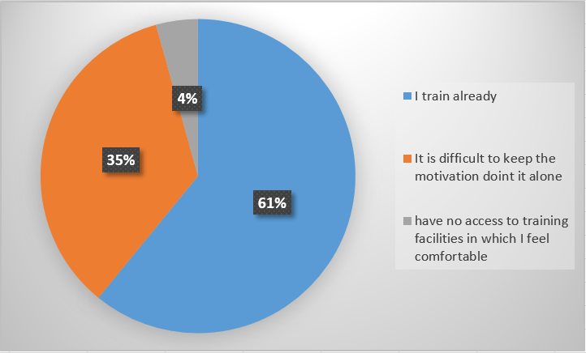

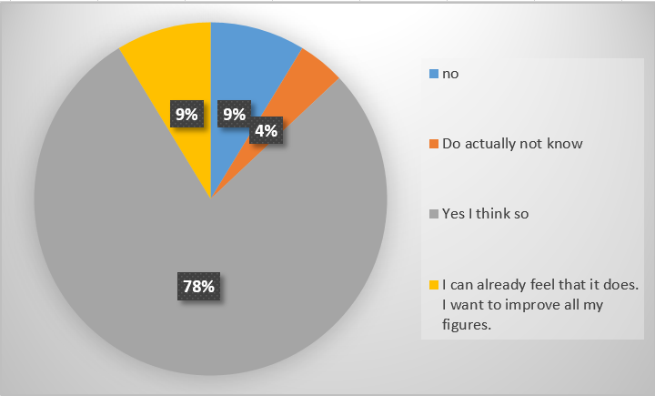If you have let yourself be tested, do you think that having a number of different physical competences and areas means something to your motivation to strengthen these figures?

How was the course schedule?

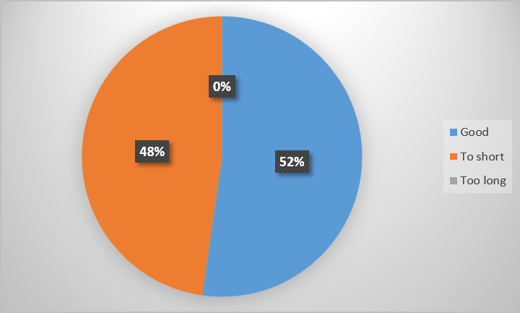

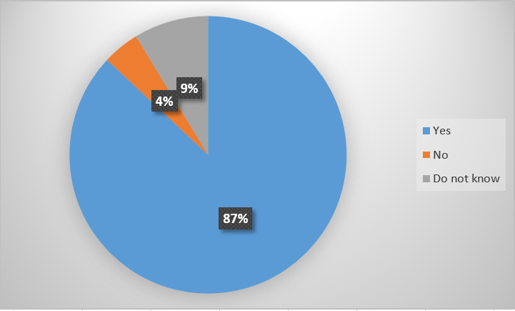Do you think the course had a content and a quality that will make you recommend hour acquaintances to participate if it will be re-launched.

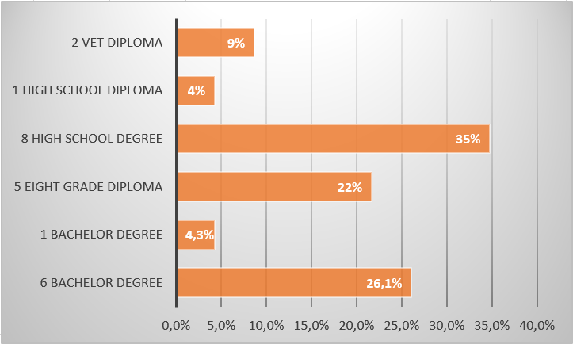Educational background.

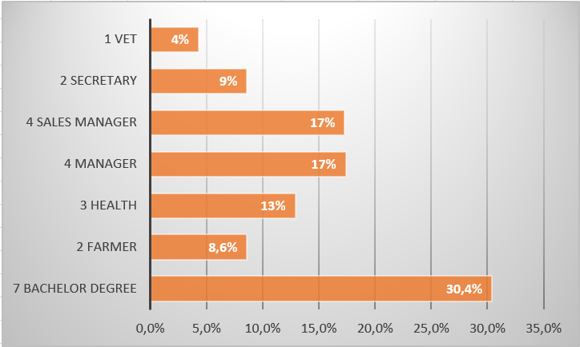My last position/job type before I retired.